**NODE JS**

1.

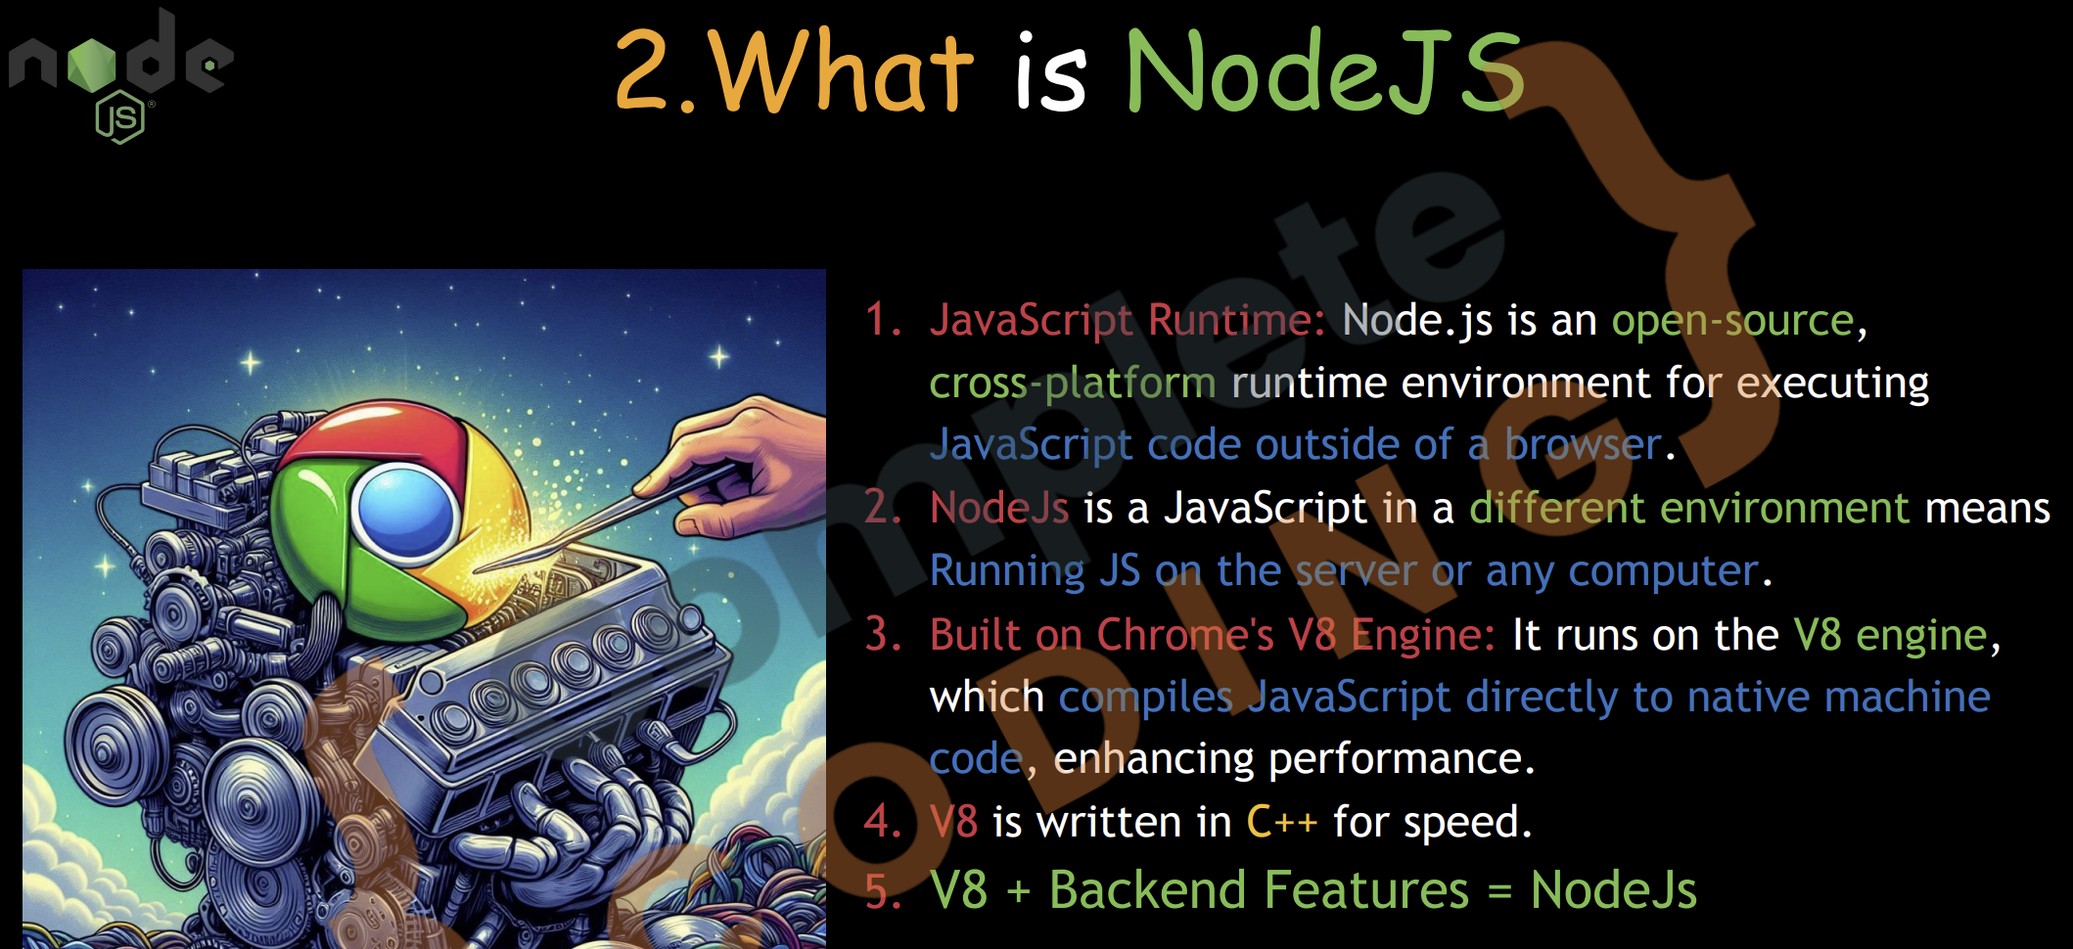

Node.js is a JavaScript runtime built on Chrome's V8 engine, allowing developers to run JavaScript on the server-side. It uses an event-driven, non-blocking I/O model, making it lightweight and efficient.

In Node.js, the I/O (Input/Output) model refers to how the runtime handles interactions with external systems, such as file systems, databases, and network requests.

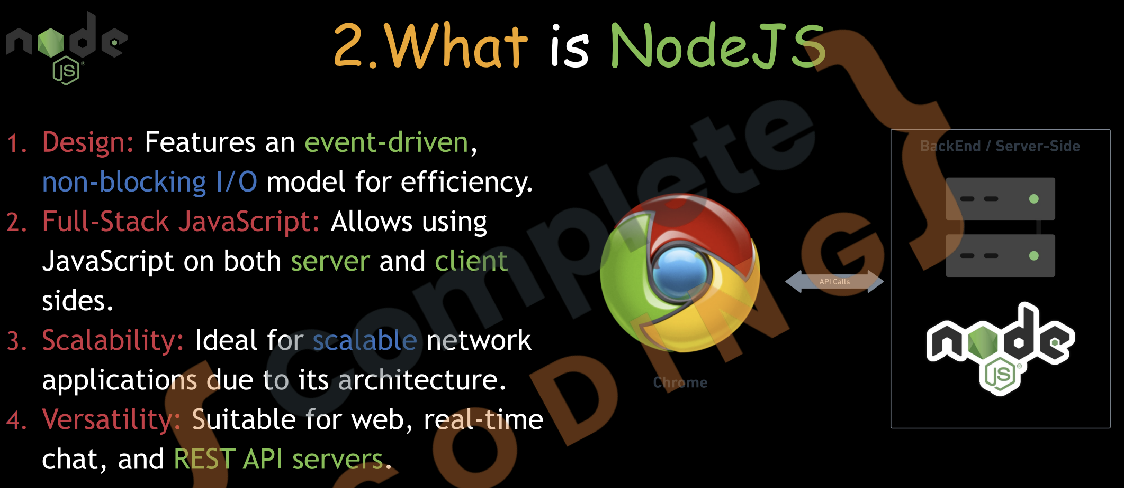

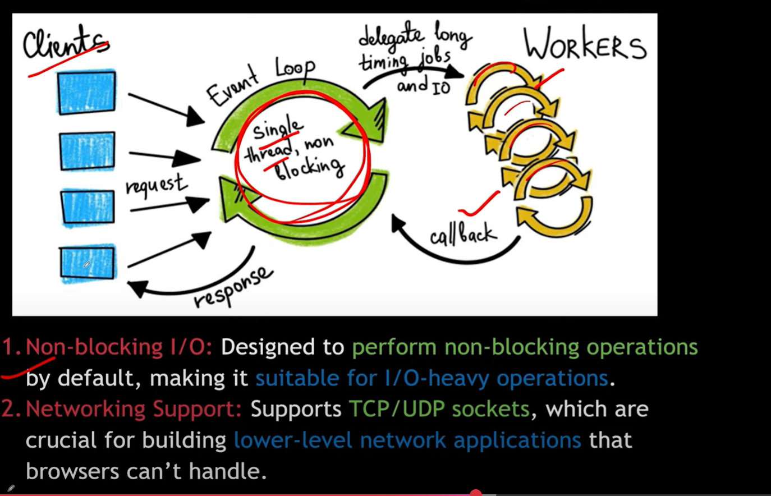

DNS

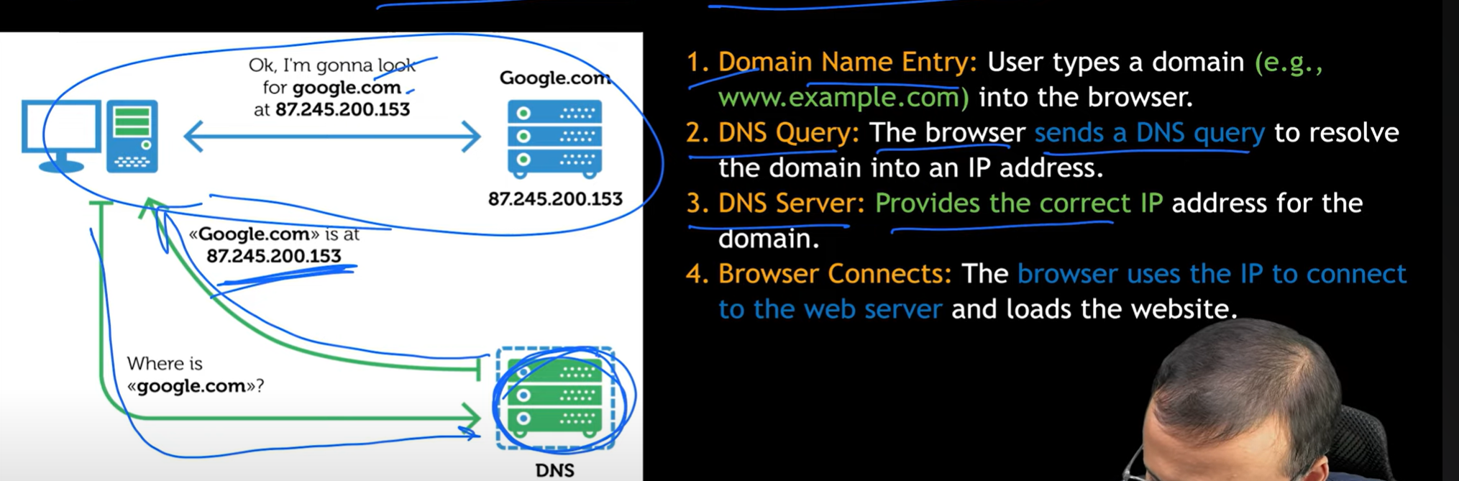

**TCP (Transmission Control Protocol)**

**TCP** is like sending a message through a **delivery service** that:

* **Breaks** your message into pieces (packets)
* **Delivers** them in **order**
* **Checks** if each one arrives
* **Resends** if something is missing

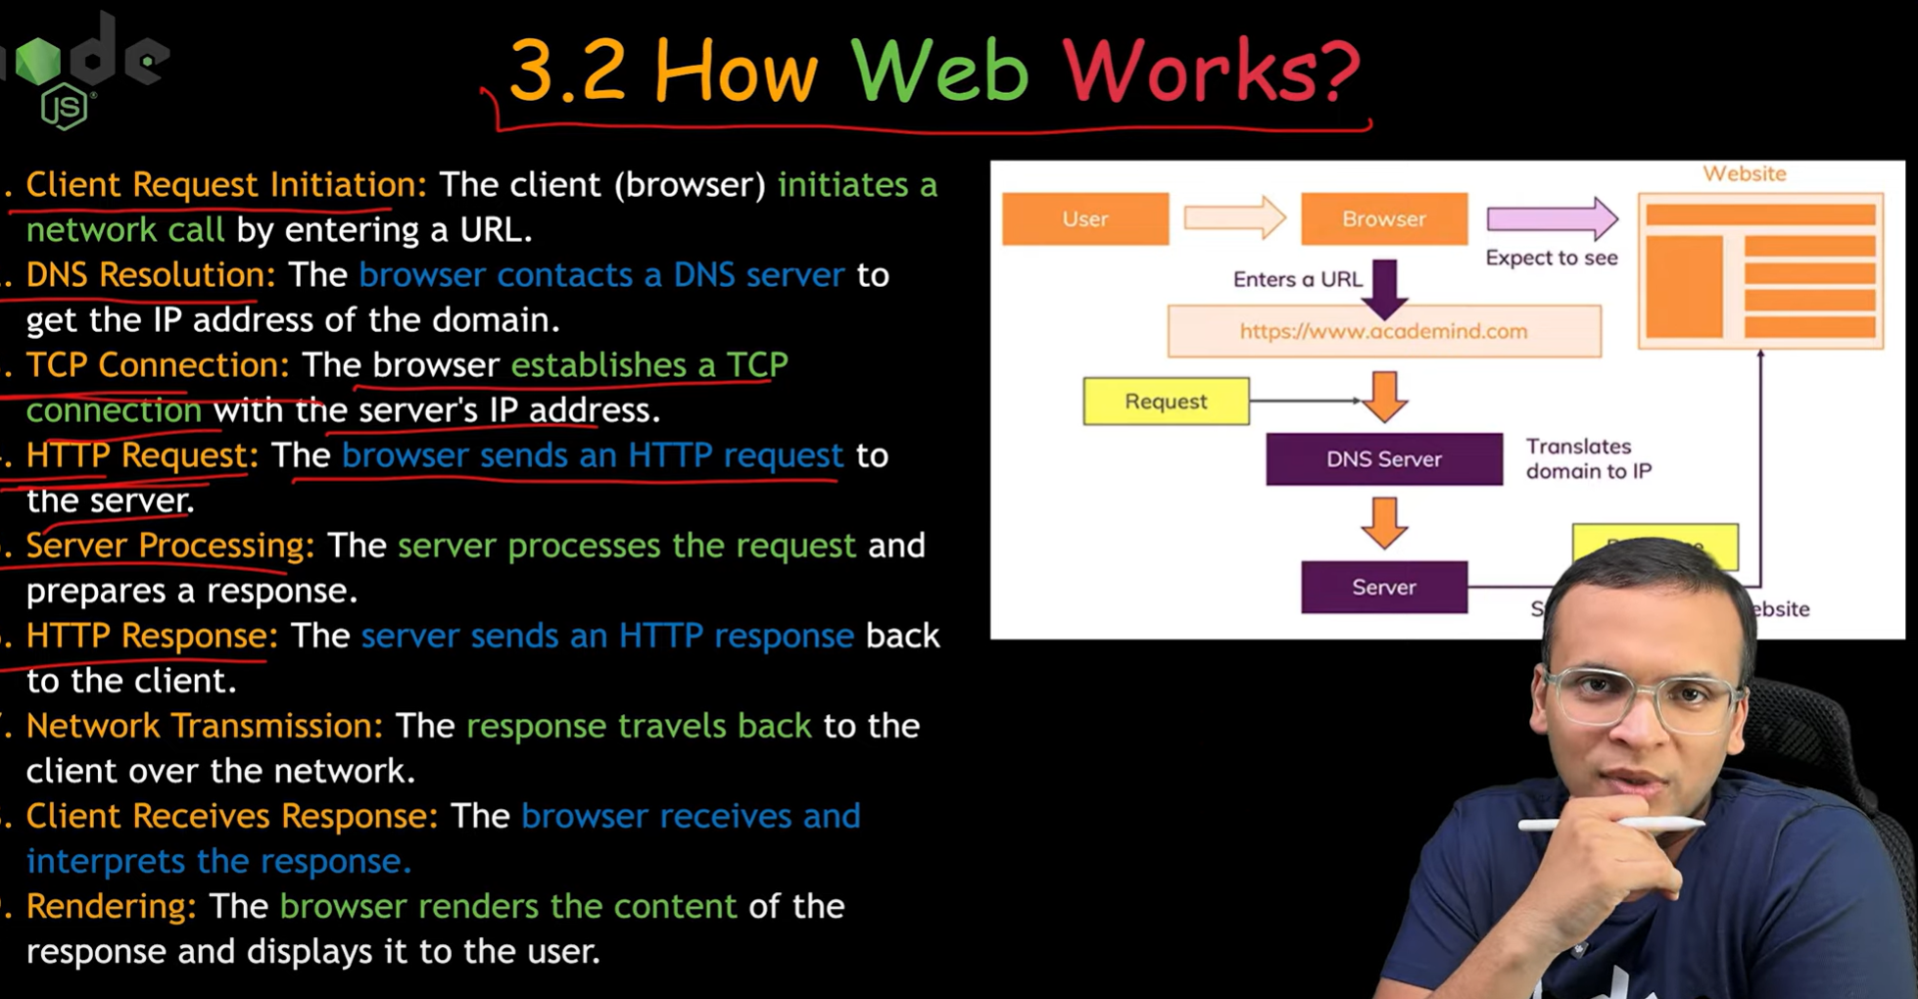

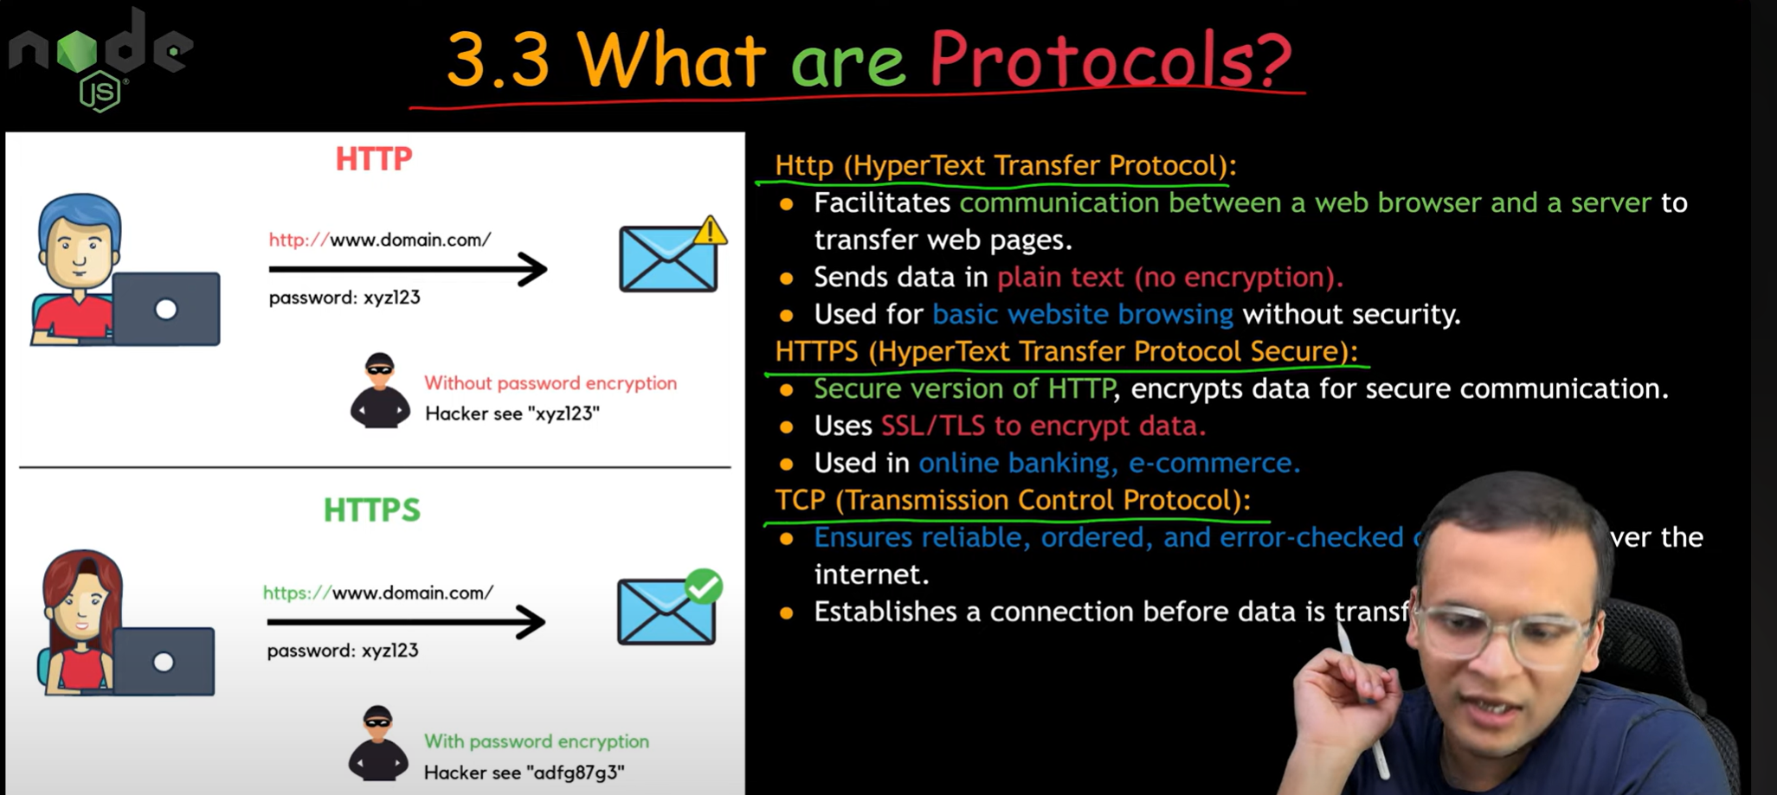

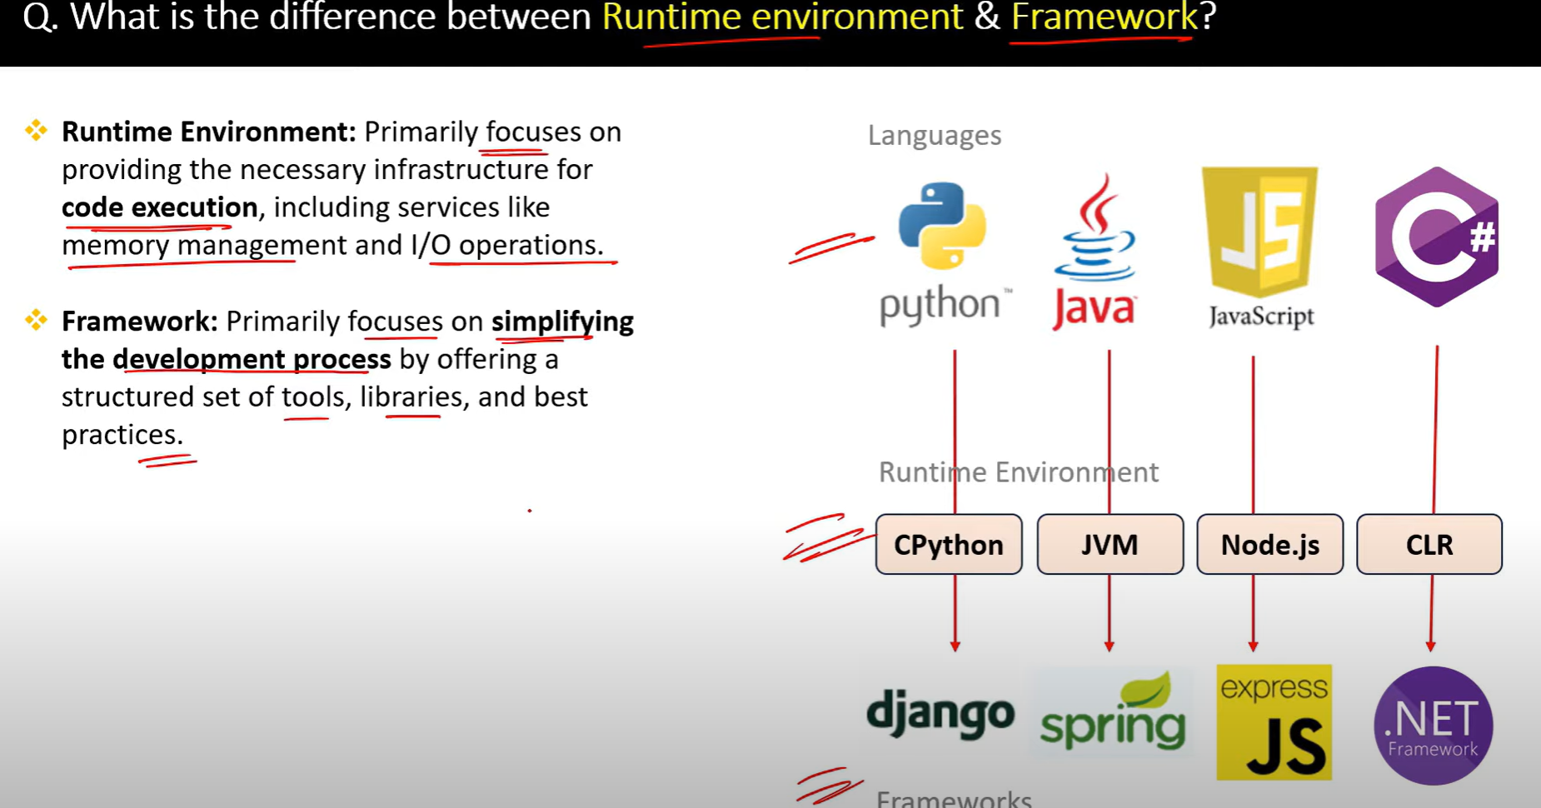

3.

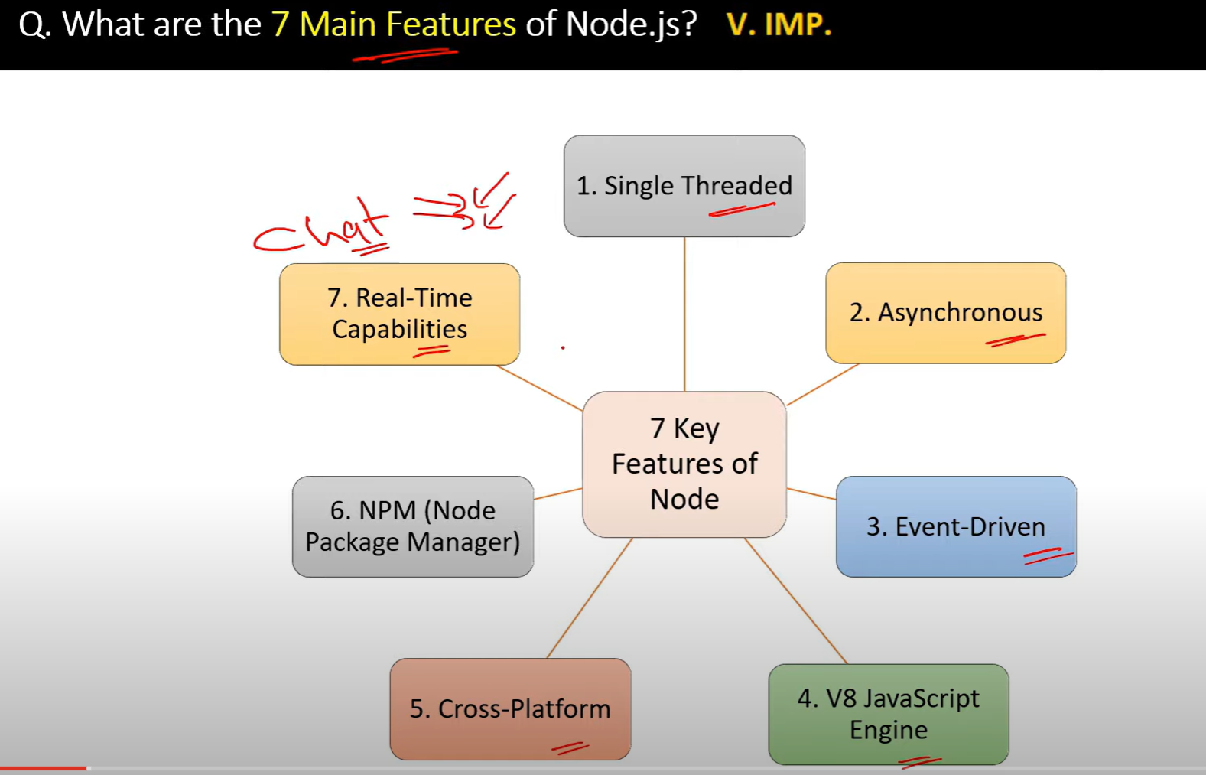

5.

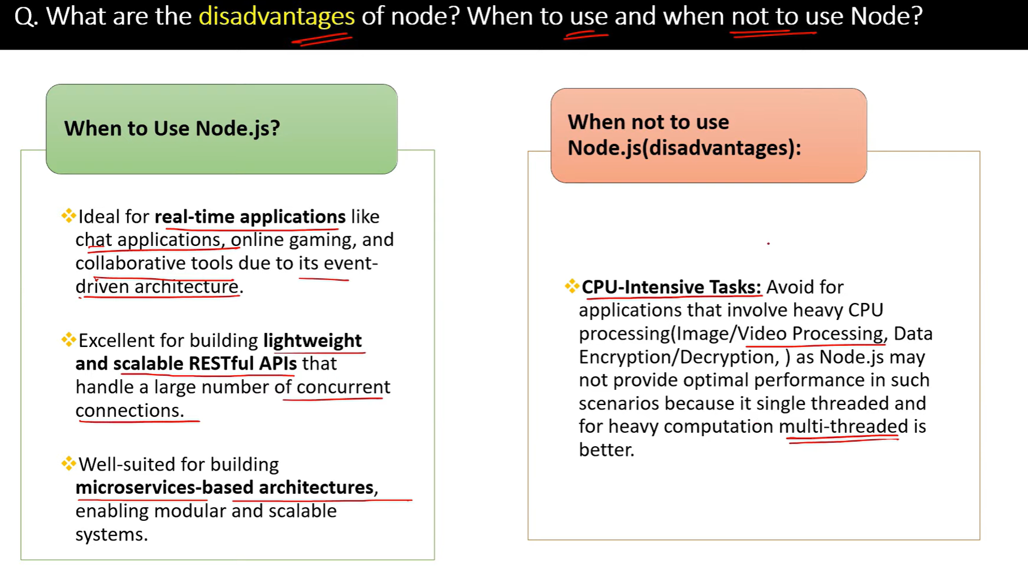

6. Is javascript Single Threaded programming?

1. javascript is a single threaded language. Only one thing can happen at a time. Not multiple things can happen at a time.
2. Event loop is a mechanism that allows javascript to perform non-blocking operations.
3. CallStack is a mechanism that allows javascript to perform synchronous operations. Which executes the code line by line.

[**https://www.youtube.com/watch?v=UXWBl77dq3A**](https://www.youtube.com/watch?v=UXWBl77dq3A)

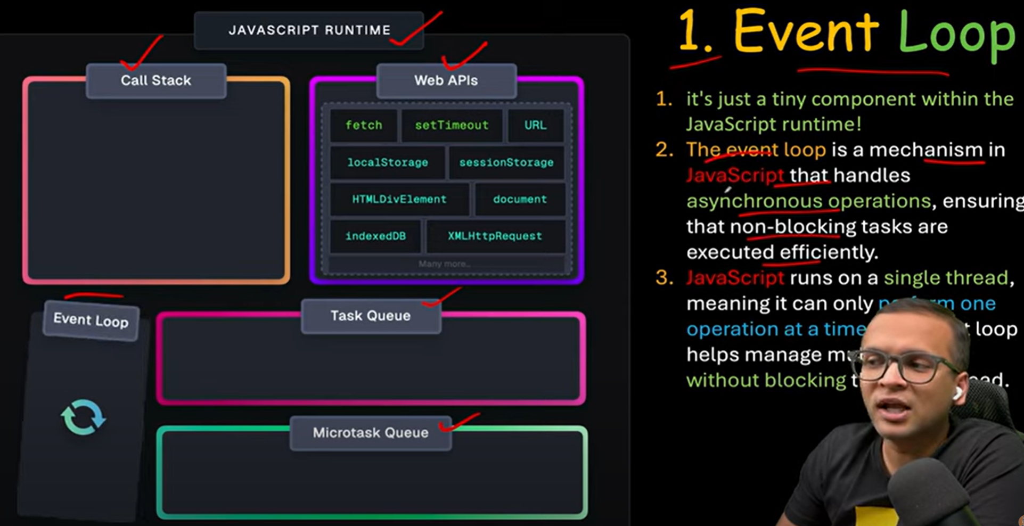

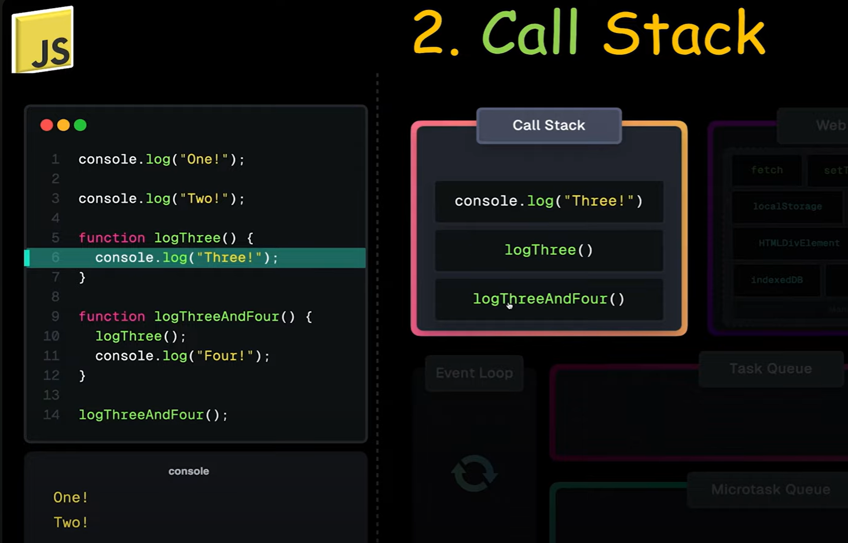

Call stack will run the basic operation in console and normal function

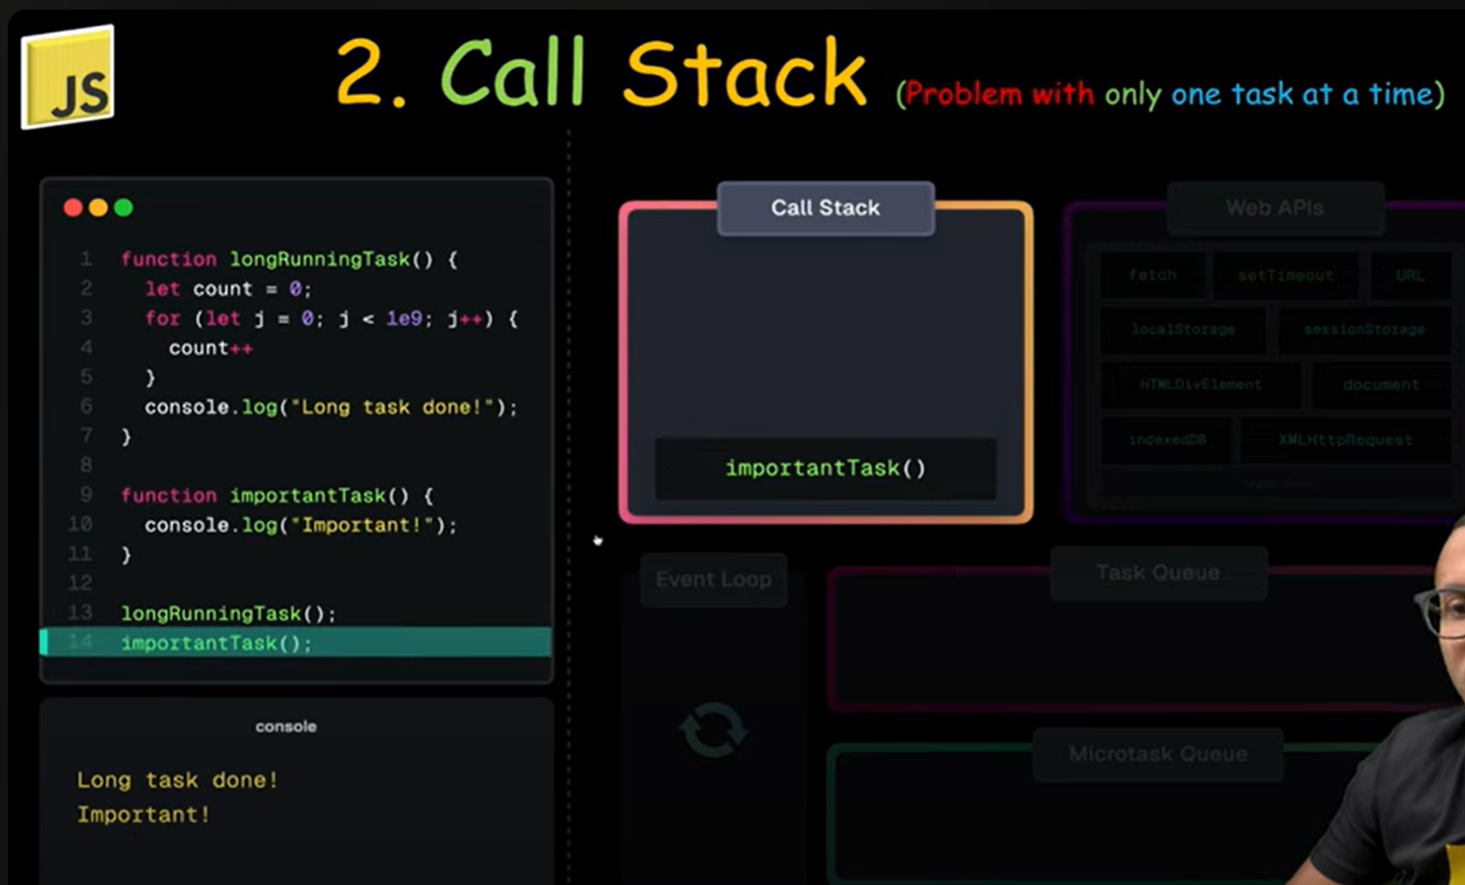

Problem with the callstack is if there is one function which takes too much time and then the second function will be waiting until first function finishes execution because js is single threaded

1. Web APIs are provided by the browser. They are not part of javascript. They are used to perform non-blocking operations.

   web api is a bridge to use all the features of the browser.

   Types of web APIs:

   -Fetch Api : It is used to make network requests.

   -TimersApi : It is used to delay the execution of a function.Like setTimeout, setInterval, etc.

   - Geolocation Api : It is used to get the location of the user.

   - WebStorage Api : It is used to store data in the browser.Like localStorage, sessionStorage, etc.

   - File Api : It is used to read and write files in the browser.

   - Performance Api : It is used to get the performance of the browser.

   - Html Dom Api : It is used to manipulate the DOM.

   - Url Api : It is used to handle urls.

   - Canvas Api : It is used to draw graphics on a webpage.

   - Audio/Video Api : It is used to play audio and video on a webpage.

   - Image Api : It is used to manipulate images on a webpage.

   - WebSocket Api : It is used to create a two-way communication channel between the browser and the server.

   - Notification Api : It is used to display notifications on a webpage.

   - Web Workers Api : It is used to run javascript in the background.

   - Sensor Api : It is used to access the sensors of the browser.

   - Gpu Api : It is used to access the gpu of the browser.

   many more.

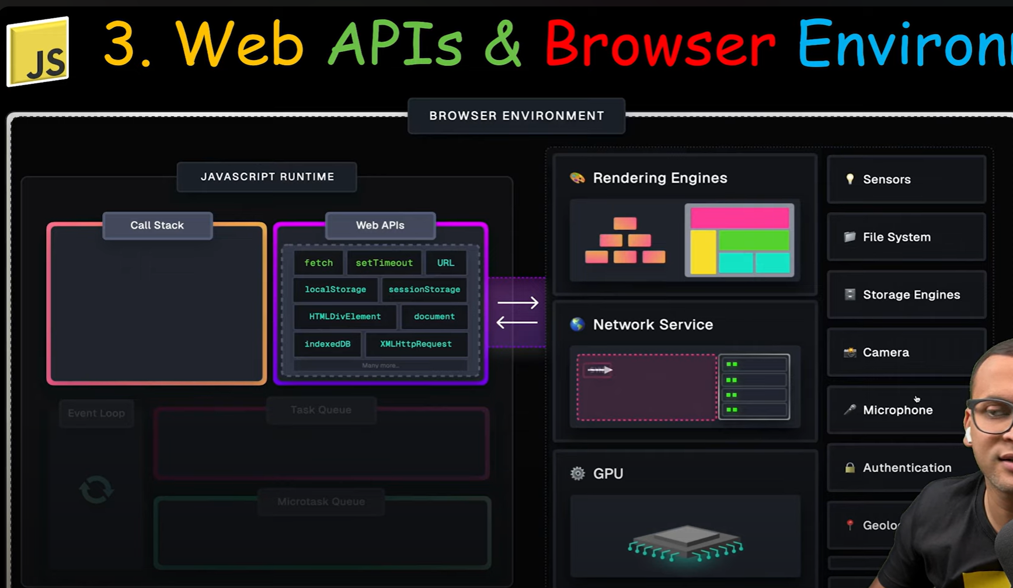

1. Event Loop: It is a loop that continuously checks the call stack and the callback queue.
2. If the call stack is empty, it takes the first item from the callback queue and pushes it to the call stack.

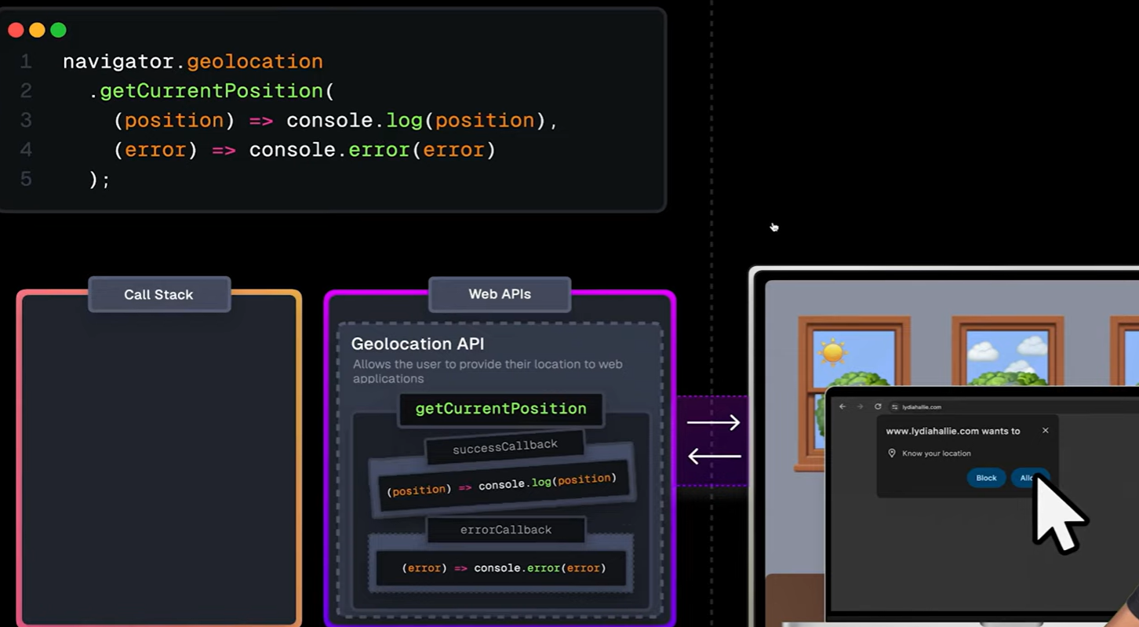

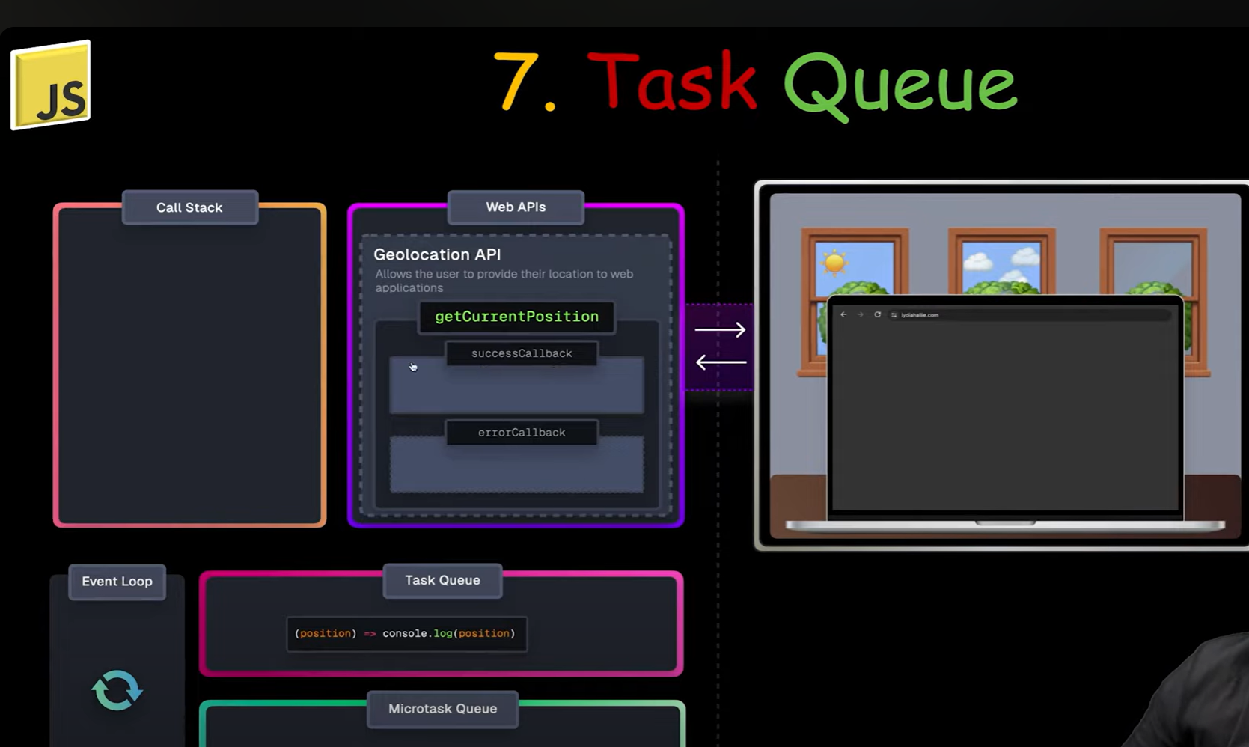

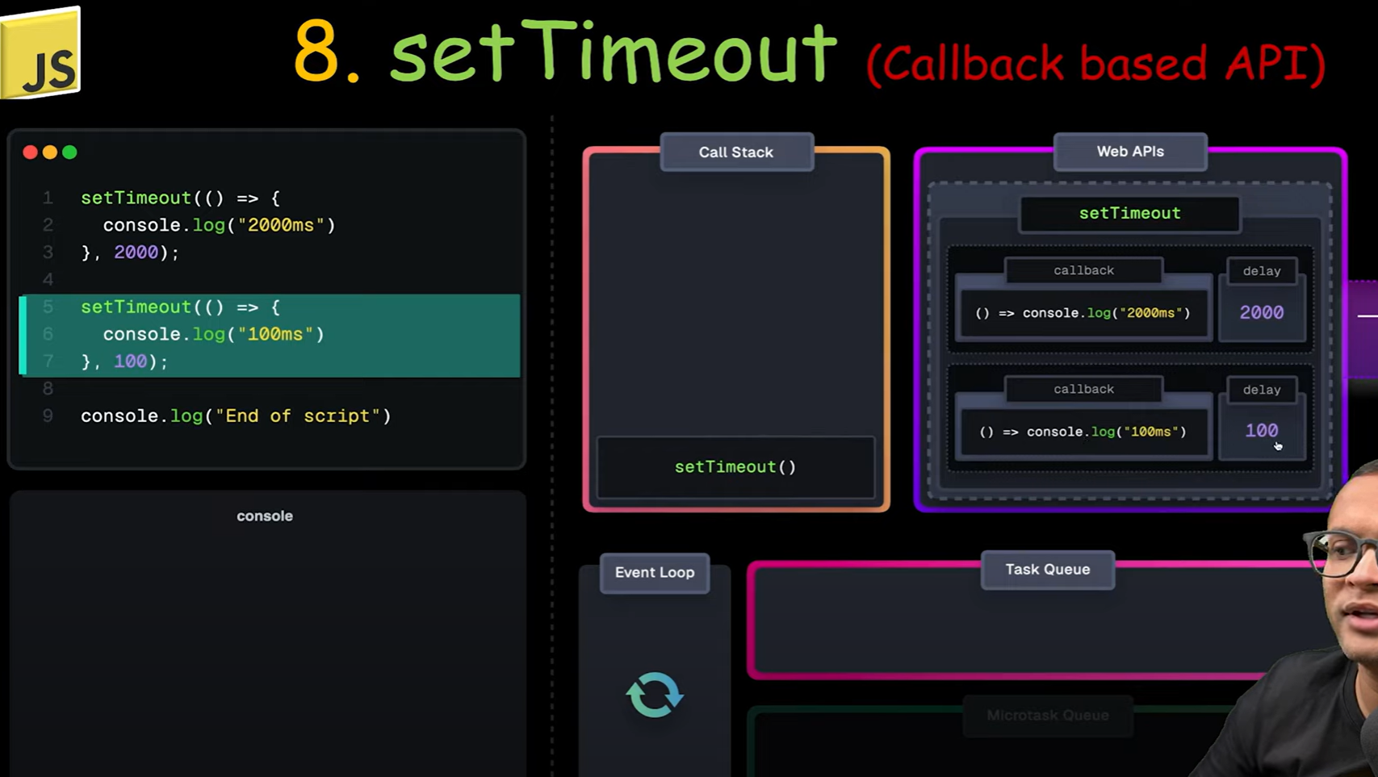

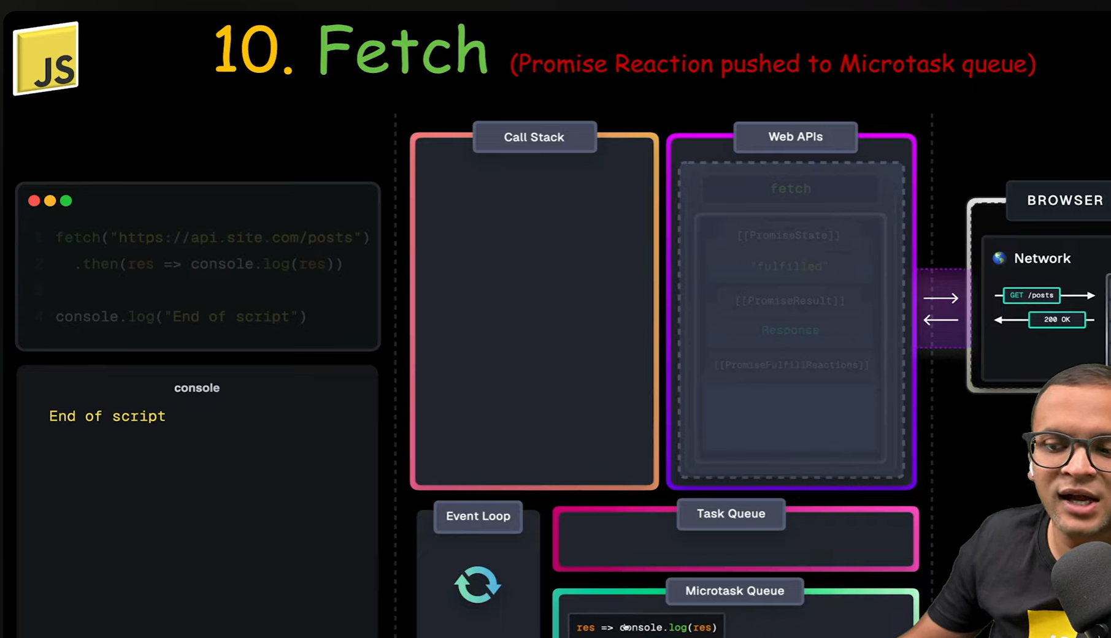

1. Task Queue: It is a queue that stores the callbacks that are ready to be executed. Which are finshed by web apis.
2. Microtask Queue: It is priority queue that stores the callbacks that are ready to be executed. Which are finshed by web apis.
3. Callback Queue: It is another queue in the runtime with lower priority than Microtask Queue. manly promises callbacks are pushed here.

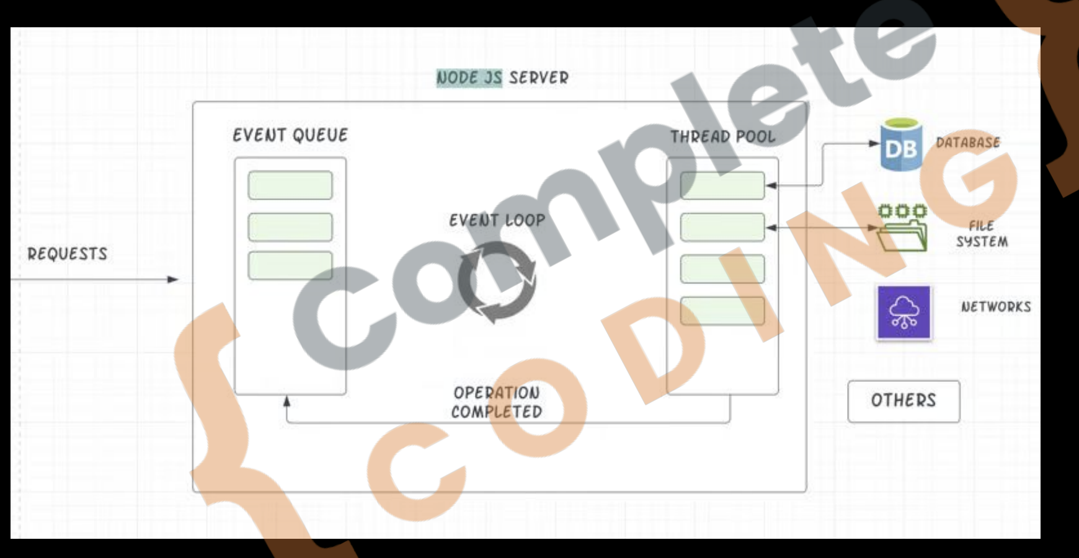

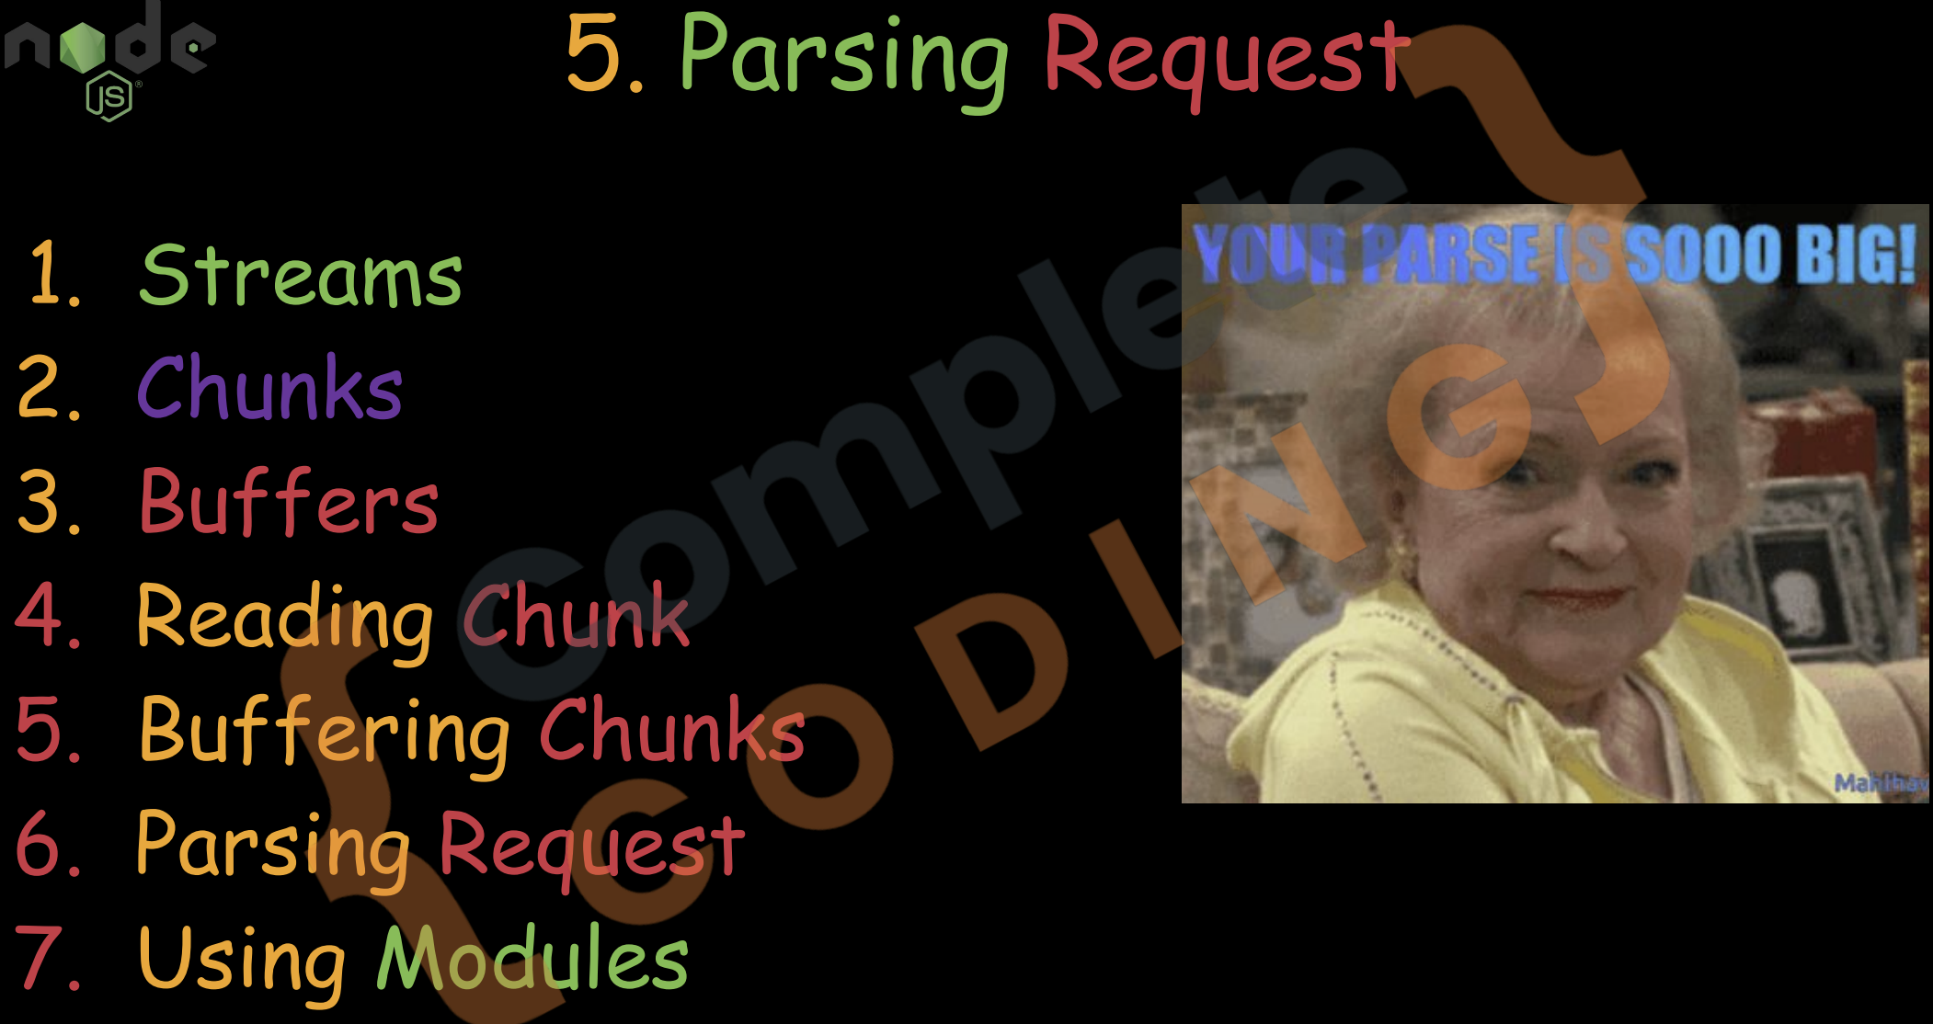

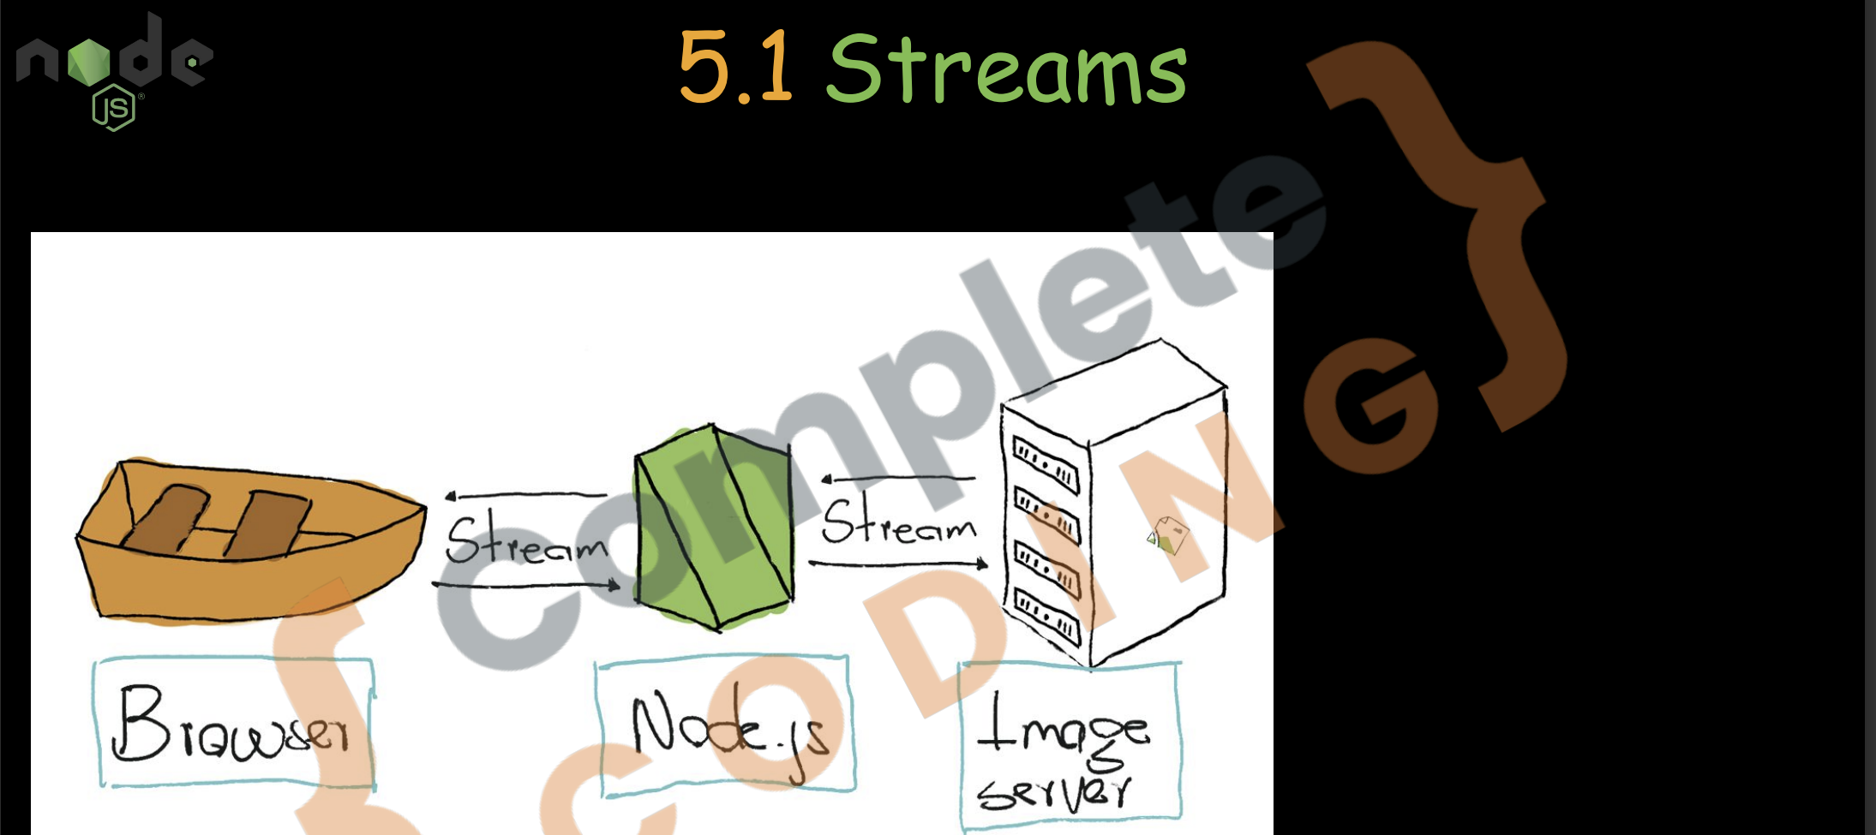

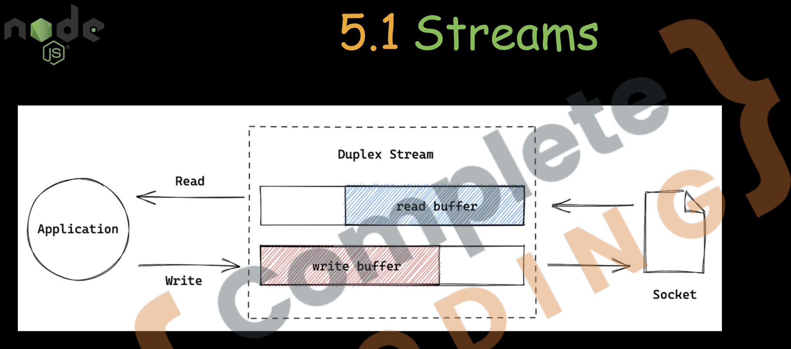

**Streams = Handle big data in small chunks** without loading everything into memory.

**Real-life Example:**

Like **reading a book one page at a time** instead of holding the entire book in memory.

const fs = require('fs');

const readableStream = fs.createReadStream('bigfile.txt', 'utf8');

readableStream.on('data', chunk => {

  console.log('Received chunk:', chunk);

});

readableStream.on('end', () => {

  console.log('Done reading file.');

});

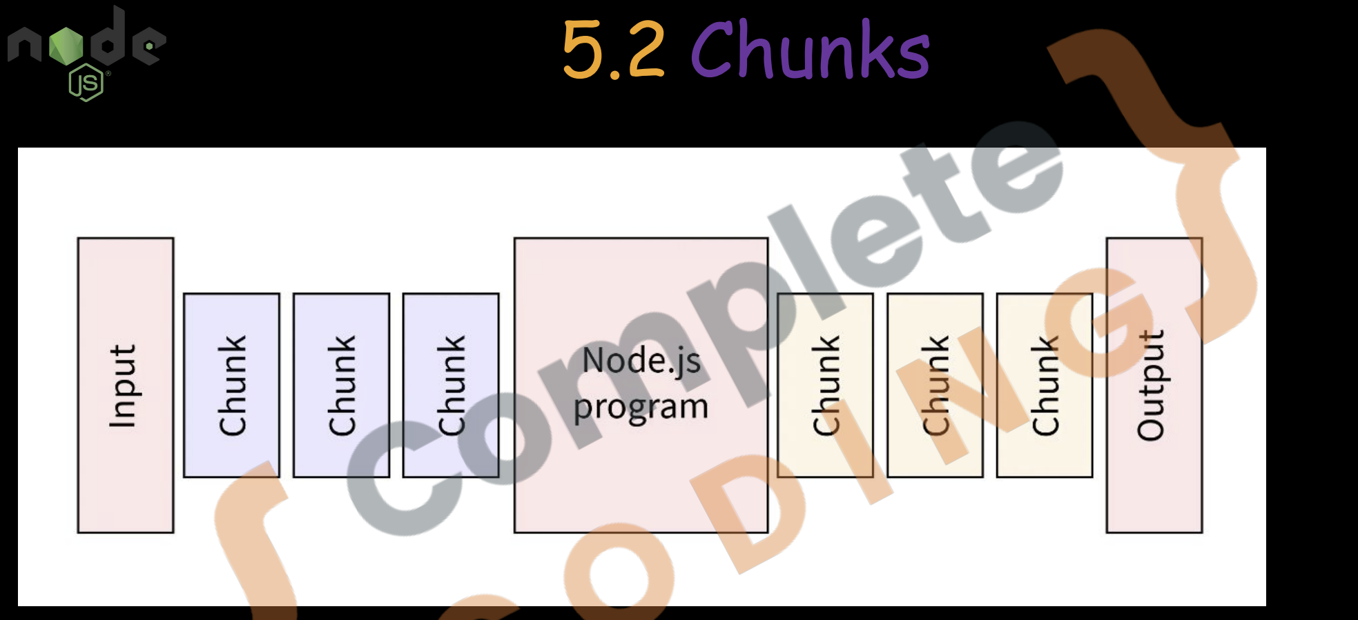

**Chunks = Data packets** coming in one-by-one instead of all at once.

readableStream.on('data', (chunk) => {

  console.log('Got a chunk:', chunk);

});

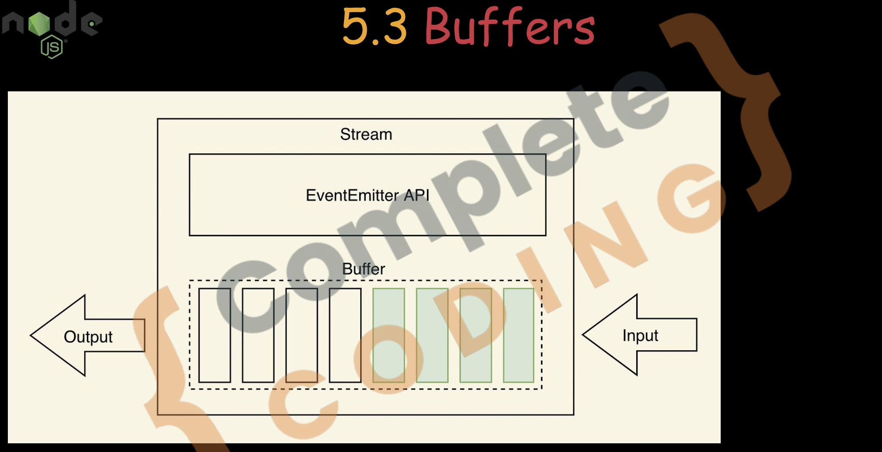

**A Buffer is a temporary storage area for binary data — like images, files, or video — that Node.js uses when working with streams or low-level data.**

**Real-life Example:**

When you're watching a video, it’s **buffered** before playing — so chunks of video data are held in a **buffer box** before being shown.

const buffer = Buffer.from('Hello');

console.log(buffer);        // <Buffer 48 65 6c 6c 6f>

console.log(buffer.toString()); // Hello

5.

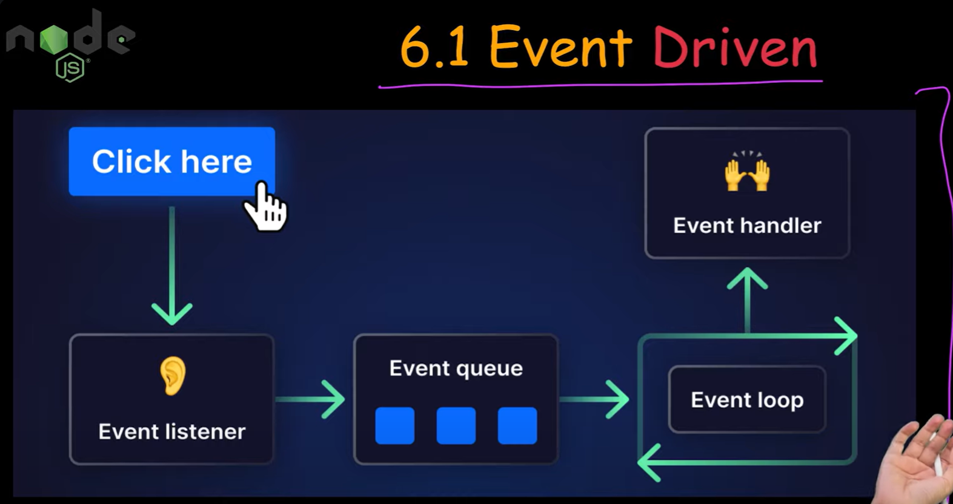

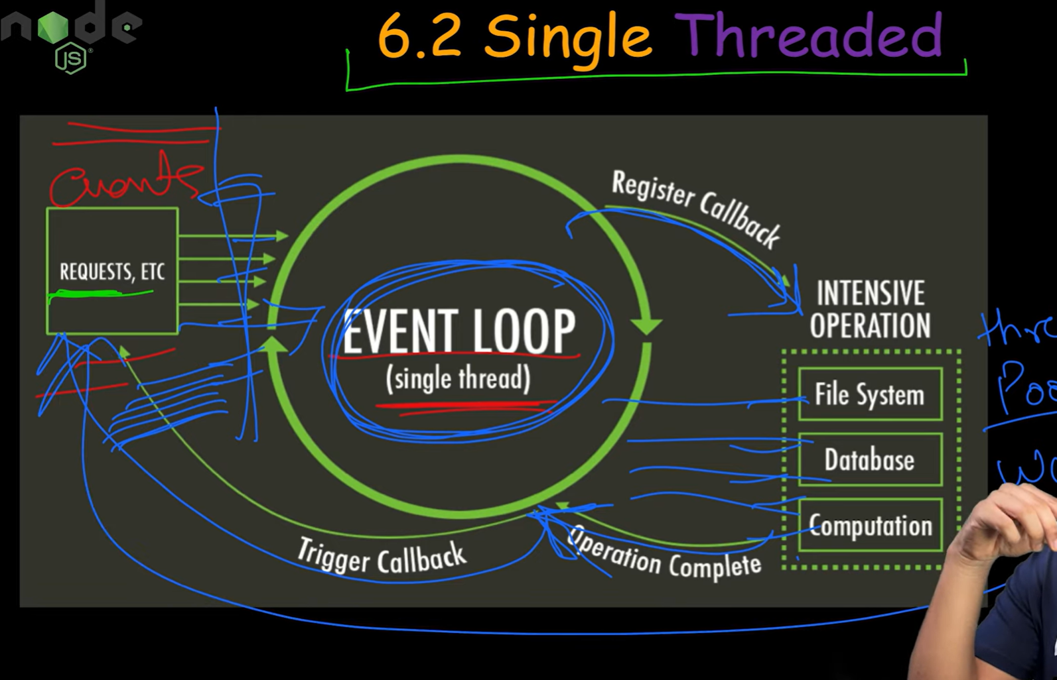

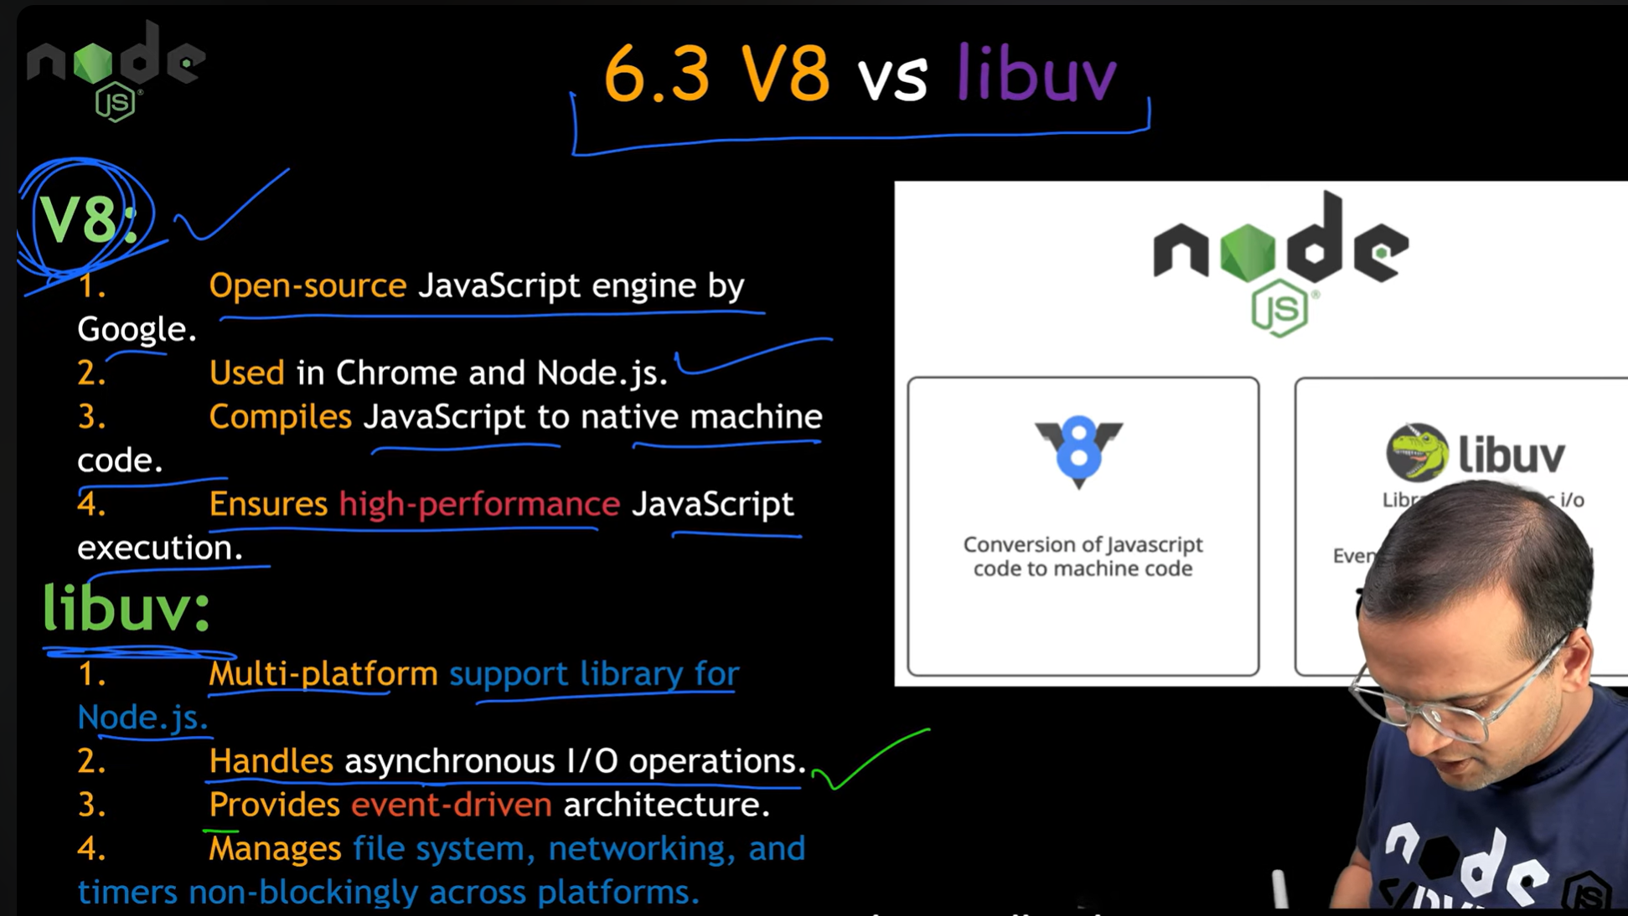

**libuv is a C library** used by Node.js to handle asynchronous operations like:

* File system I/O
* Network I/O
* Timers (setTimeout)
* DNS
* Child processes

**💡 Why does Node.js use libuv?**

Node.js is **single-threaded** in JavaScript (it runs on one thread), but it needs to do many things **at the same time** — like handling requests, reading files, and talking to databases.

🔑 So libuv gives Node.js the **power of multithreading behind the scenes**, even though your code looks single-threaded!

**🧠 Real-Life Analogy**

Imagine Node.js is a **waiter (JavaScript)** in a busy restaurant. The waiter:

* Takes your order (function call)
* Gives it to the kitchen (libuv)
* Moves to the next customer immediately

The **kitchen (libuv)** has many cooks (worker threads), who prepare the food (I/O tasks), and notify the waiter when it’s ready.

**⚙️ libuv Key Features**

| **Feature** | **Example in Node.js** |
| --- | --- |
| **Event Loop** | setTimeout, nextTick() |
| **Thread Pool** | fs.readFile, crypto.pbkdf2 |
| **Async I/O** | HTTP, TCP, File System |
| **Cross-platform** | Works on Windows, Linux, macOS |

**🔄 How Node.js & libuv Work Together**

text

CopyEdit

Your Code (JavaScript)

|

┌───────▼────────┐

│ Event Loop │ <---- Comes from libuv

└───────┬────────┘

↓

┌────────────────────────┐

│ libuv Thread Pool │

│ - Disk access │

│ - Crypto tasks │

└────────────────────────┘

**📦 Example: File Read (using libuv internally)**

const fs = require('fs');

fs.readFile('hello.txt', 'utf-8', (err, data) => {

if (err) throw err;

console.log('File content:', data);

});

🔍 What happens:

1. JS code asks to read the file
2. libuv sends this to the **thread pool**
3. Another thread reads the file
4. libuv pushes result to **event loop**
5. Node calls your callback with the data

**🛠 Node.js Components Summary**

| **Component** | **Description** |
| --- | --- |
| **V8** | Runs your JavaScript code |
| **libuv** | Handles async tasks (event loop, I/O) |
| **Node APIs** | Provides functions like fs.readFile |
| **Bindings** | Connects JS and C++ libraries |

**✅ In Simple Terms:**

| **Part** | **What it Does** |
| --- | --- |
| **libuv** | Gives Node.js superpowers for I/O |
| **Why it matters** | Makes Node.js fast & non-blocking |
| **Used for** | File system, network, timers, DNS, etc. |

**🧵 What is a Worker Thread in Node.js?**

A **Worker Thread** is a way to run **JavaScript code in parallel** using multiple threads.

By default, Node.js is **single-threaded** — meaning it runs JavaScript on one thread. But for **CPU-heavy tasks**, this can block everything. That’s where **Worker Threads** help.

**✅ Key Use Cases:**

* Heavy computations (e.g., data processing, image resizing)
* Avoiding blocking the main event loop
* Running CPU-intensive tasks in the background

**💡 Real-Life Analogy**

Imagine:

* You're the main chef (main thread)
* You have many assistants (worker threads)
* Instead of doing every job yourself (blocking), you give tasks to assistants
* They do the work and report back

This keeps the kitchen (your app) running smoothly!

**🔄 How Worker Threads Work in Node.js**

Here's the architecture:

┌────────────────────────┐

│ Main Thread (Event Loop) │

└────────┬──────────────┘

↓

┌────────────────────────┐

│ Worker Thread #1 │

└────────────────────────┘

┌────────────────────────┐

│ Worker Thread #2 │

└────────────────────────┘

**How Does It Impact CPU Threads?**

Node.js has:

* A **main thread** (event loop for async tasks)
* A **libuv thread pool** (usually 4 threads)
* When you use worker_threads, you **create OS-level threads**, which directly use **CPU cores**

**🔧 CPU Impact**

| **Scenario** | **CPU Load** | **Explanation** |
| --- | --- | --- |
| Normal async I/O (libuv) | Low | Uses thread pool efficiently |
| CPU-heavy in main thread | High | Blocks Node.js (bad!) |
| CPU-heavy in worker threads | Medium | Runs in parallel, spreads CPU usage |

So, **worker threads do consume more CPU**, but they **prevent the main thread from getting blocked**, which keeps your app responsive.

**🧪 Worker Thread vs Cluster**

| **Feature** | **worker_threads** | **cluster** |
| --- | --- | --- |
| Use Case | CPU-intensive tasks | Scaling server (multi-process) |
| Shared Memory | Yes (SharedArrayBuffer) | No |
| Communication | Fast (via messaging) | Slower |
| Threads vs Process | Thread (lightweight) | Process (heavyweight) |

**✅ Summary**

| **Term** | **Meaning** |
| --- | --- |
| **Worker Thread** | A way to run JS code on a separate thread |
| **Why needed** | Offload CPU-heavy work from main thread |
| **How many?** | As many as system can handle (based on cores) |
| **Impact on CPU** | More parallel threads = more CPU usage |

If you want, I can help you:

* Build a multi-threaded task processor in Node
* Visualize how many cores your system has and use them
* Compare performance with vs without worker threads

Let me know what you want to try next, Roy!

**Yes — libuv has an internal thread pool**

But it’s **different from Node.js worker_threads**.

Let’s break it down.

**🔧 libuv’s Inbuilt Thread Pool**

**🔹 What is it?**

* libuv includes a **built-in thread pool** (default size: **4** threads).
* These threads are used to **offload blocking operations** — mostly for:
  + File system tasks
  + DNS (non-async ones)
  + Crypto
  + Compression (e.g., zlib)

**💡 libuv thread pool vs Node worker_threads**

| **Feature** | **libuv Thread Pool** | **worker_threads** |
| --- | --- | --- |
| Purpose | For async I/O (FS, crypto, etc.) | For CPU-heavy JS execution |
| Default size | 4 (configurable via UV_THREADPOOL_SIZE) | Unlimited (based on OS) |
| Shared memory | No | Optional (via SharedArrayBuffer) |
| Runs JS code? | ❌ No | ✅ Yes |
| Managed by | libuv (C library) | Node.js core (C++) |

**🔧 Example: fs.readFile using libuv thread pool**

const fs = require('fs');

fs.readFile('bigfile.txt', (err, data) => {

if (err) throw err;

console.log('Done!');

});

🔁 Even though this is async in JS, under the hood:

* Node delegates it to **libuv**
* libuv runs it in a **background thread from its pool**
* When done, it notifies the **event loop**

✅ You don’t see any threading in your JS — but it’s happening behind the scenes!

**✅ Summary**

| **Question** | **Answer** |
| --- | --- |
| Does libuv have built-in worker threads? | ✅ Yes (fixed-size thread pool) |
| What is it used for? | Async operations like FS, DNS, crypto |
| Can it run JS code like worker_threads? | ❌ No — just C-level operations |
| Can we configure it? | ✅ via UV_THREADPOOL_SIZE |

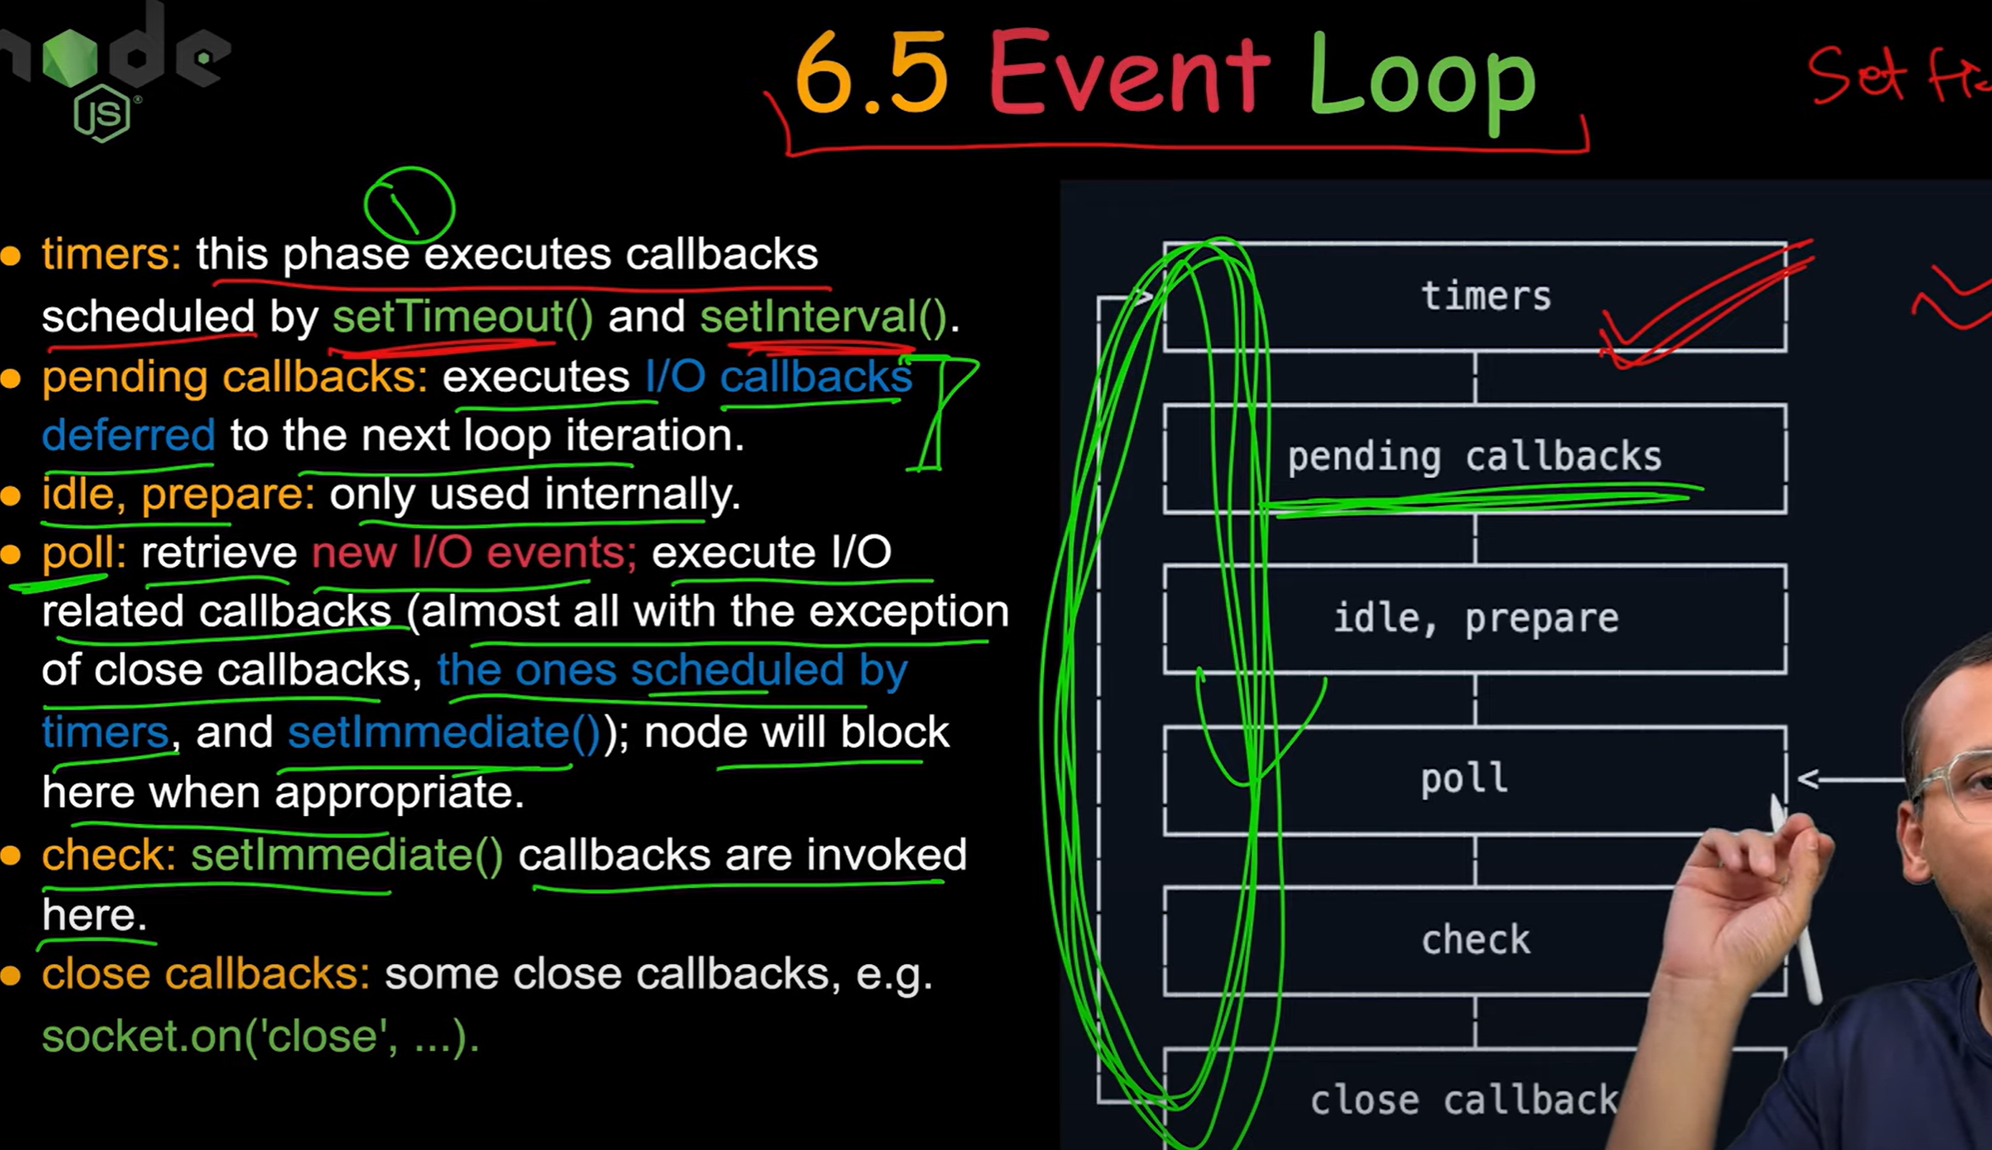

**Differences Between Child Process and Worker Thread**

| **Feature** | **Child Process** | **Worker Thread** |
| --- | --- | --- |
| **Used for** | Running a separate process | Running code in parallel in the same process |
| **Memory** | Has **separate memory** | **Shares memory** with main thread |
| **Based on** | **OS Process** (fork, exec, etc.) | **Thread** abstraction using libuv |
| **Communication** | Uses **IPC (Inter-Process Communication)** | Uses **MessagePort / SharedArrayBuffer** |
| **Performance** | Slower to start, more isolated | Faster, lighter but shares memory space |
| **Use Case** | Run scripts, shell commands, big file ops | CPU-heavy tasks (like image processing) |

**📖 In Simple Words:**

| **Concept** | **Like...** |
| --- | --- |
| **Child Process** | Asking a **new person** to do a task separately |
| **Worker Thread** | Asking your **team member** to do the task in parallel |

**Common Use Cases for Child Processes:**

| **Use Case** | **Description** |
| --- | --- |
| 🖥️ **Running Shell Commands** | Like ls, rm, git, zip, ping |
| 🧠 **Running Heavy CPU Tasks** | Do in separate process so main app stays fast |
| 🔁 **Processing Large Files** | Use child to read/transform data |
| 🌐 **Calling External Scripts** | Run Python, Java, or other Node files |
| 🧪 **Background Jobs** | Send task to child (e.g. video encoding, PDF generation) |
| ⚙️ **Microservices Architecture** | Each microservice can be a separate process |

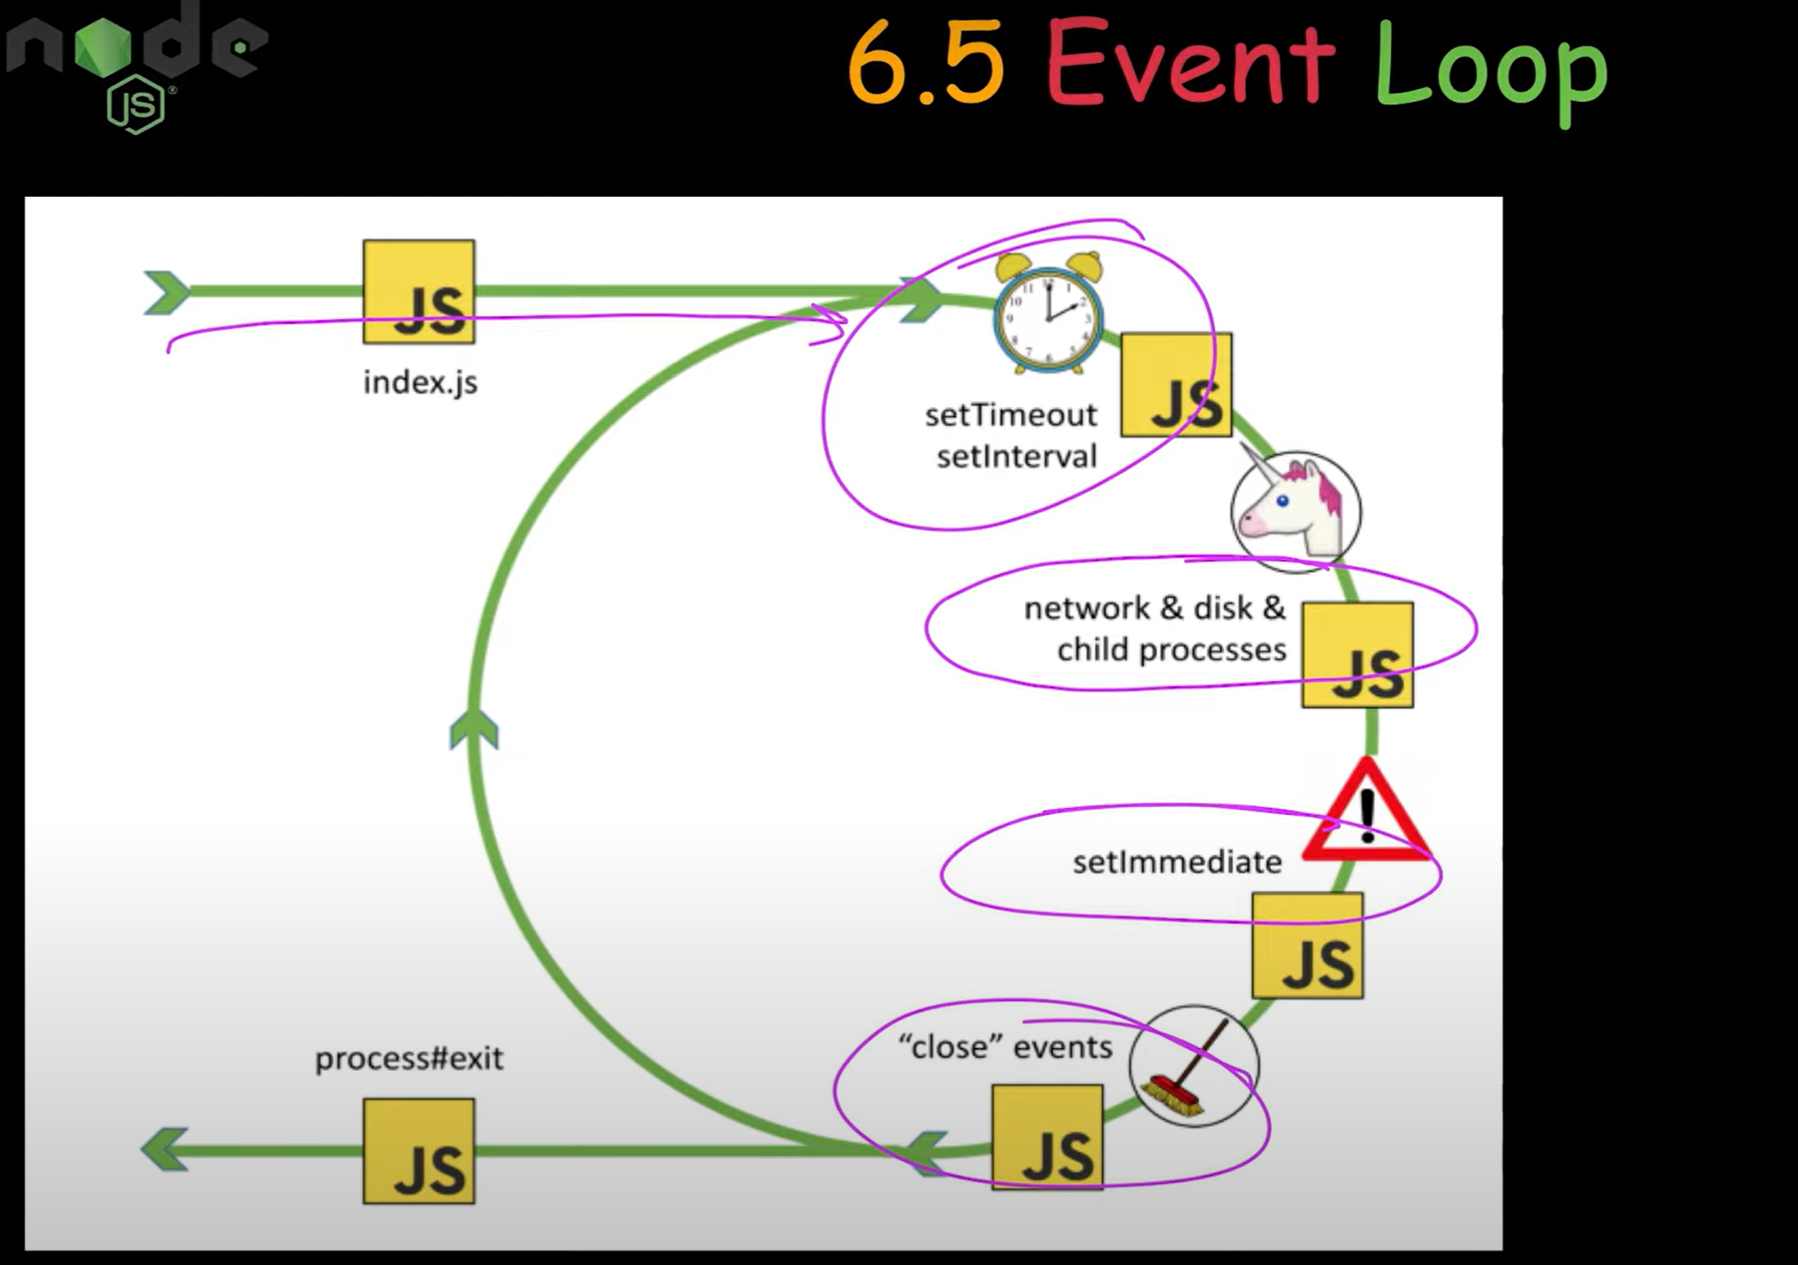

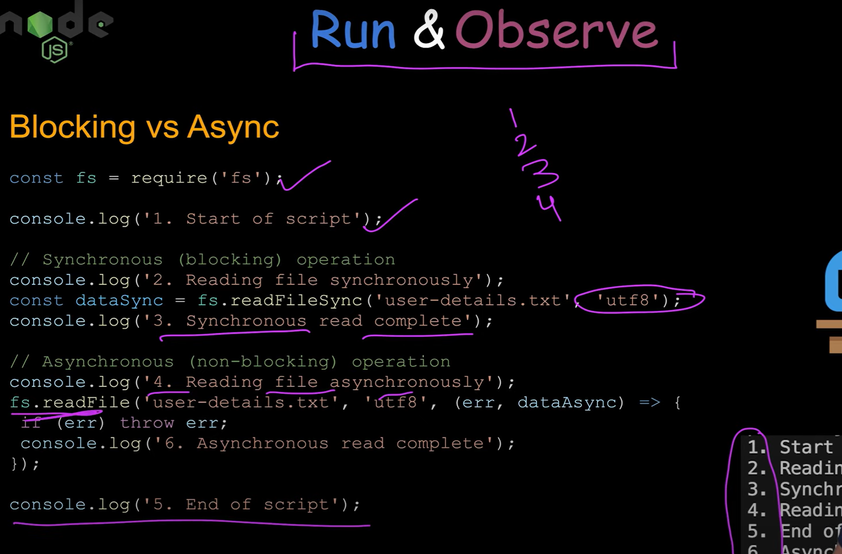

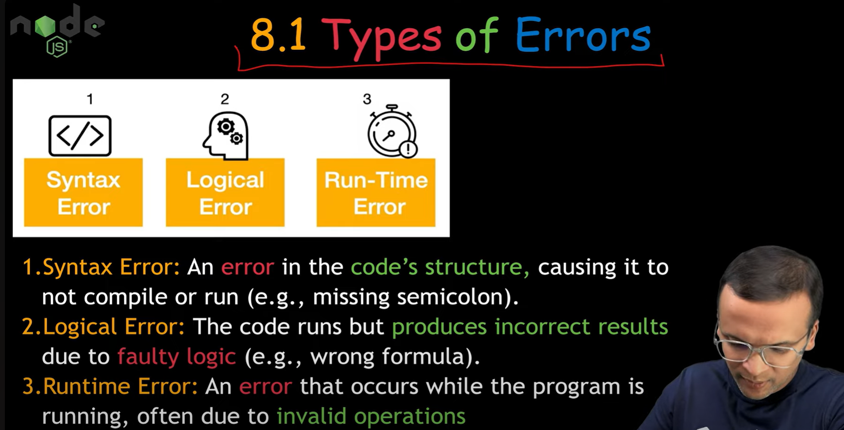

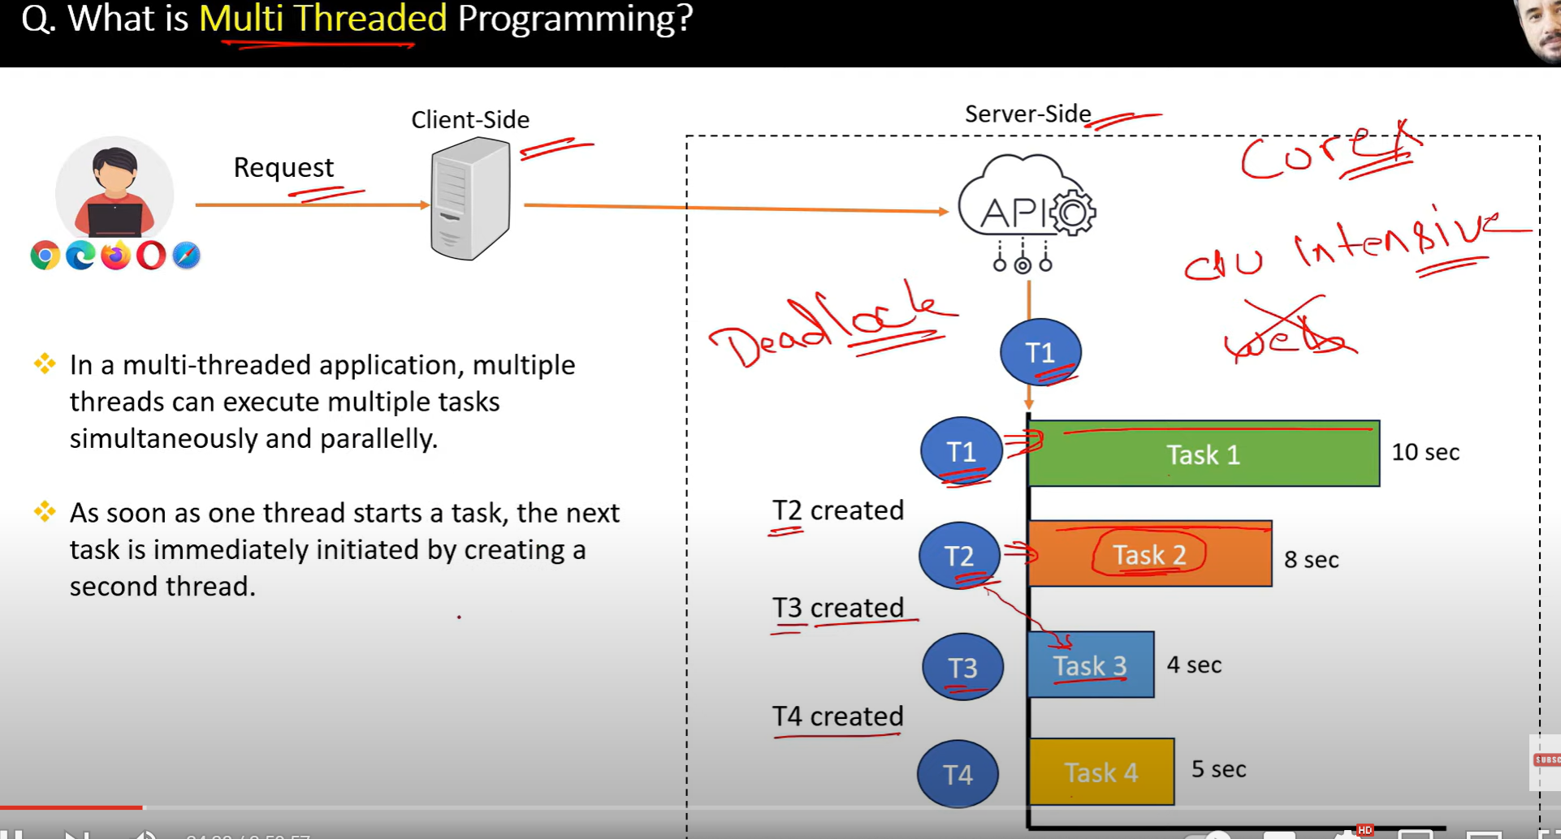

6.

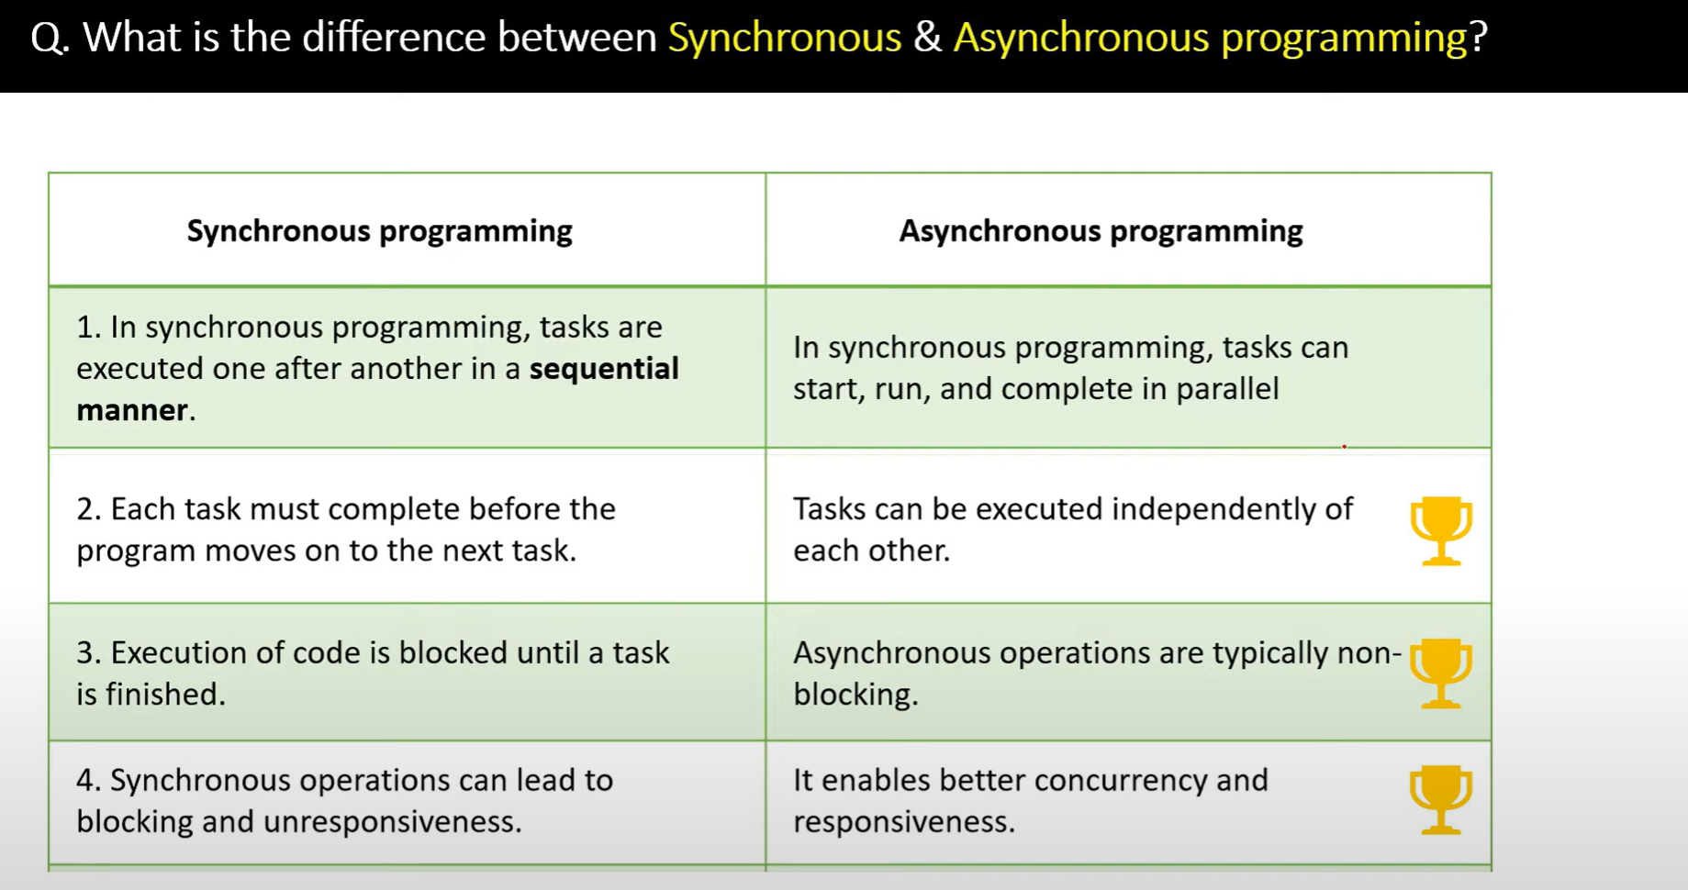

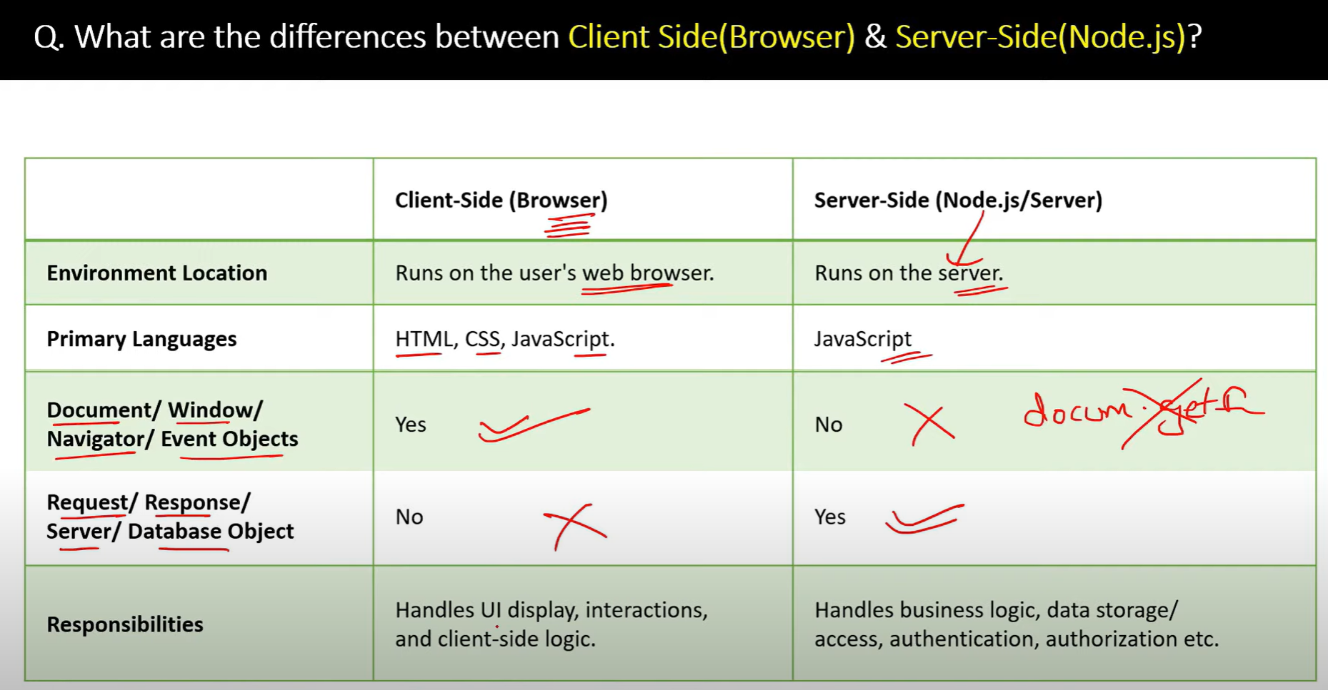

10.

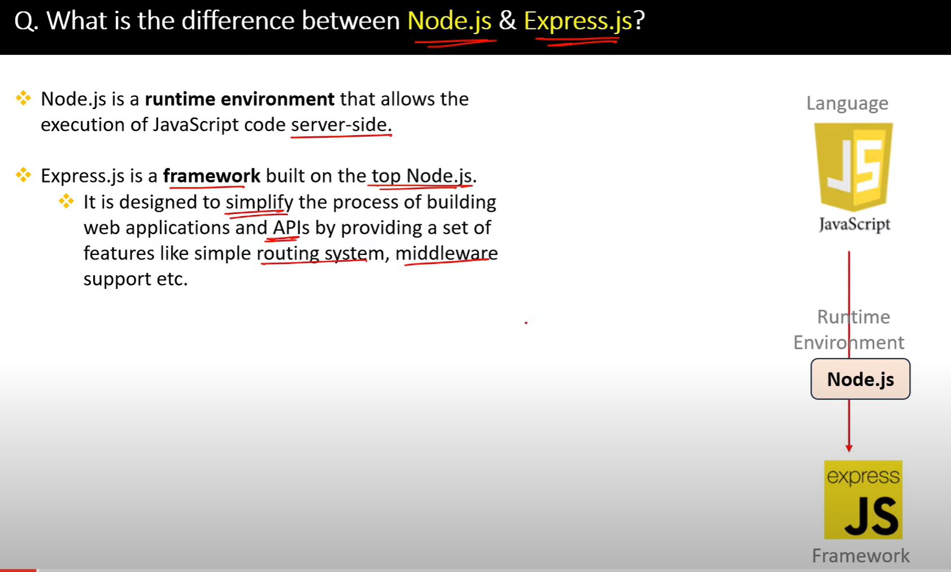

**✅ What is Concurrency?**

**Concurrency** means doing **many things at the same time**, but **not necessarily at the exact same instant** — they **start, stop, and resume** in overlapping time frames.

Imagine you're cooking:

* You **boil water**
* While it's heating, you **chop vegetables**
* Then go back to the water
* You're doing **multiple things at once**, by switching between them

That’s **concurrency**.

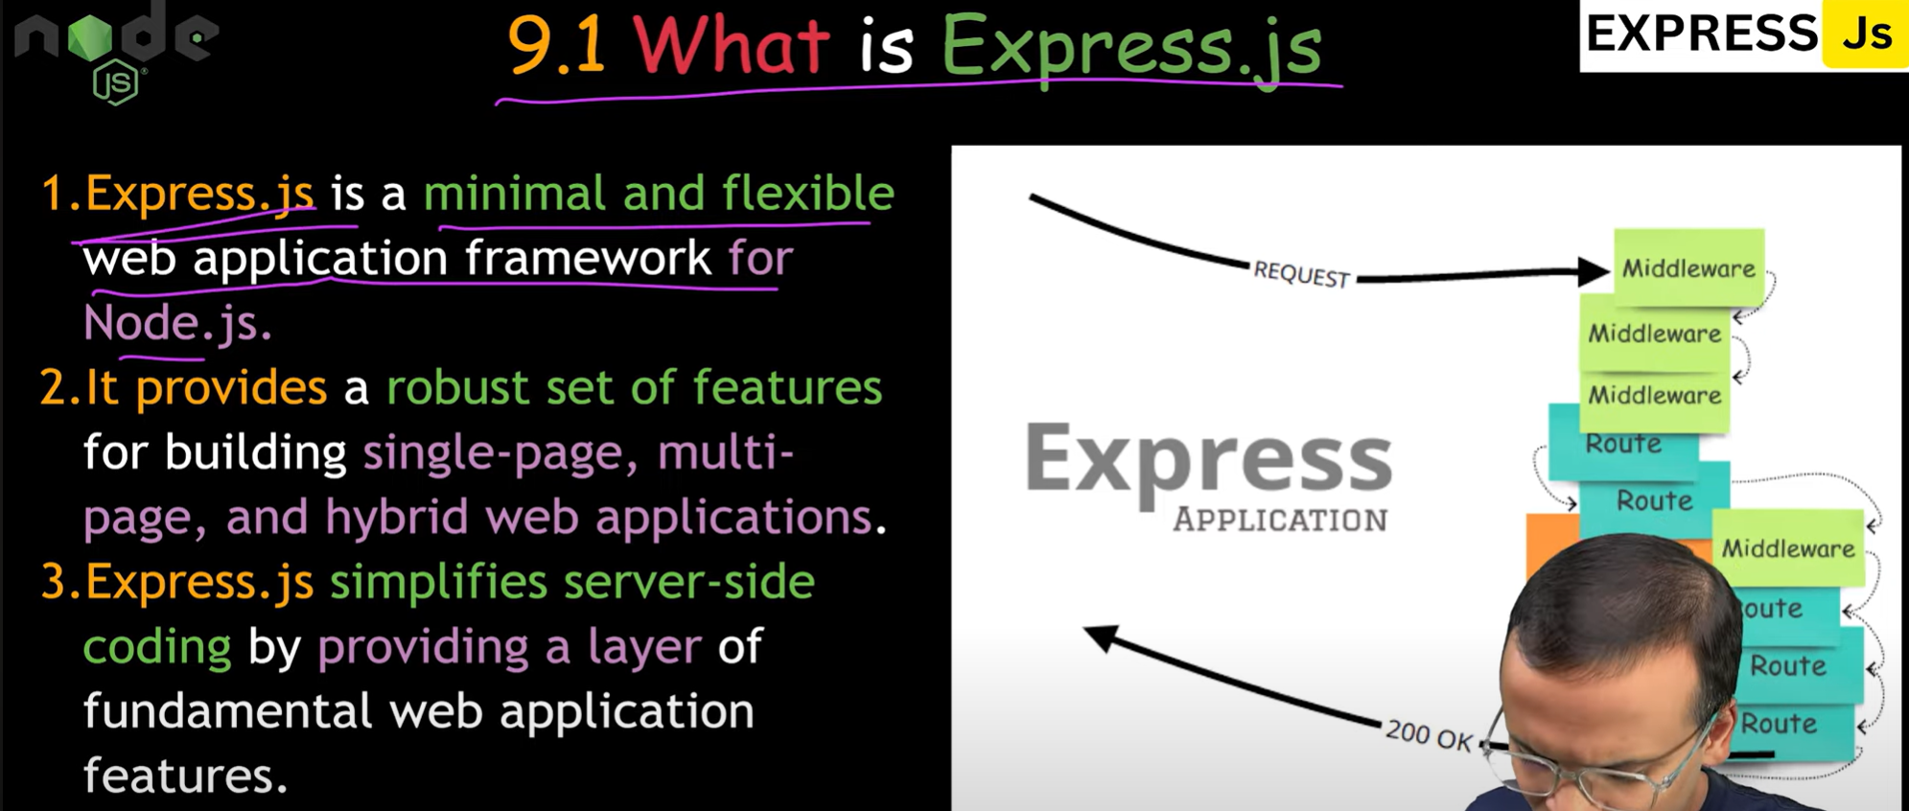

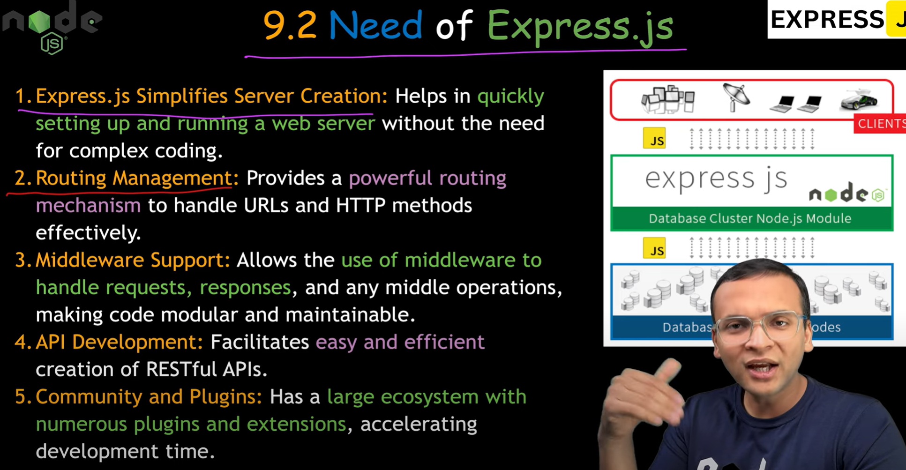

11.

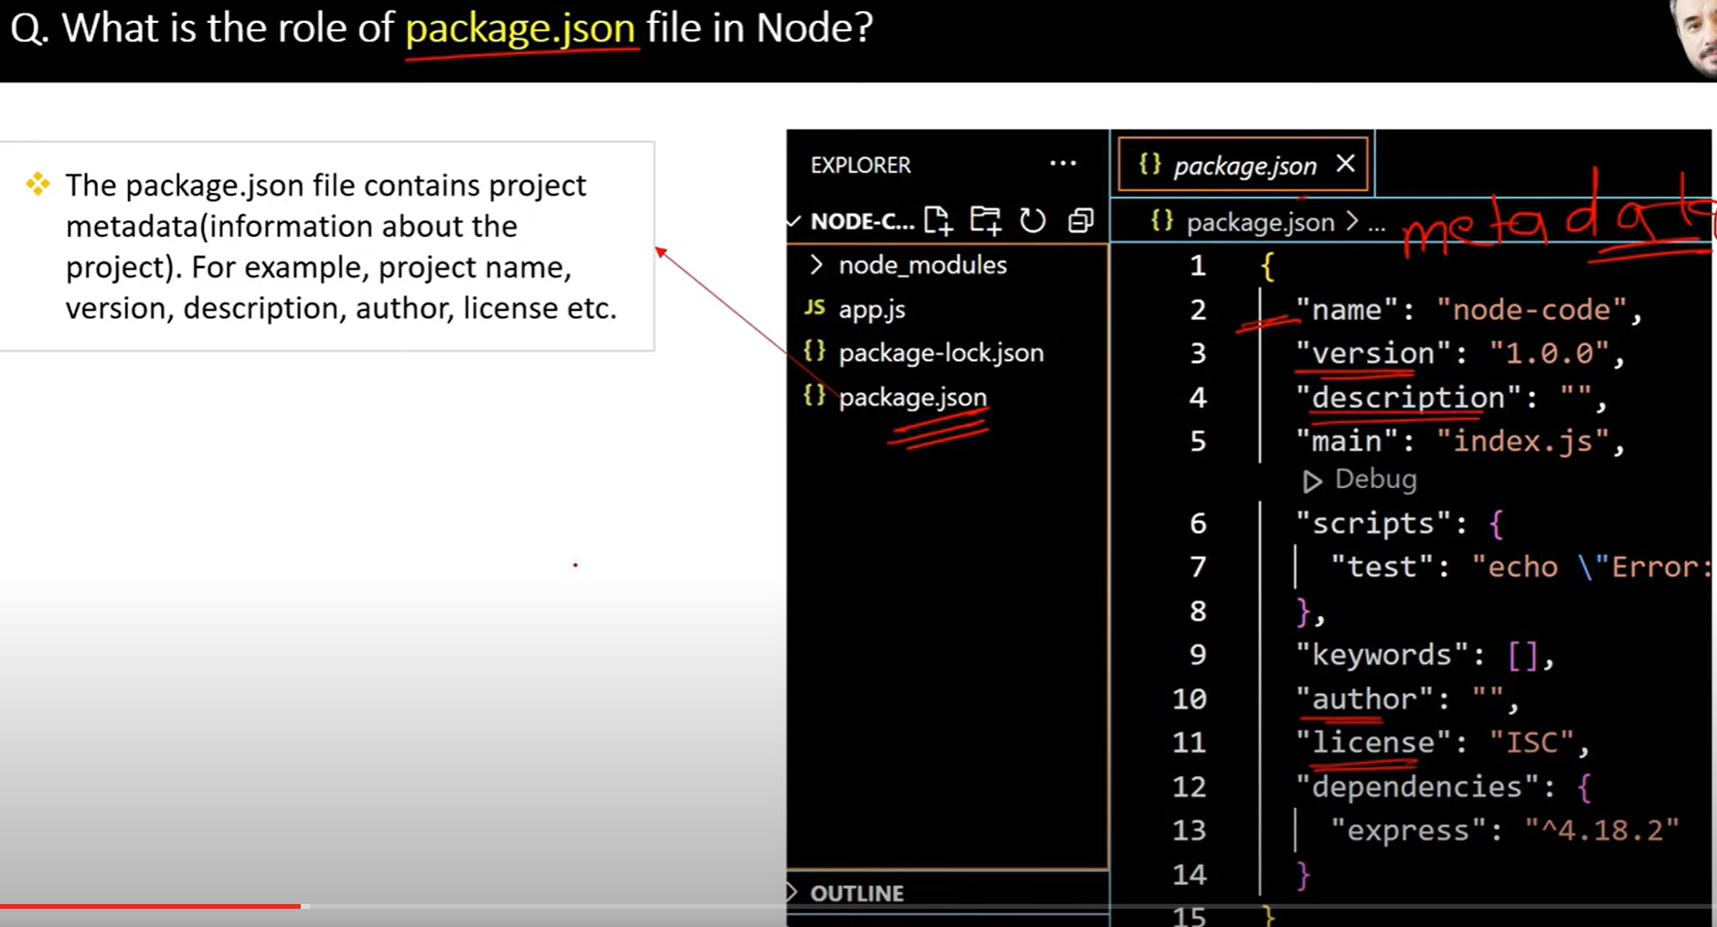

12.

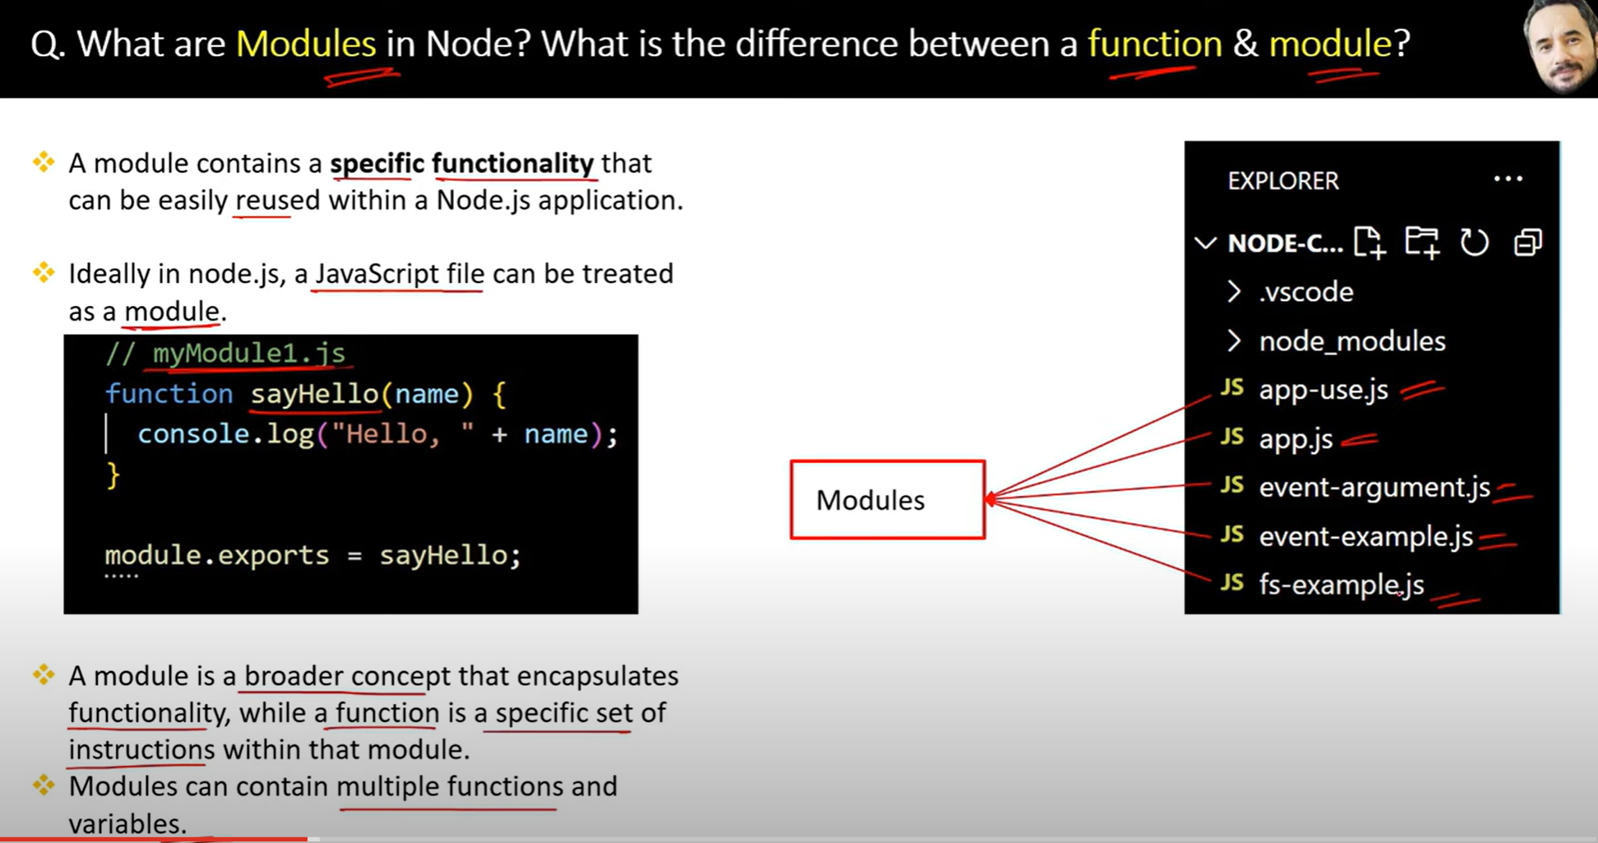

13.

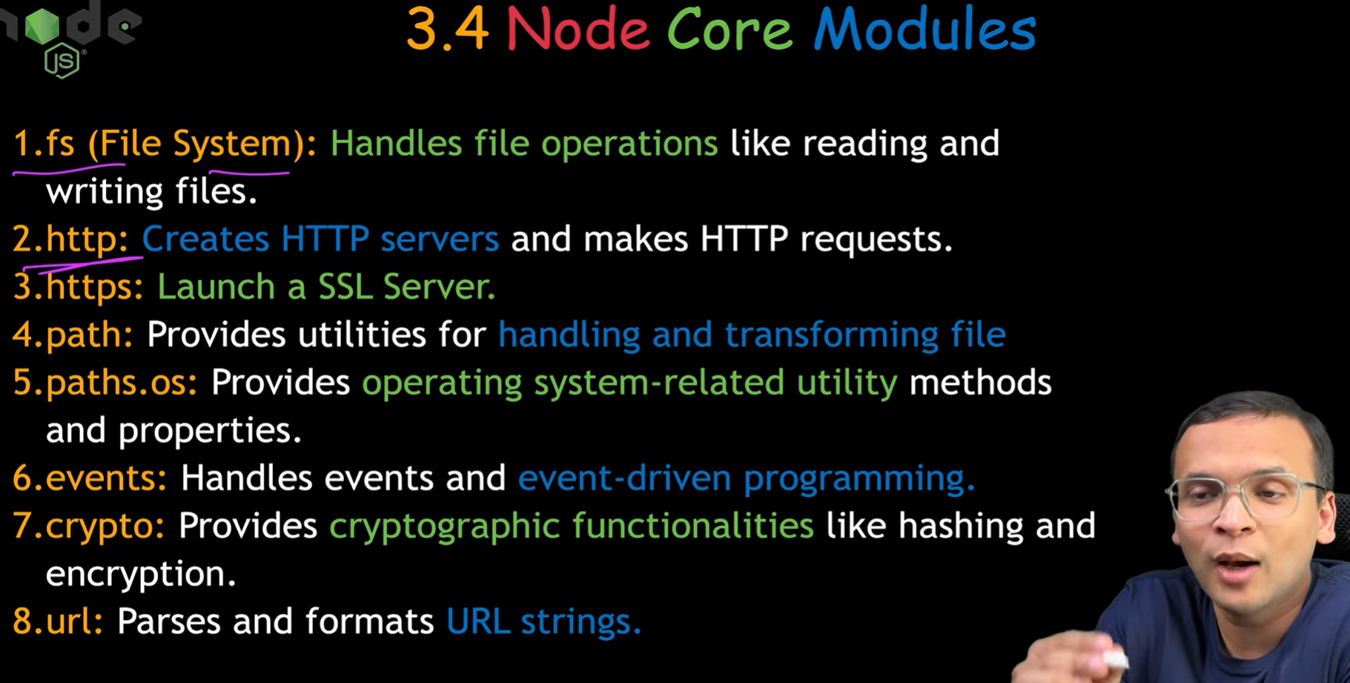

14.

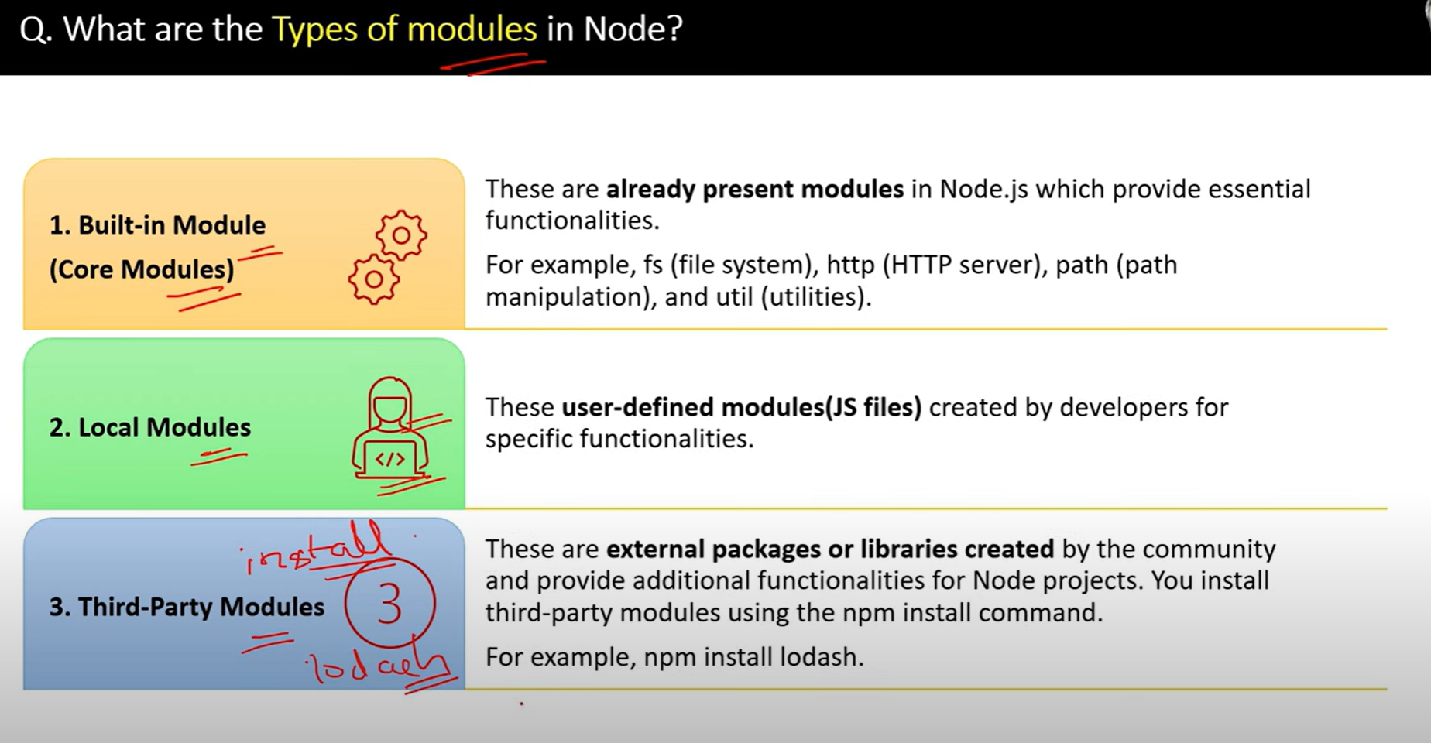

15.

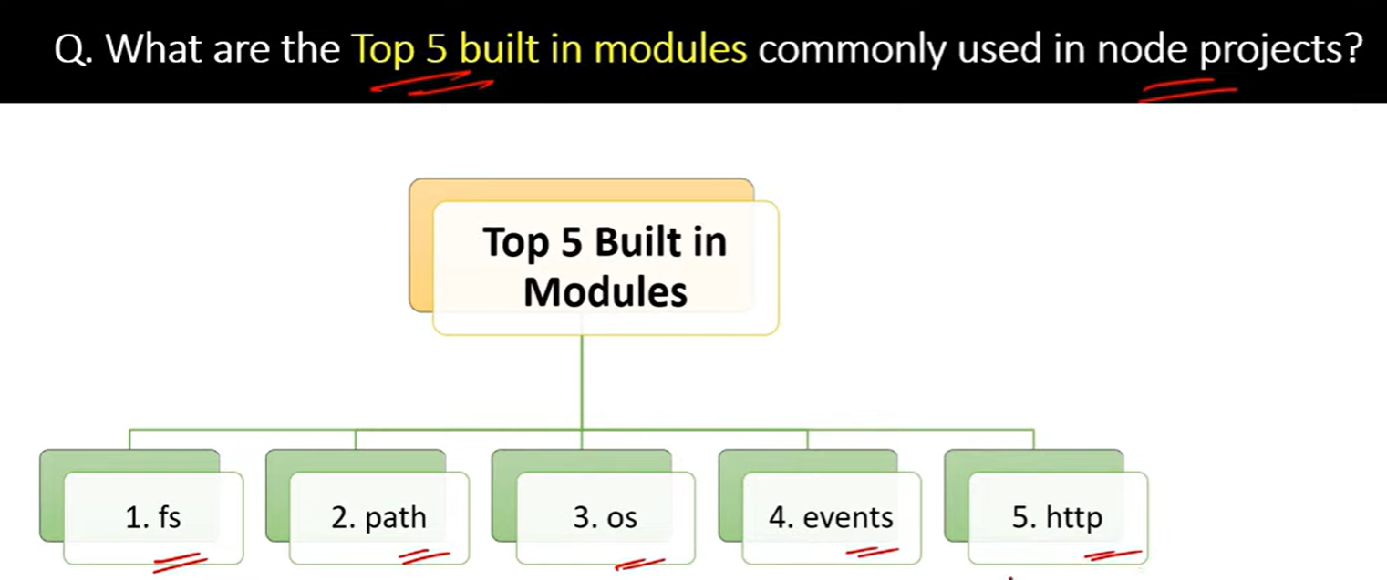

16.

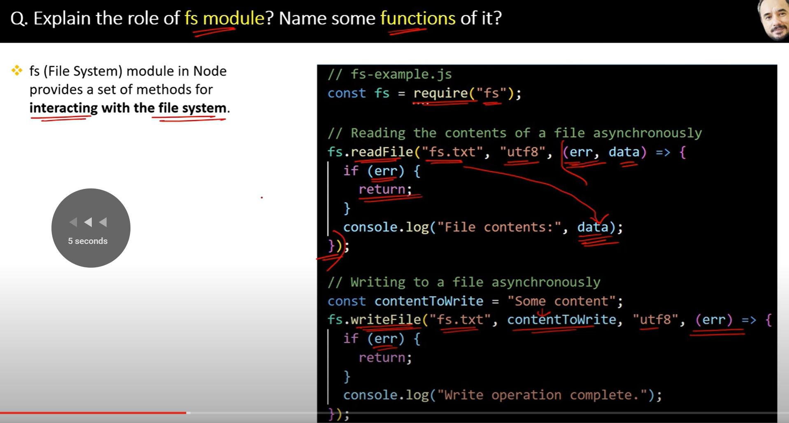

17.

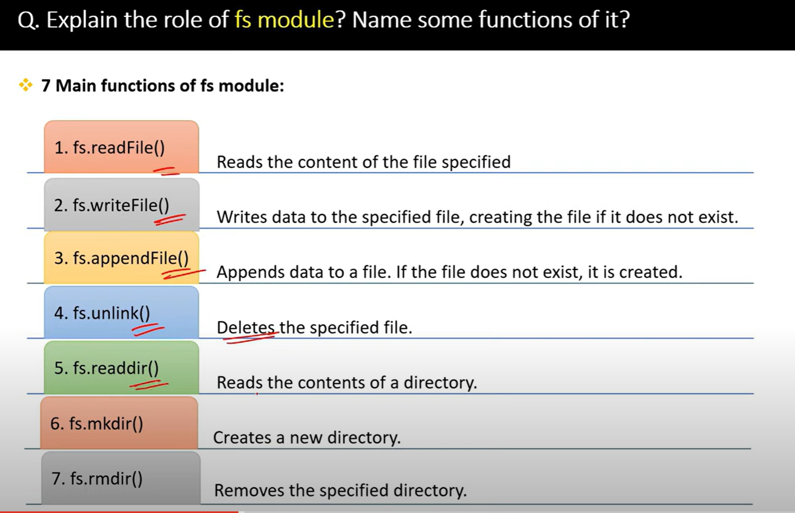

18.

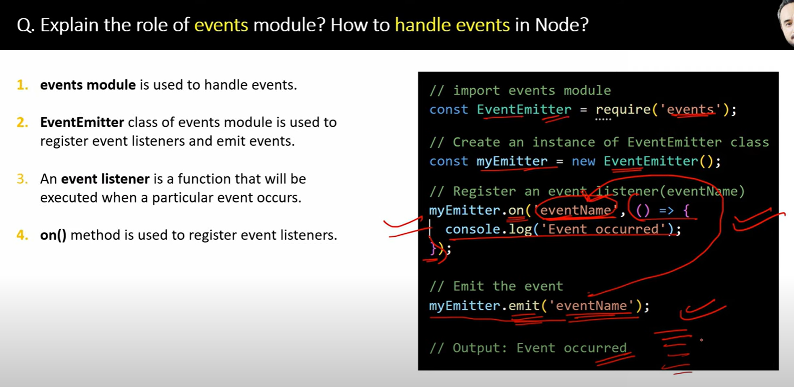

19.

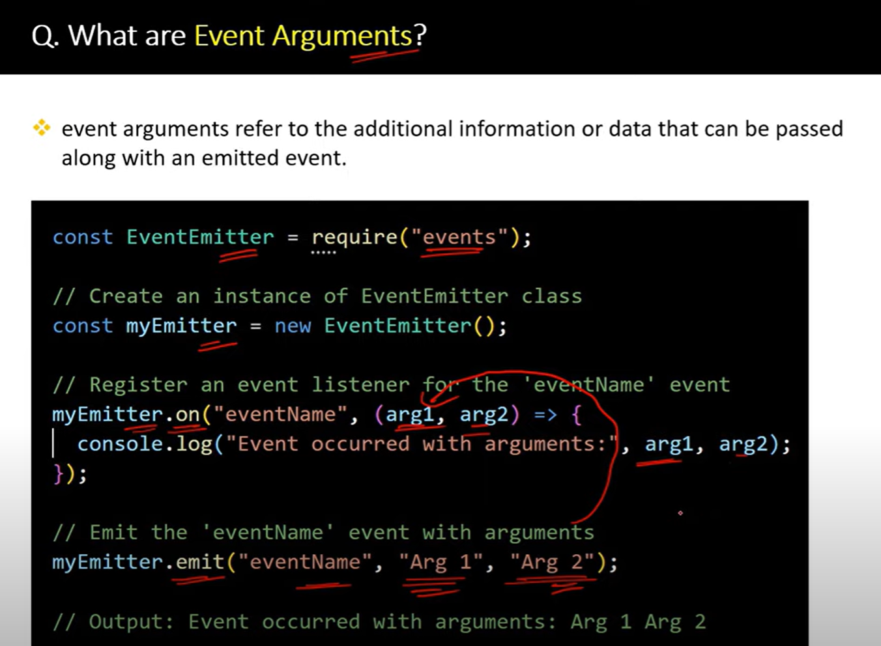

20.

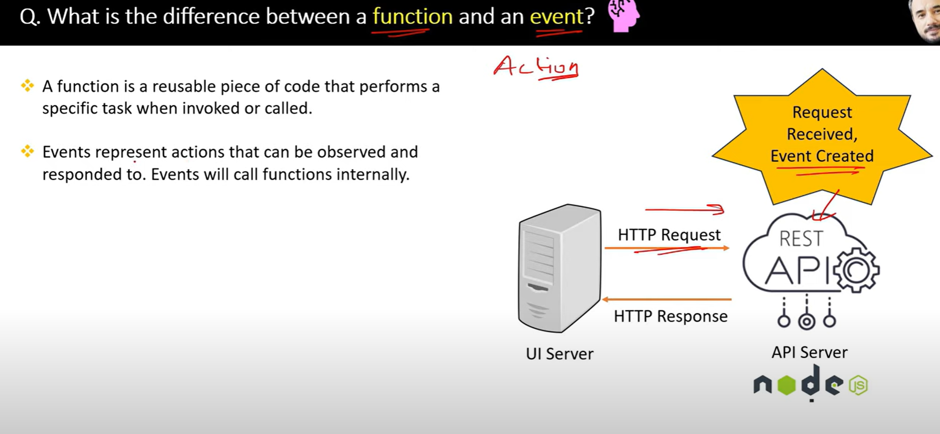

21.

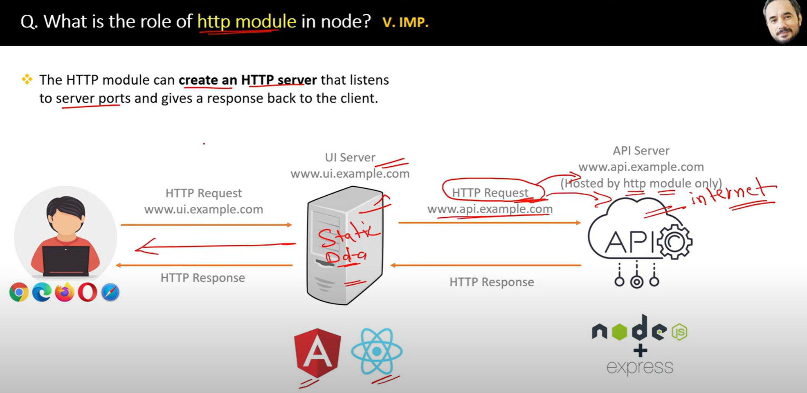

Http modules handles request and response of the server

22.

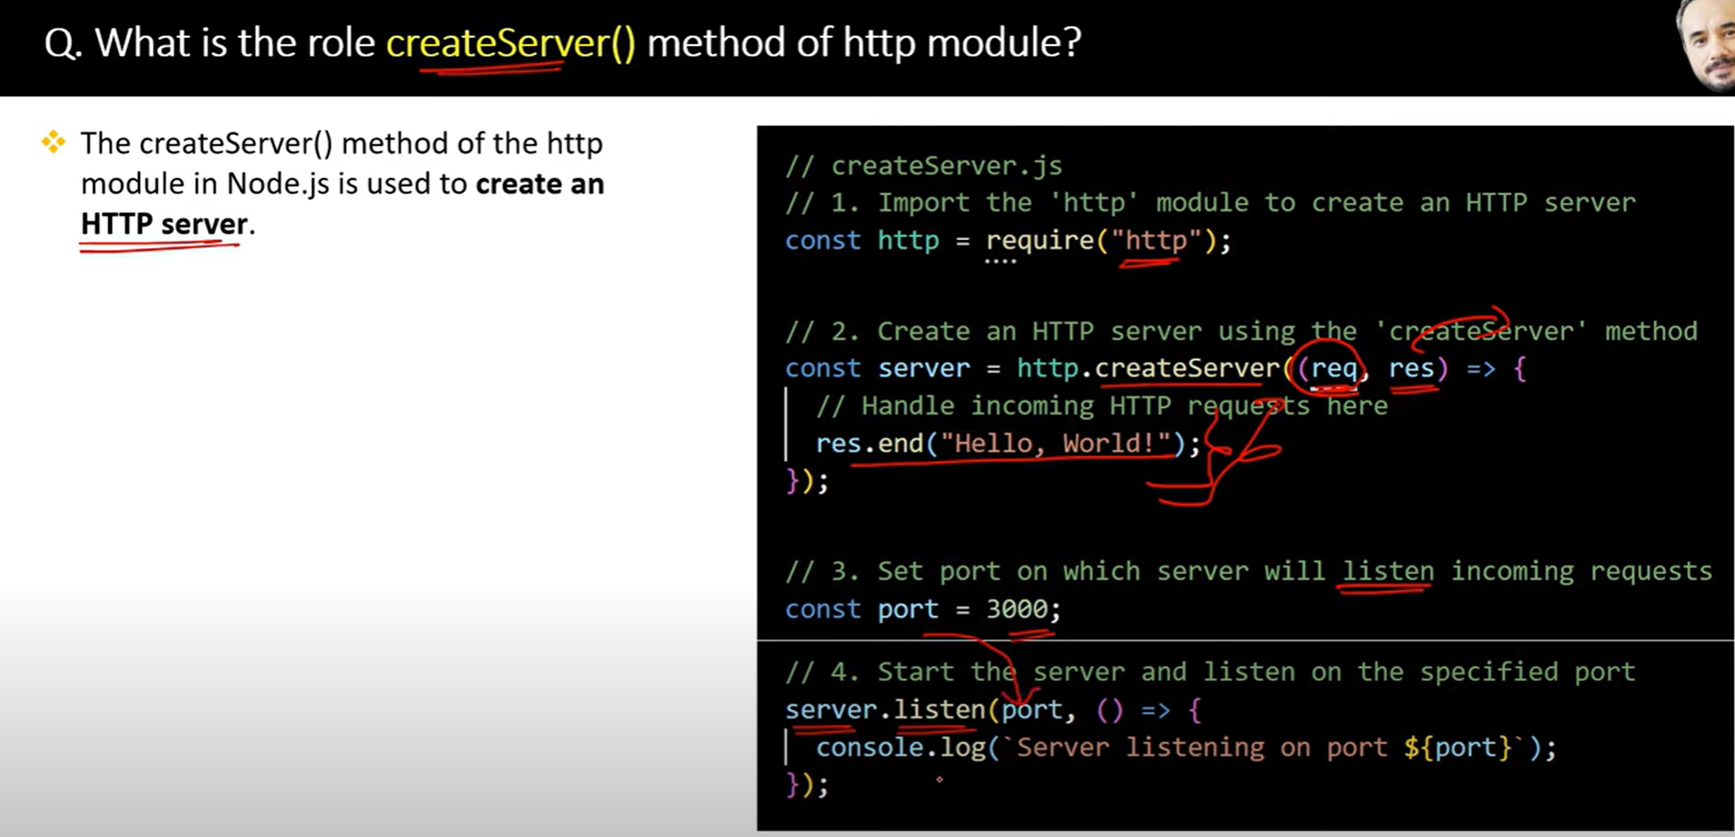

23.

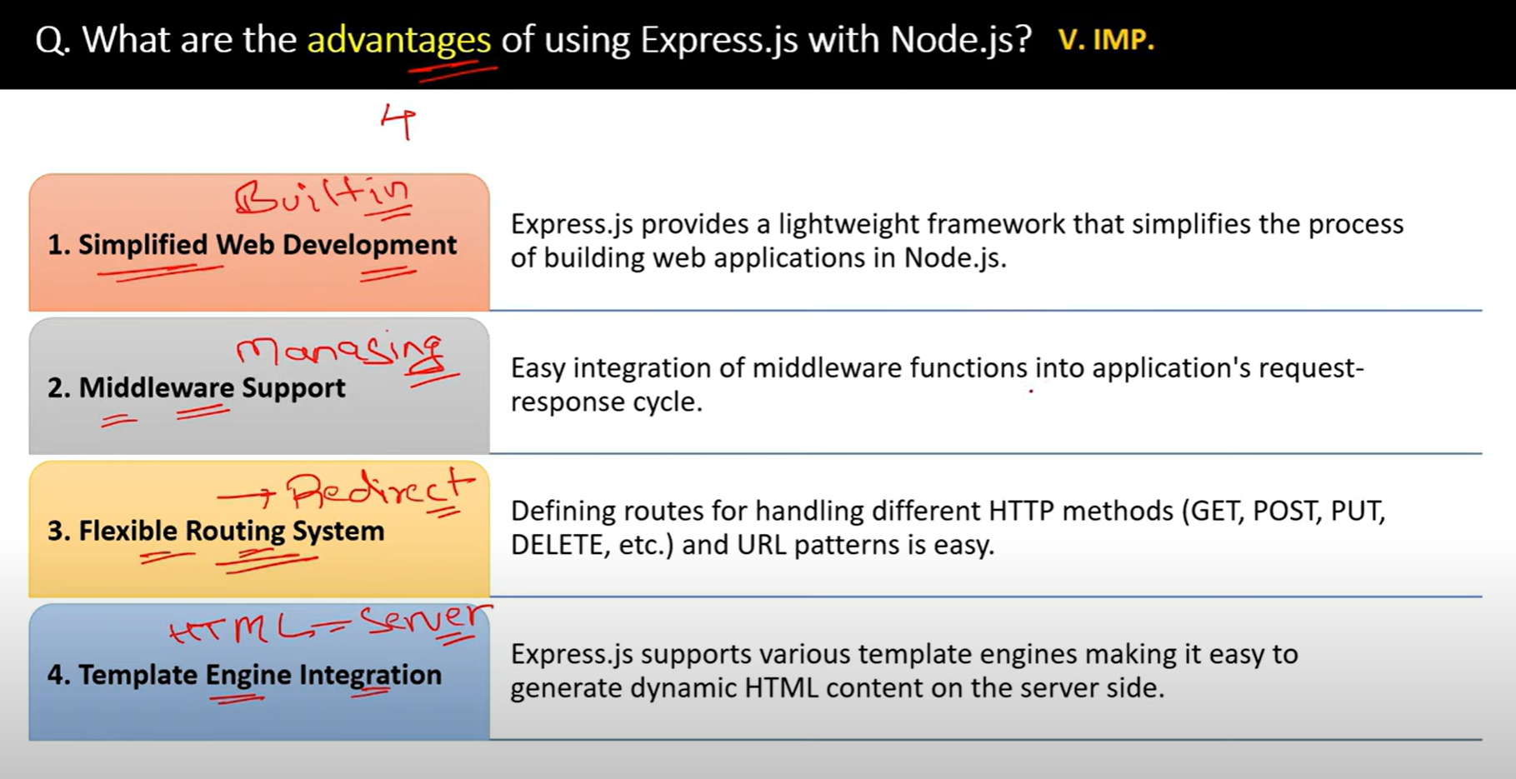

24.

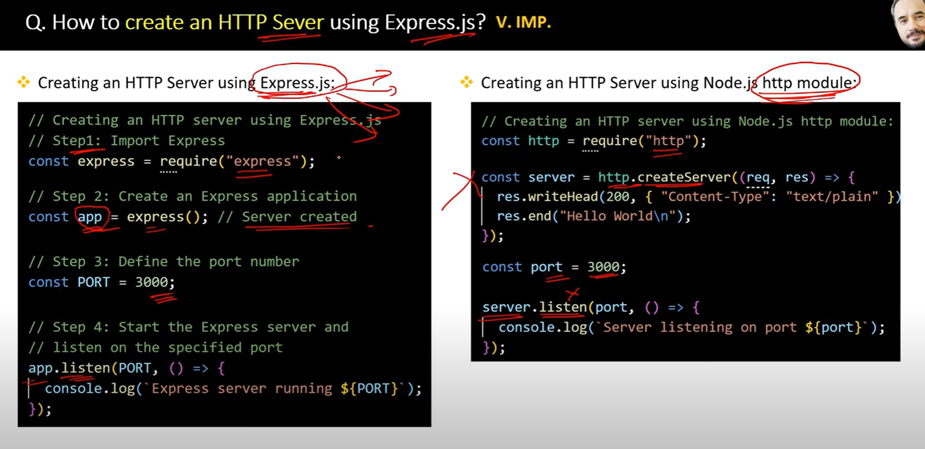

25.

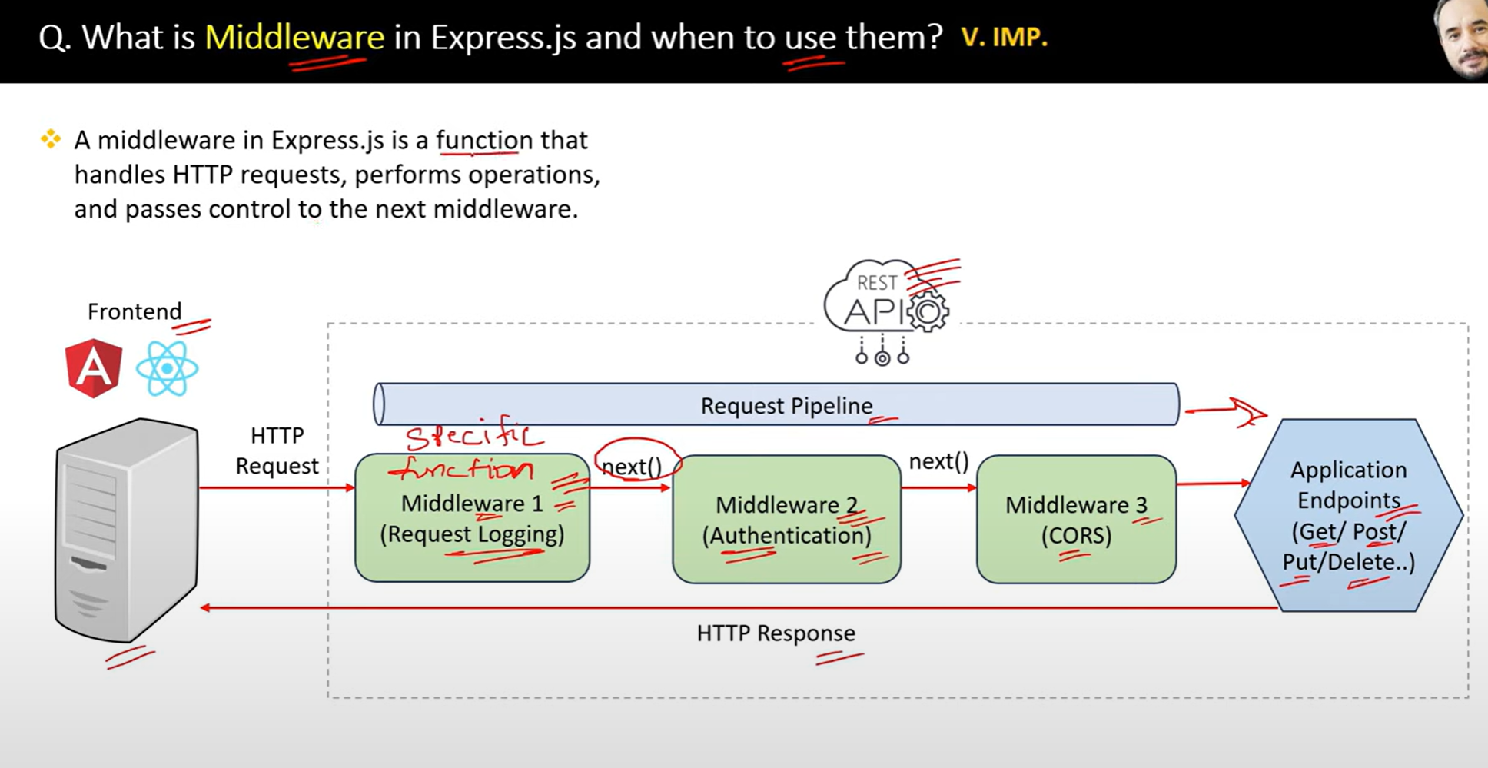

26.

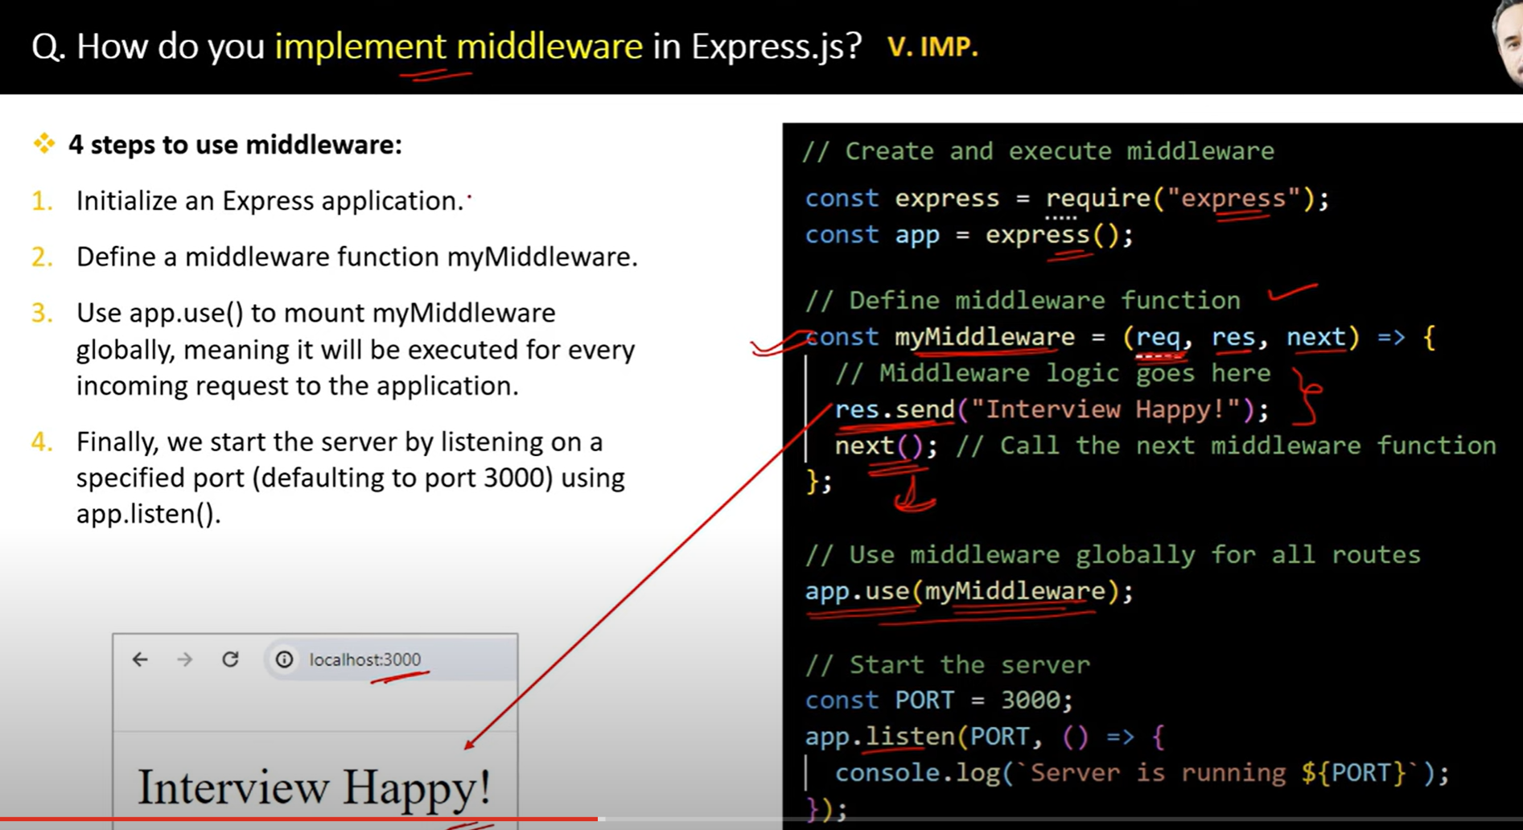

27.

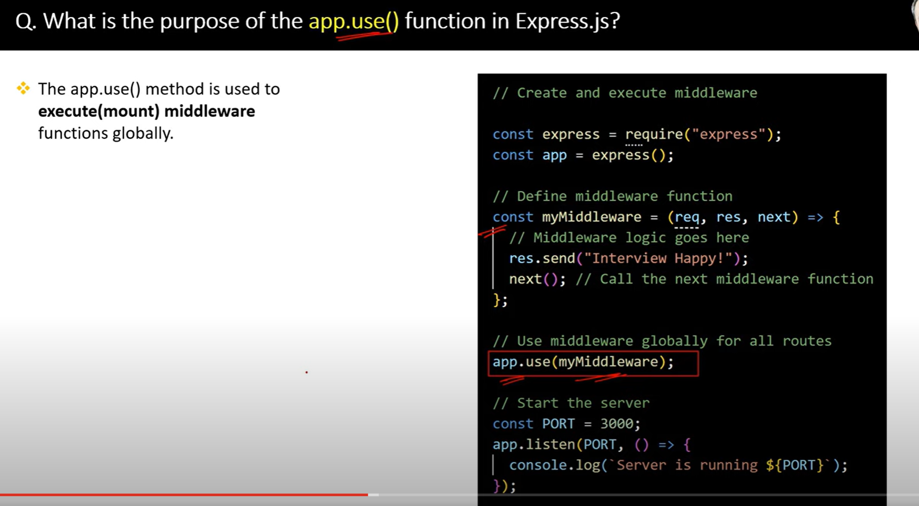

28.

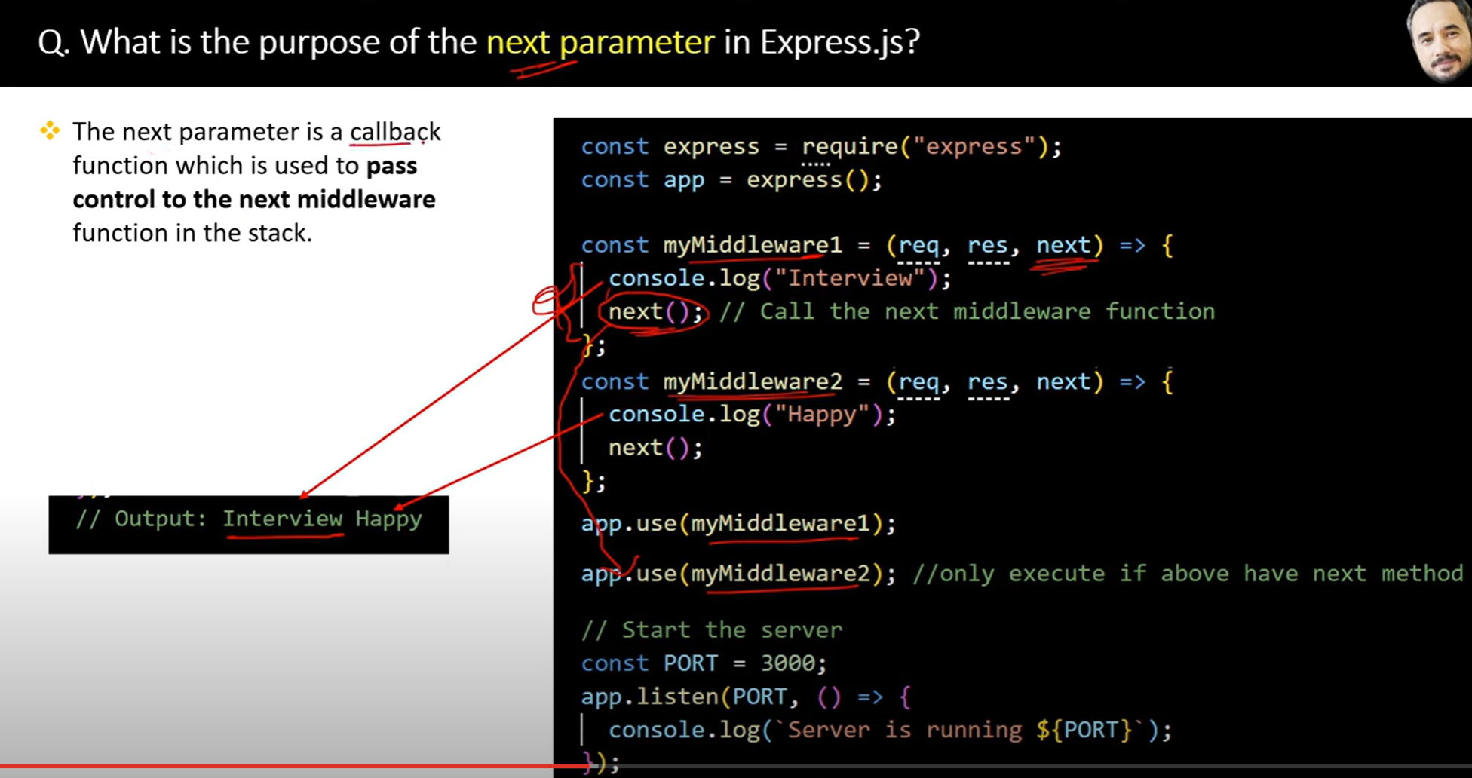

29.

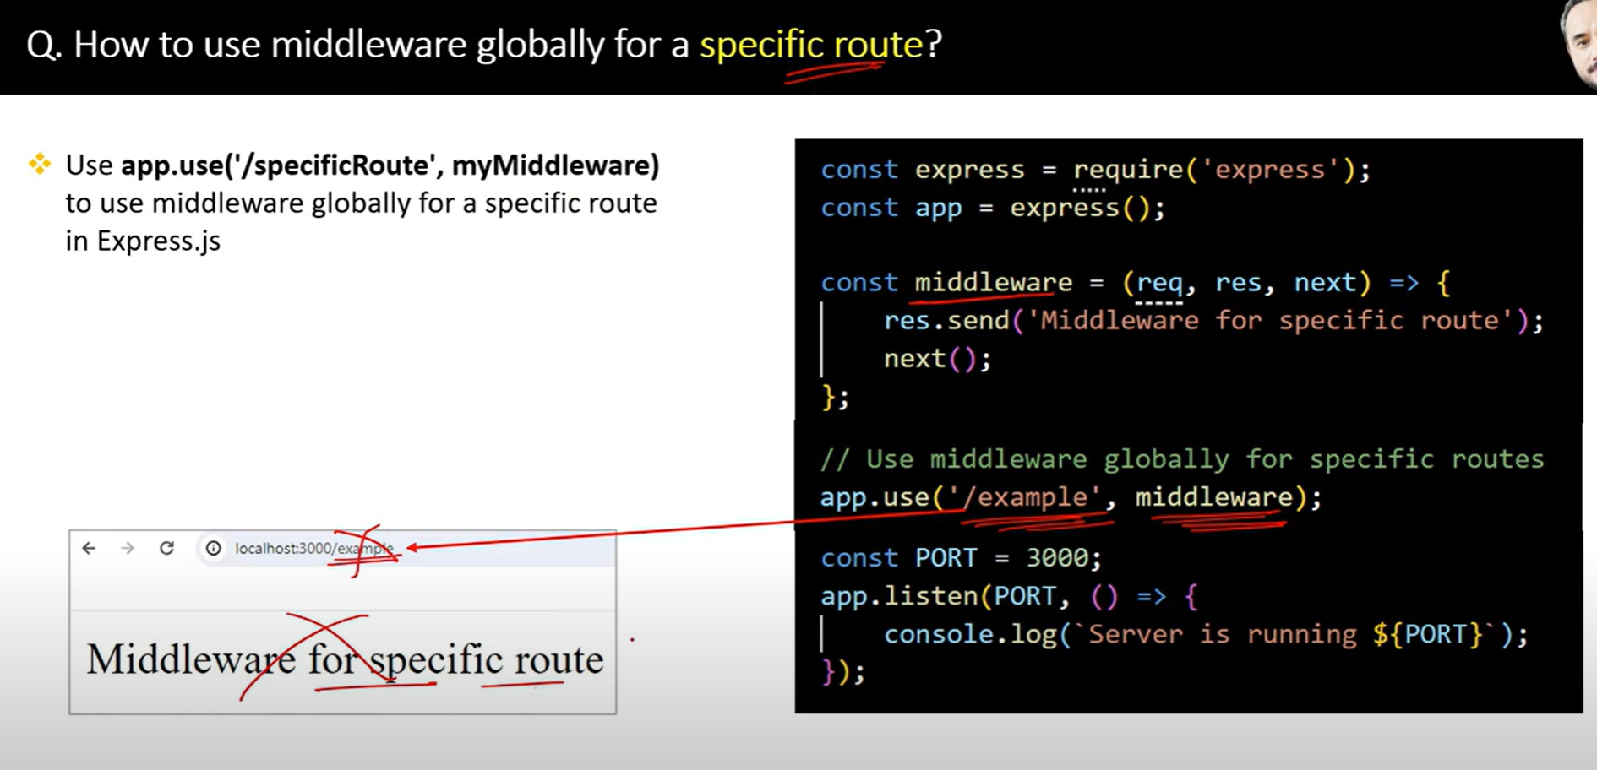

30

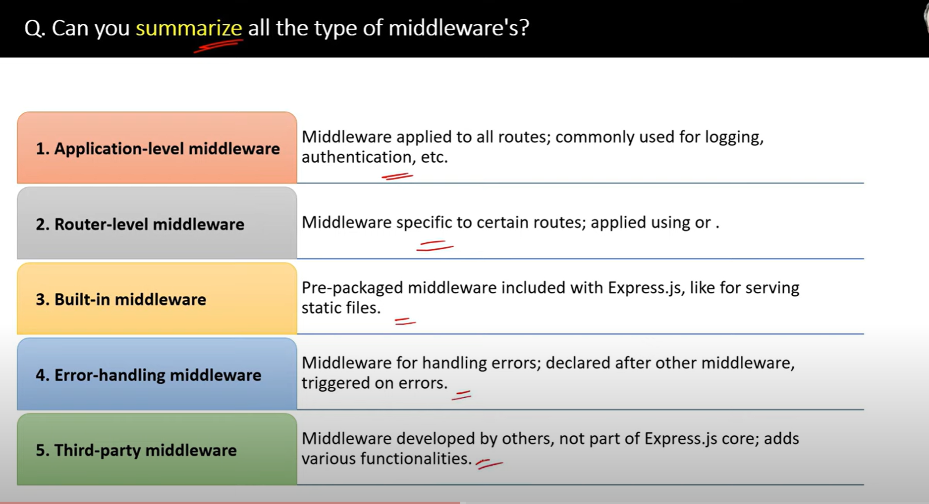

31.

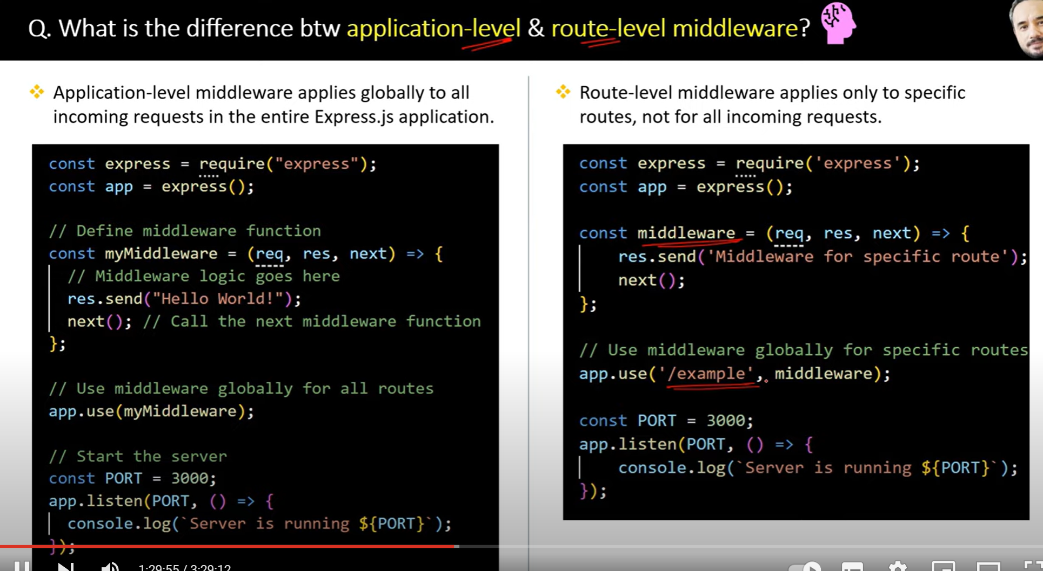

32.

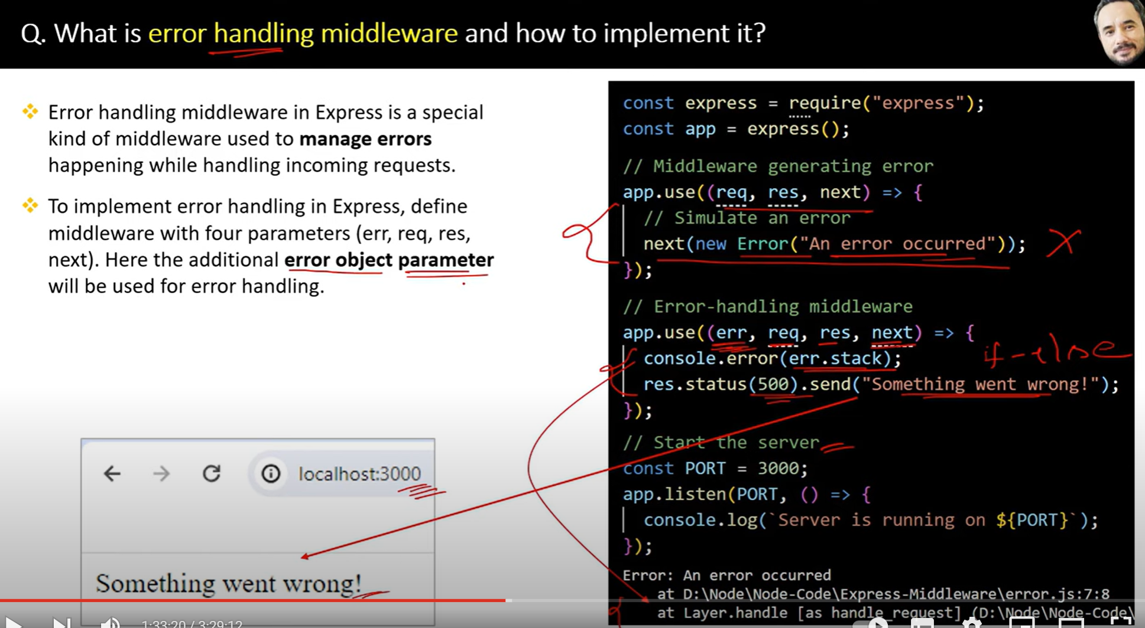

32.

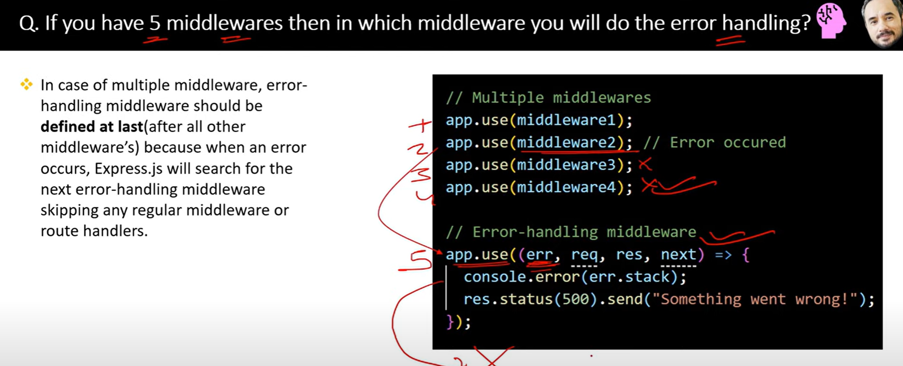

33.

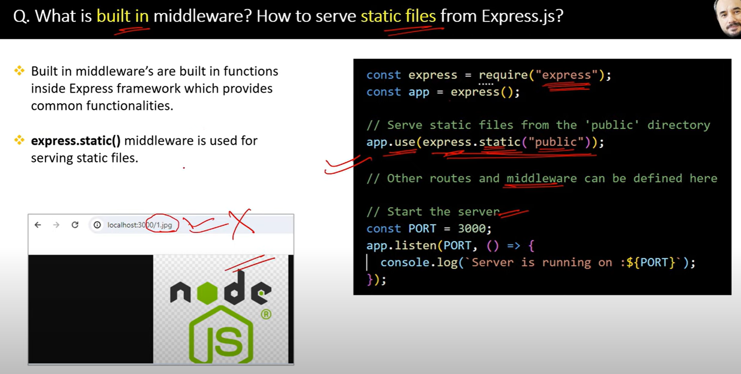

34.

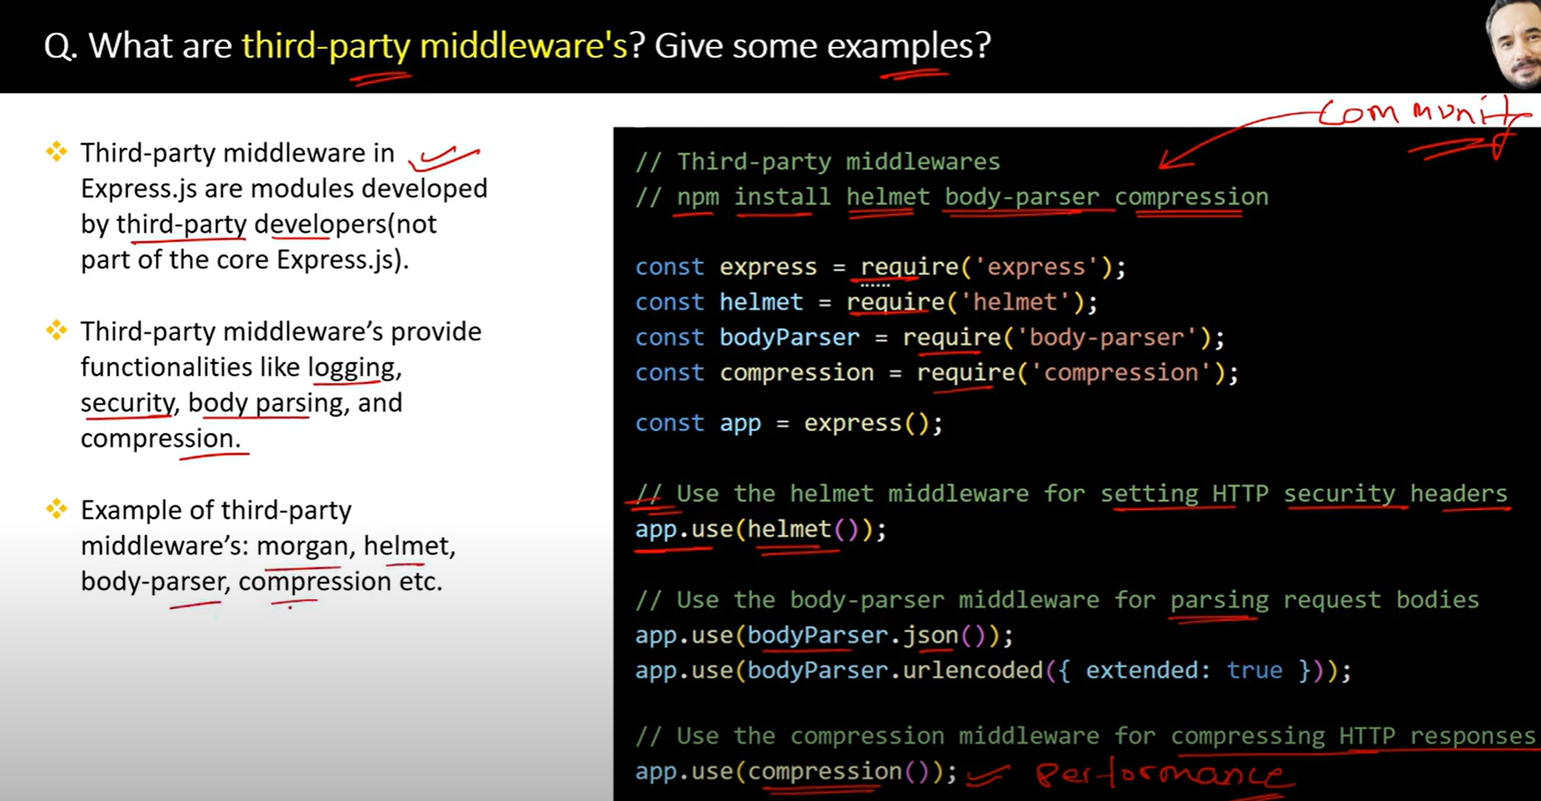

35.

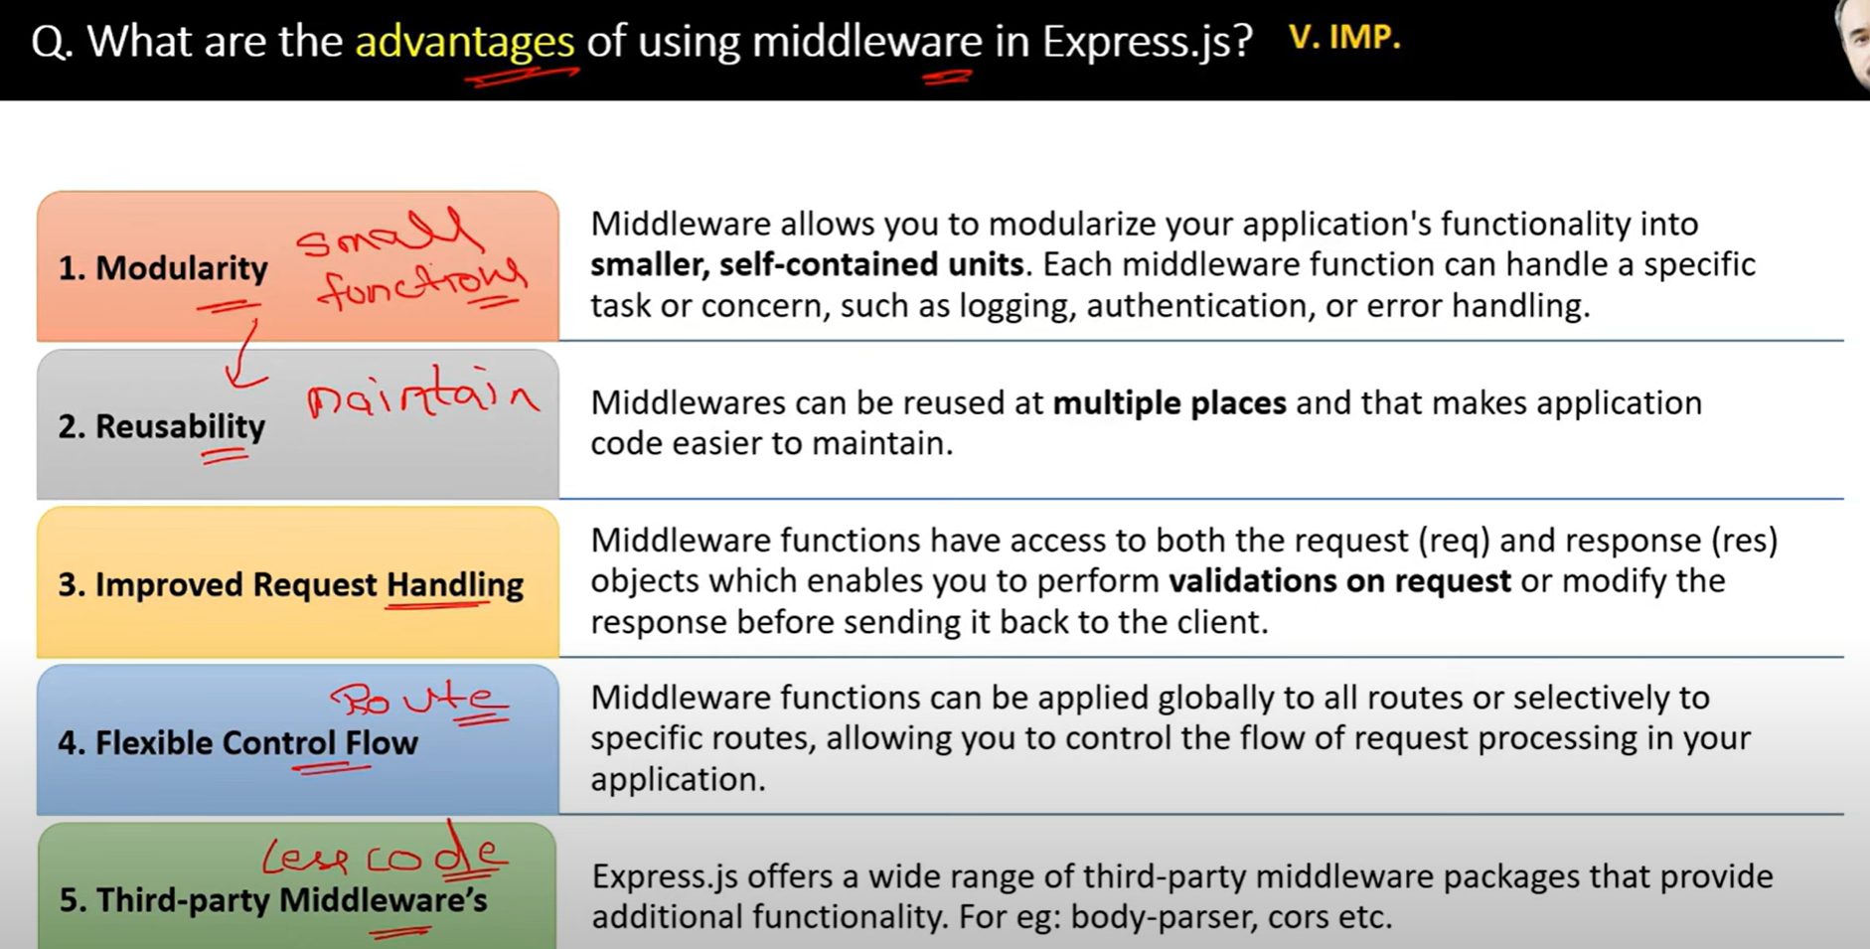

36.

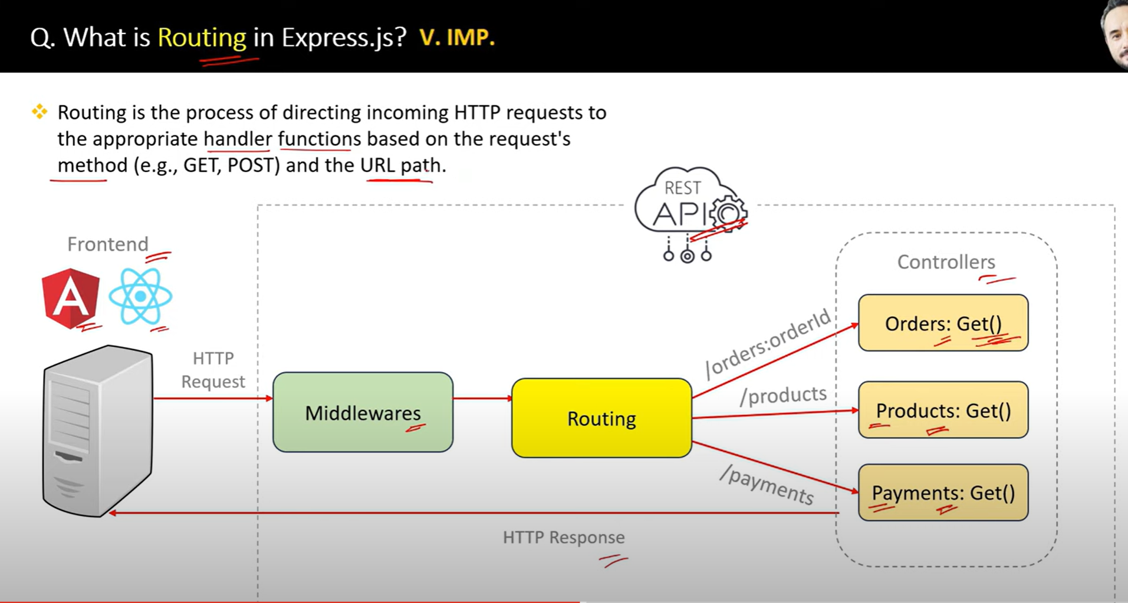

37.

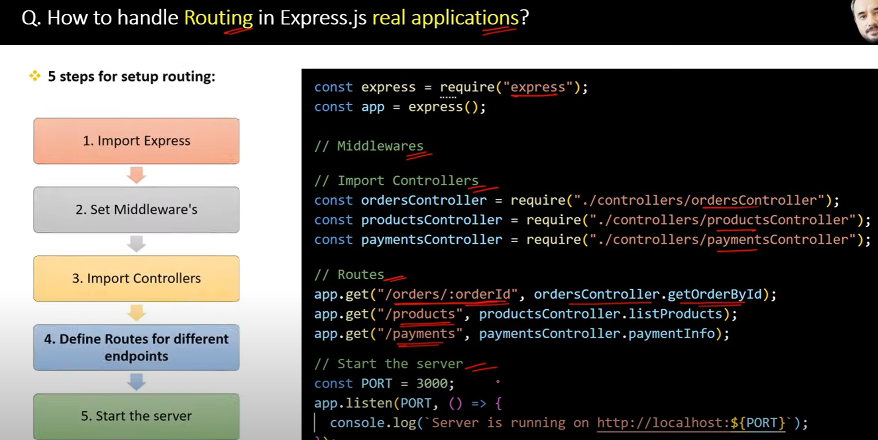

38.

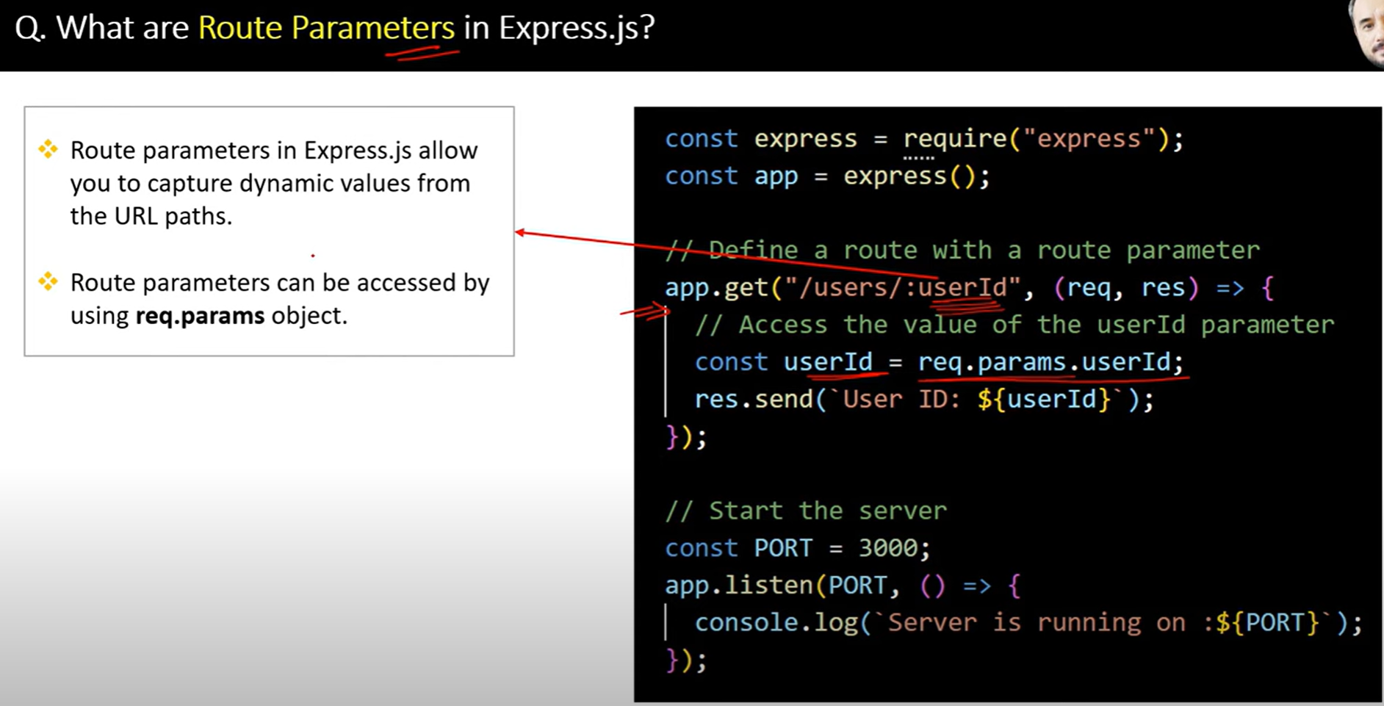

39.

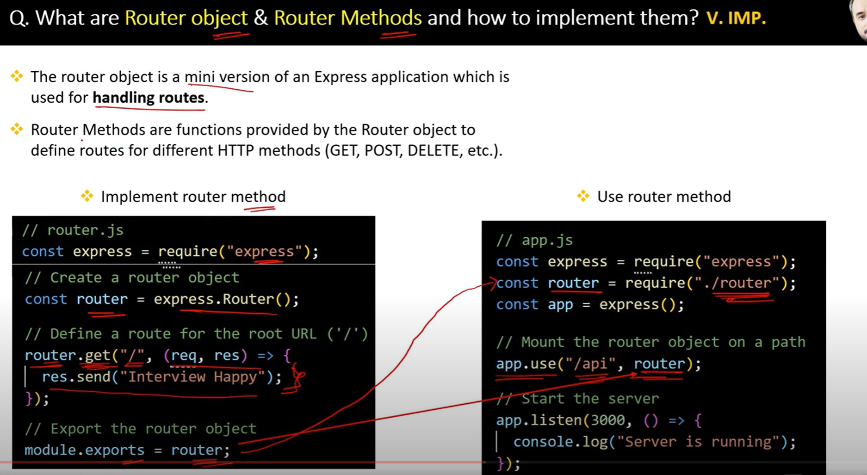

40.

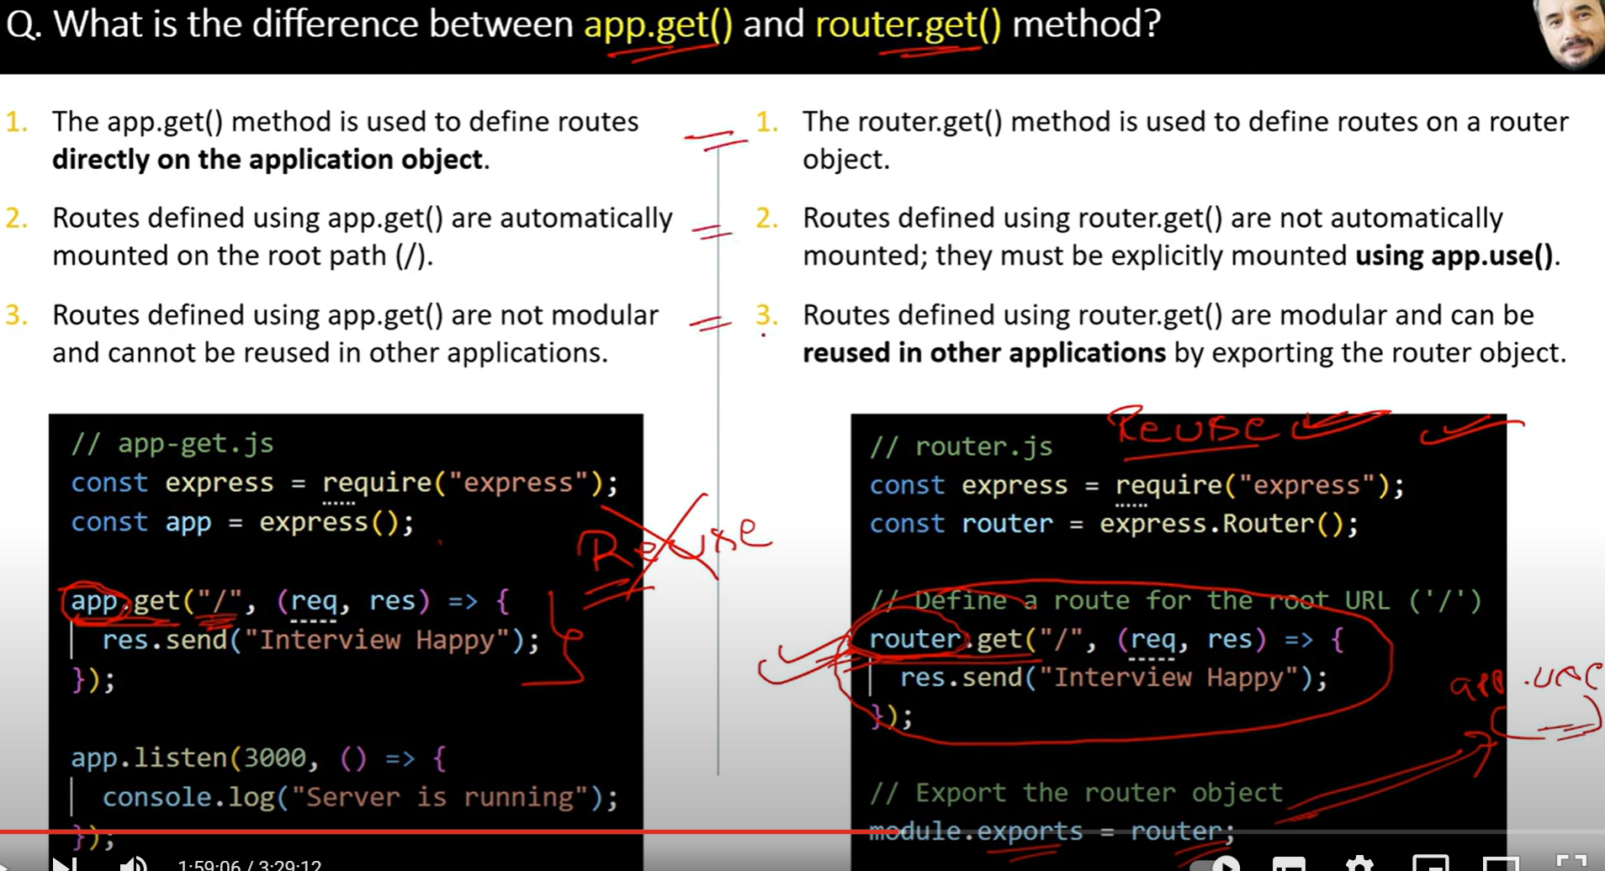

41.

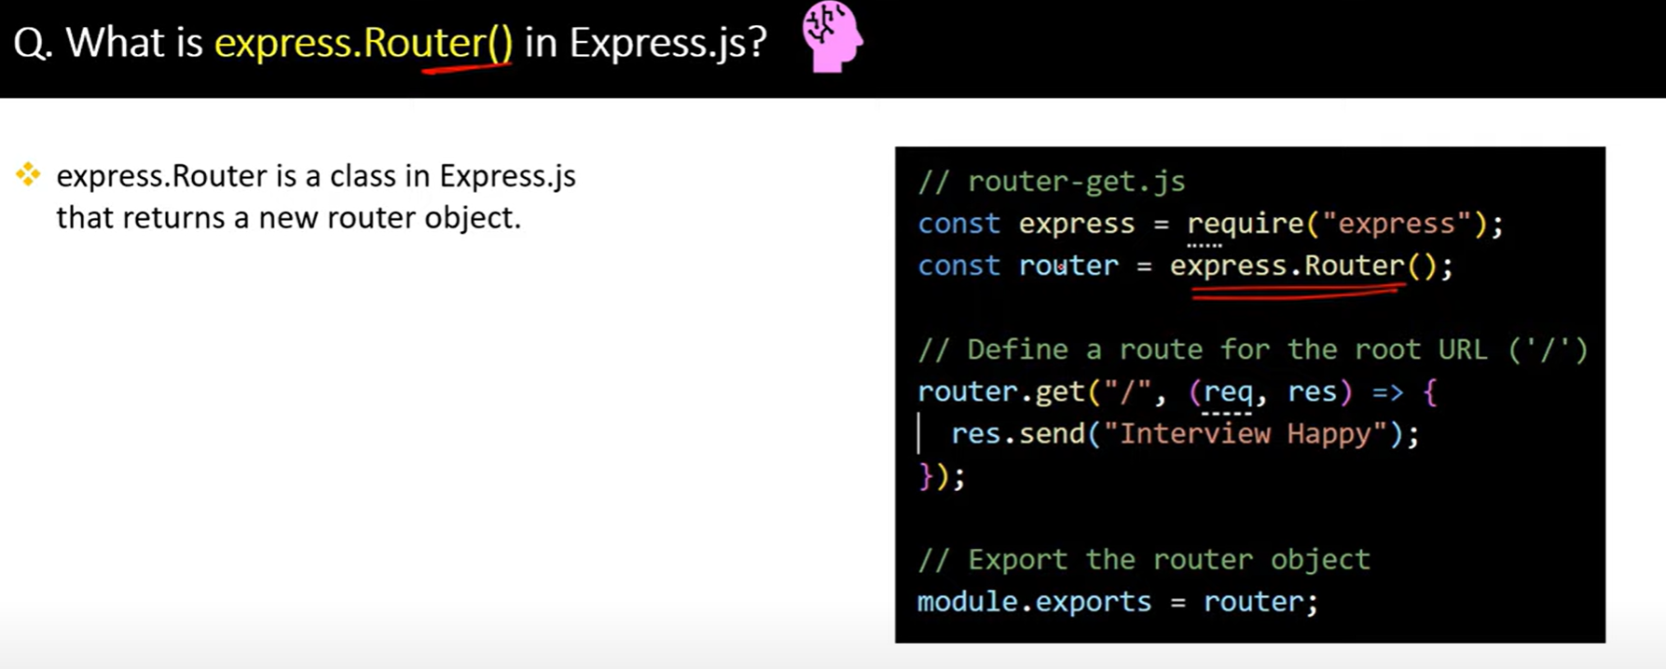

42.

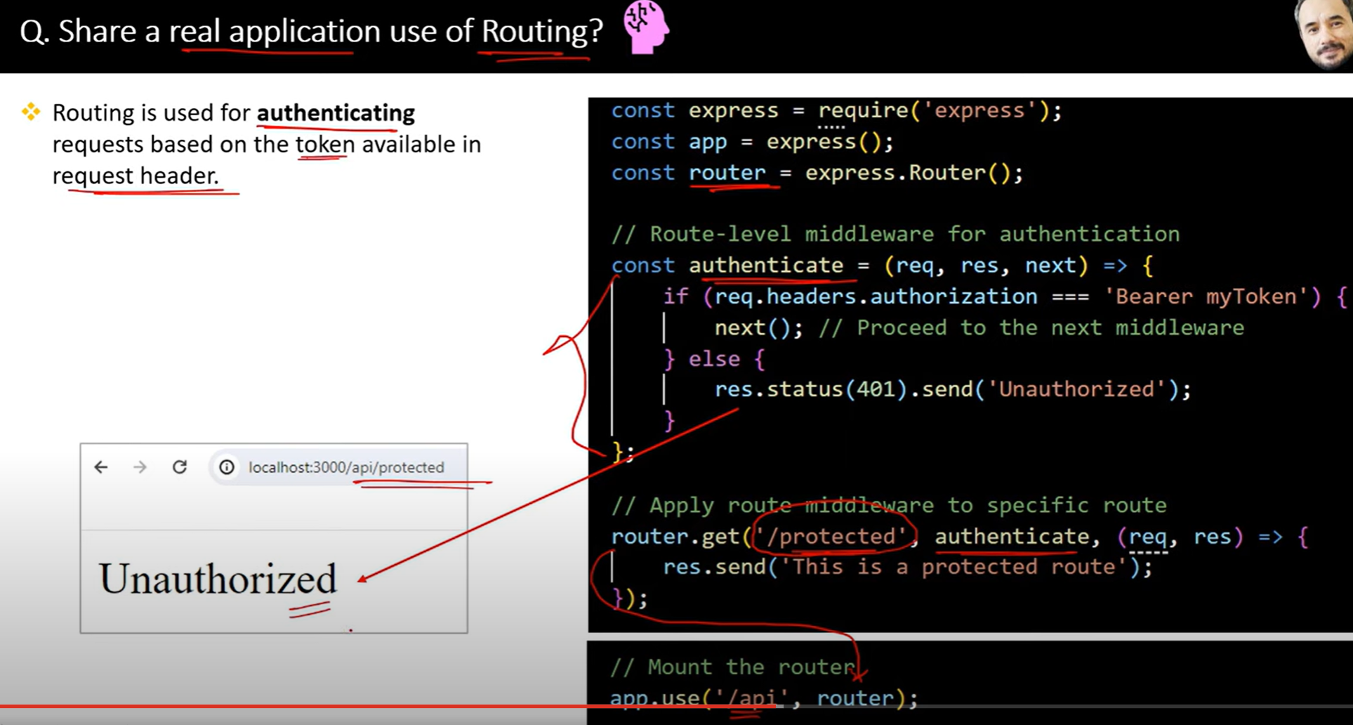

43.

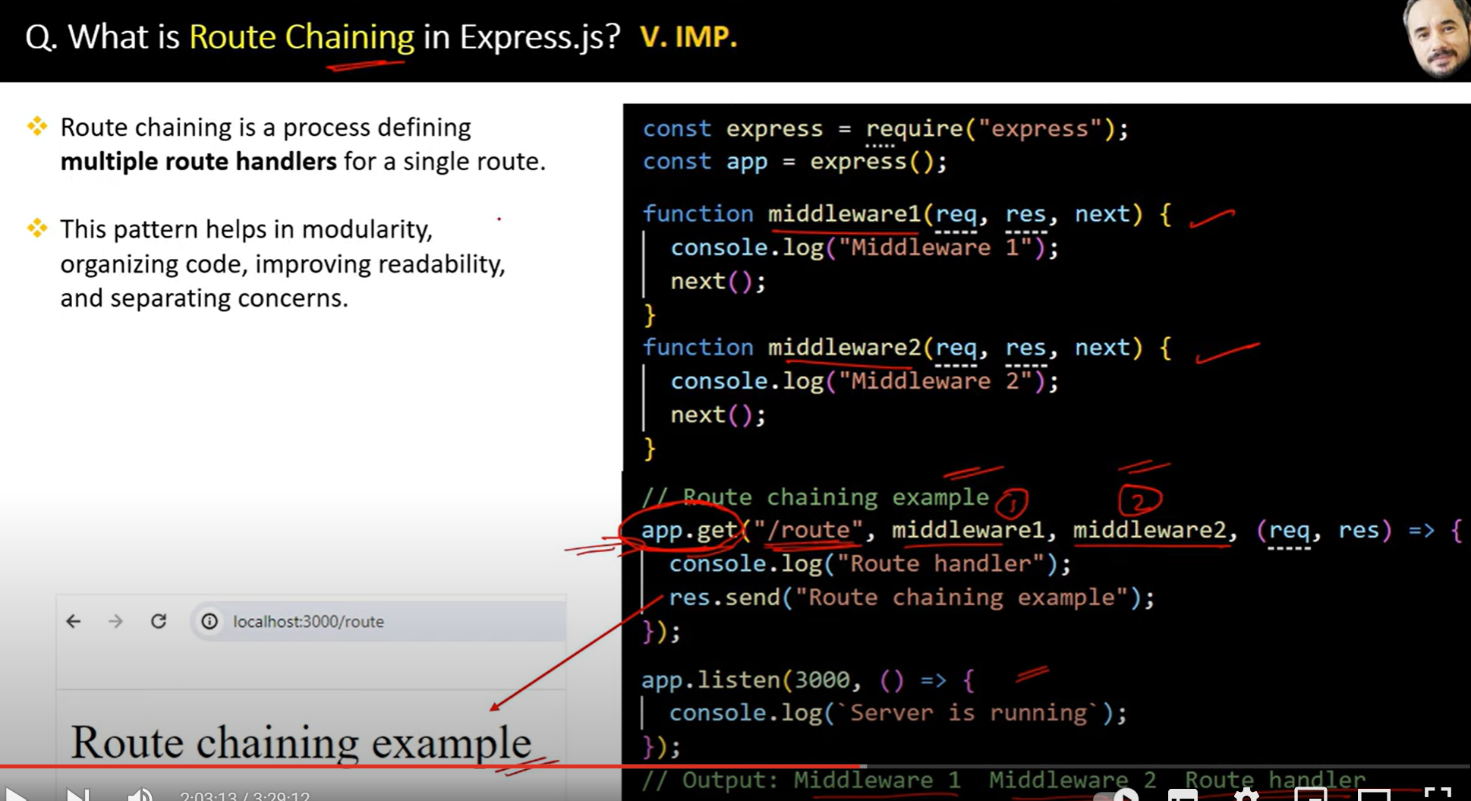

44.

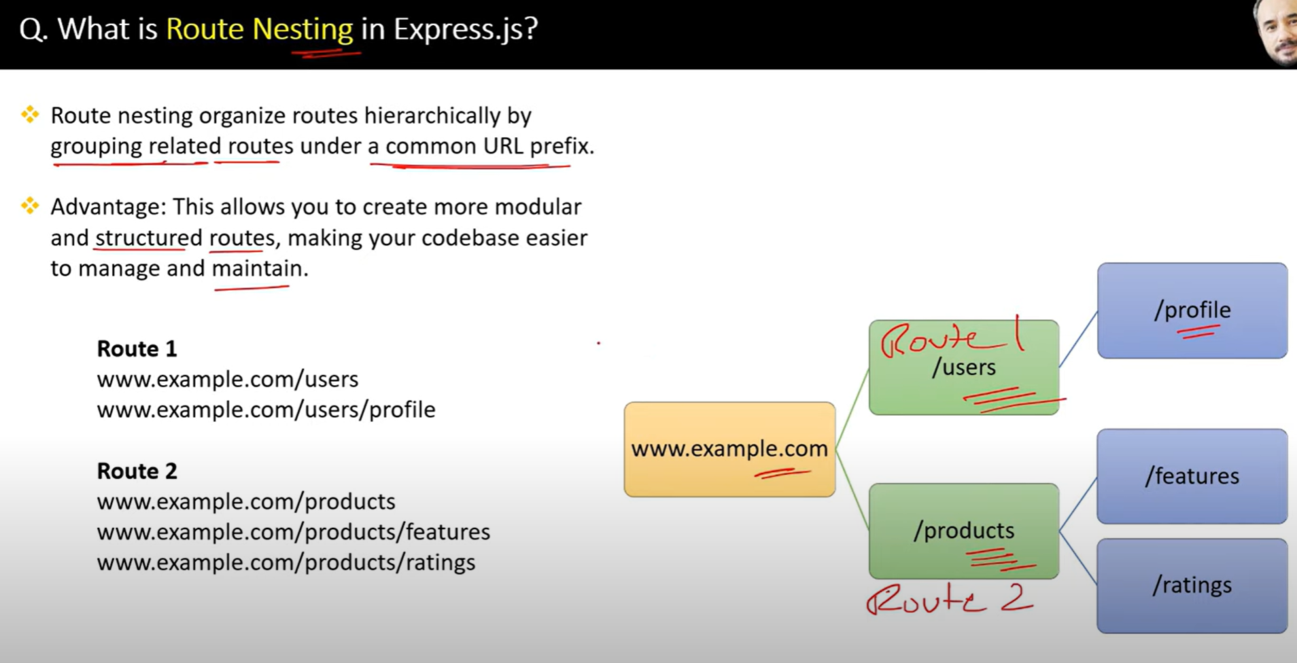

45.

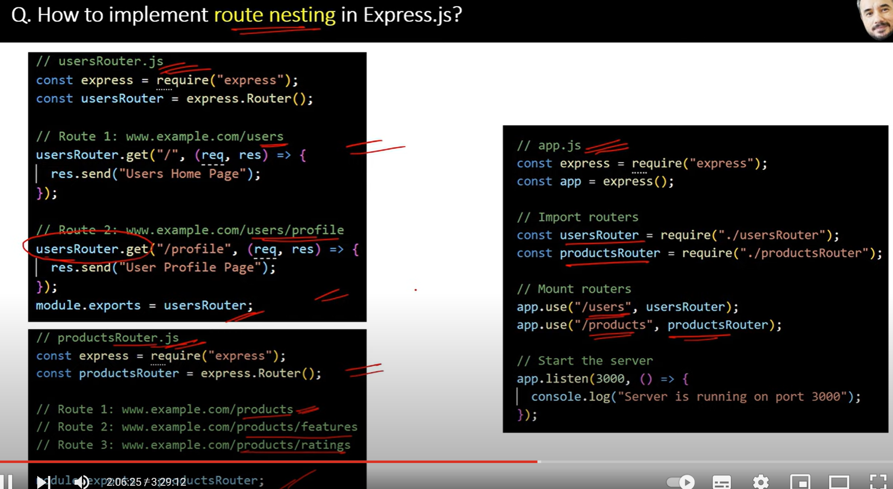

46.

47.

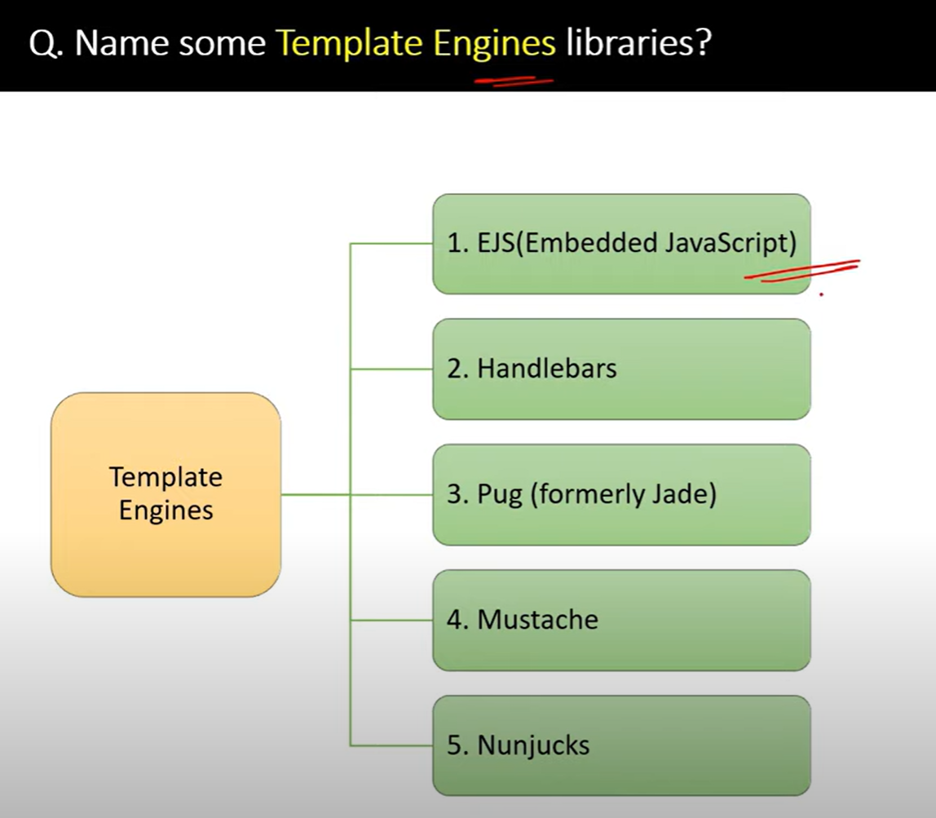

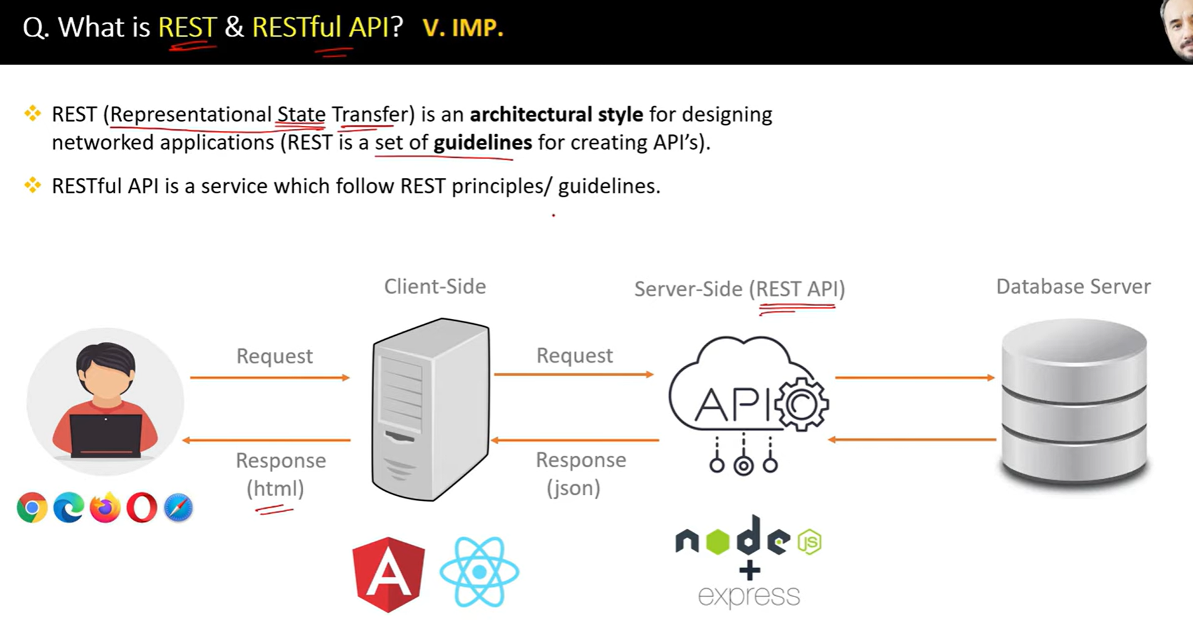

A **REST API** (Representational State Transfer Application Programming Interface) is a set of rules and conventions for building web services that allow communication between systems over the HTTP protocol. REST APIs are designed to be lightweight, stateless, and scalable,

50.

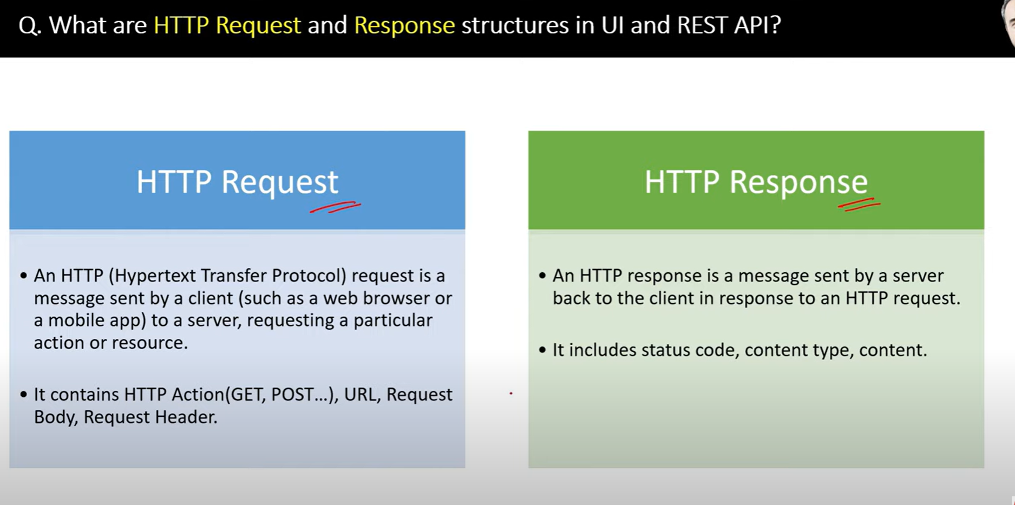

51.

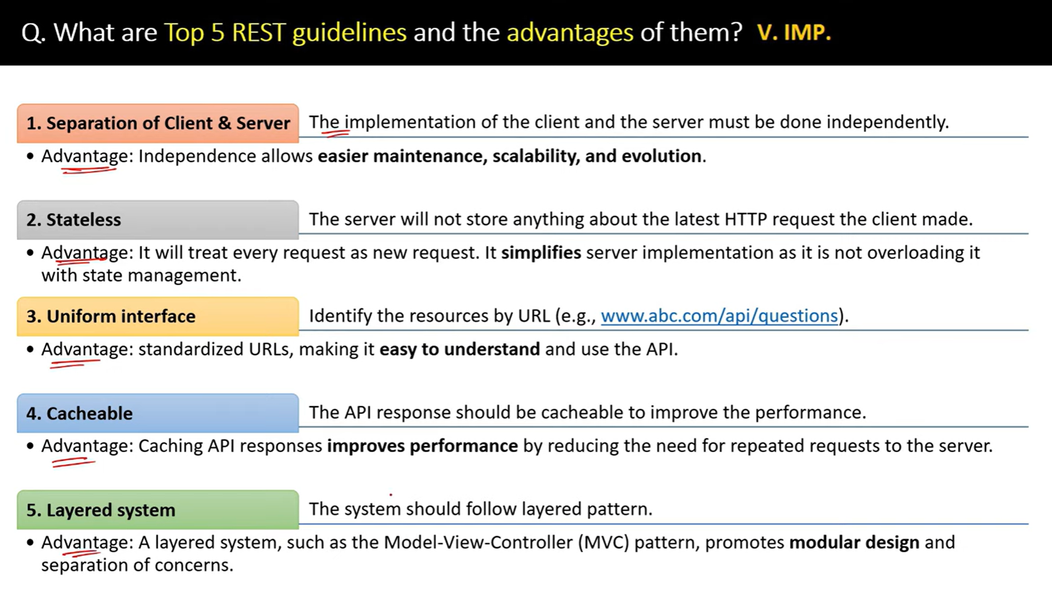

52.

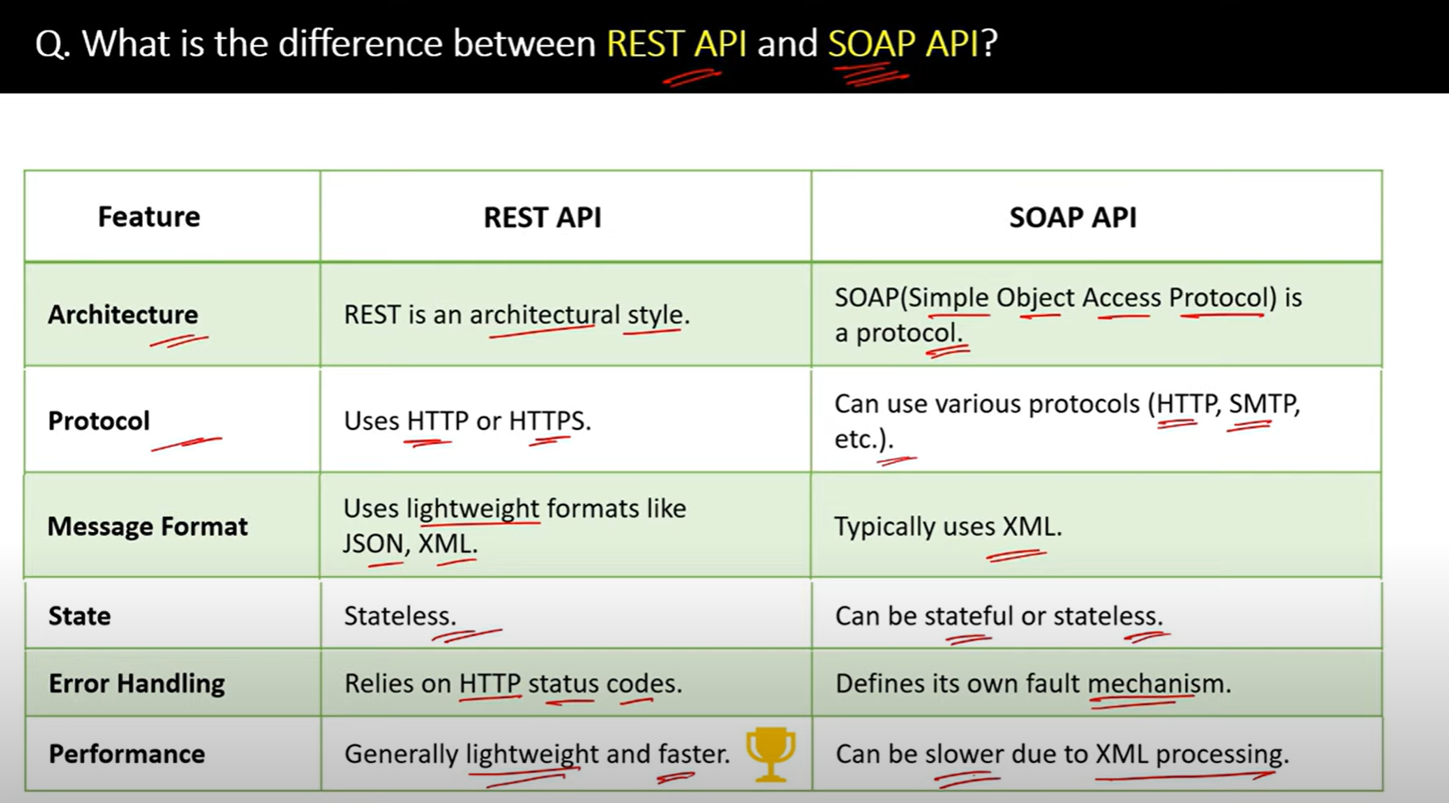

53.

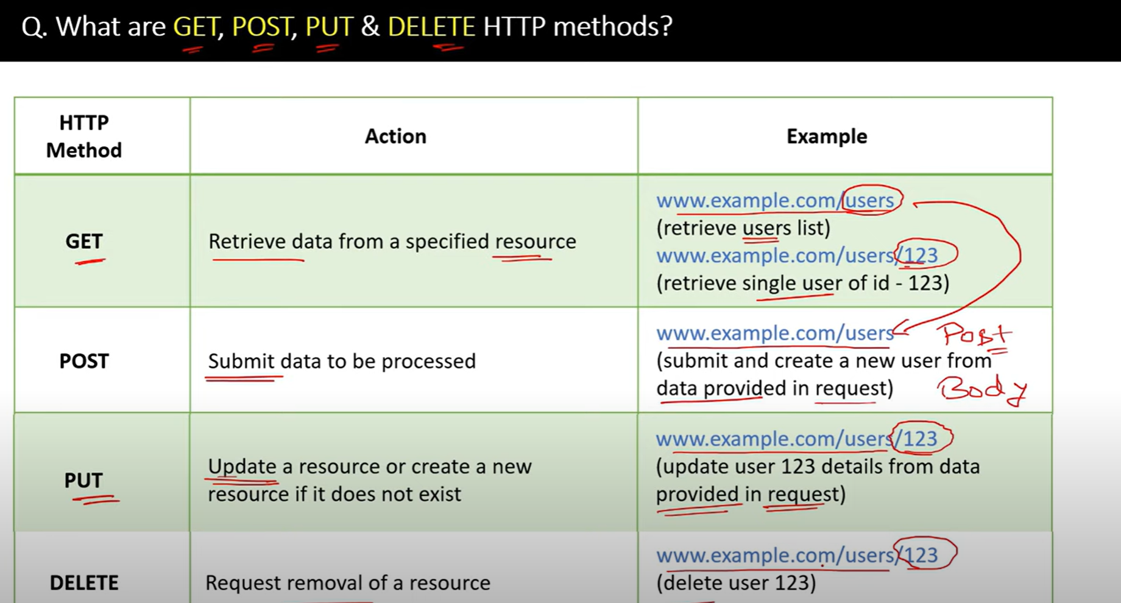

54.

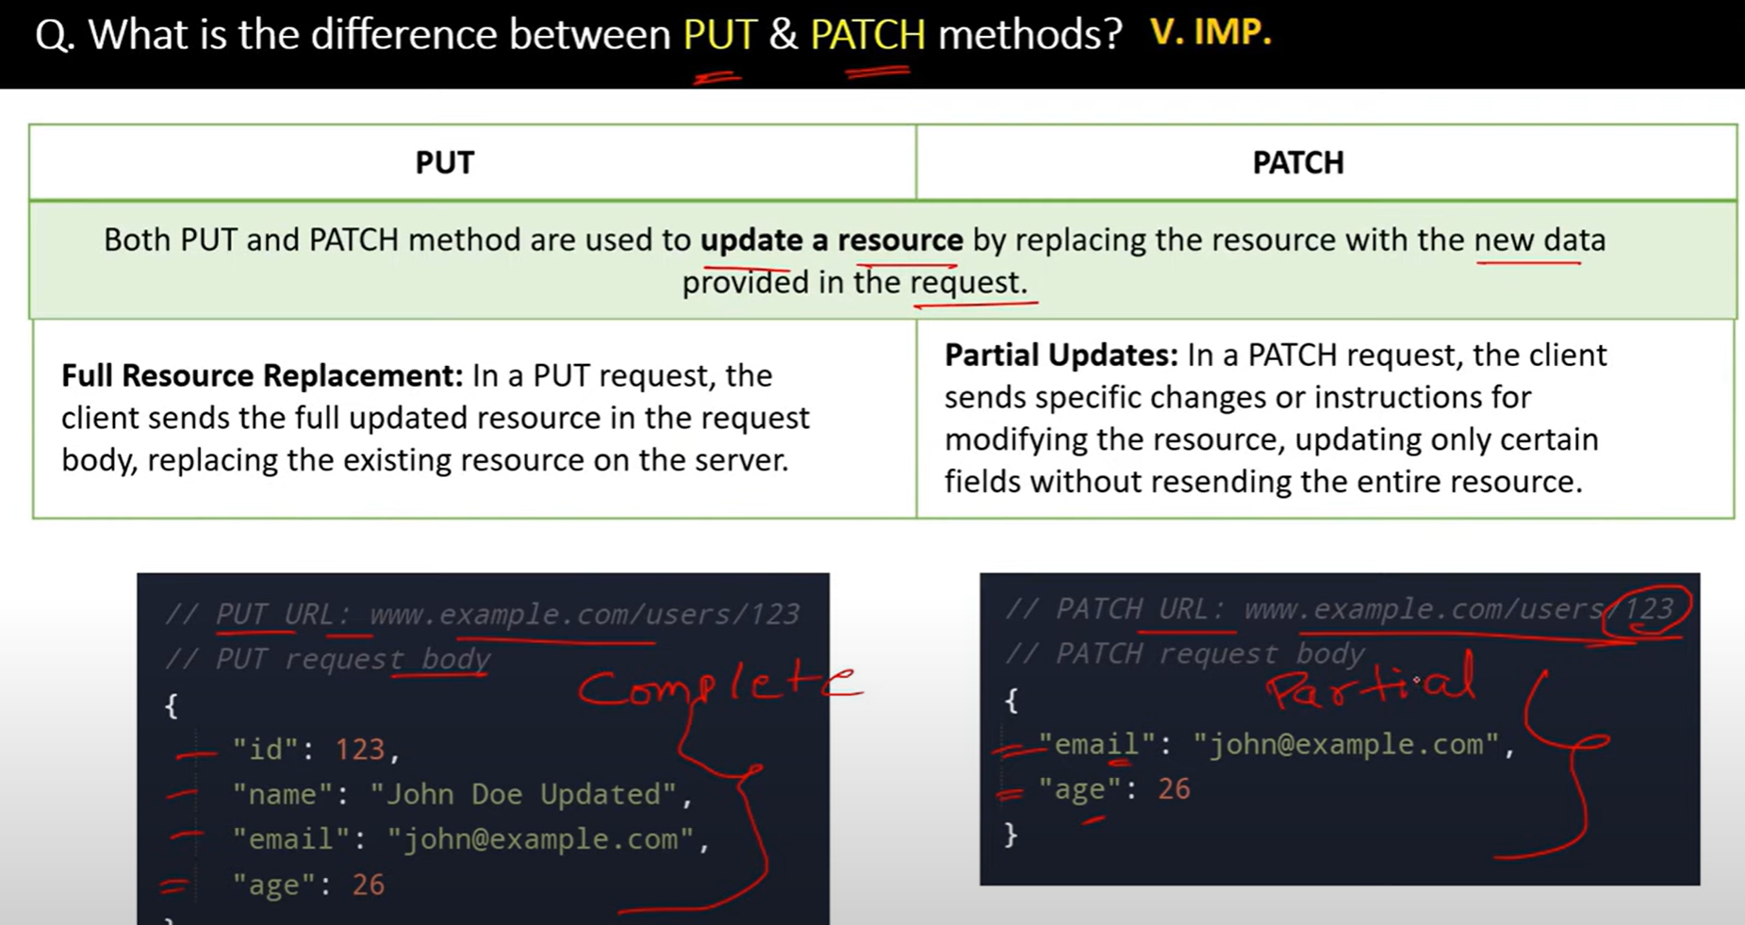

55.

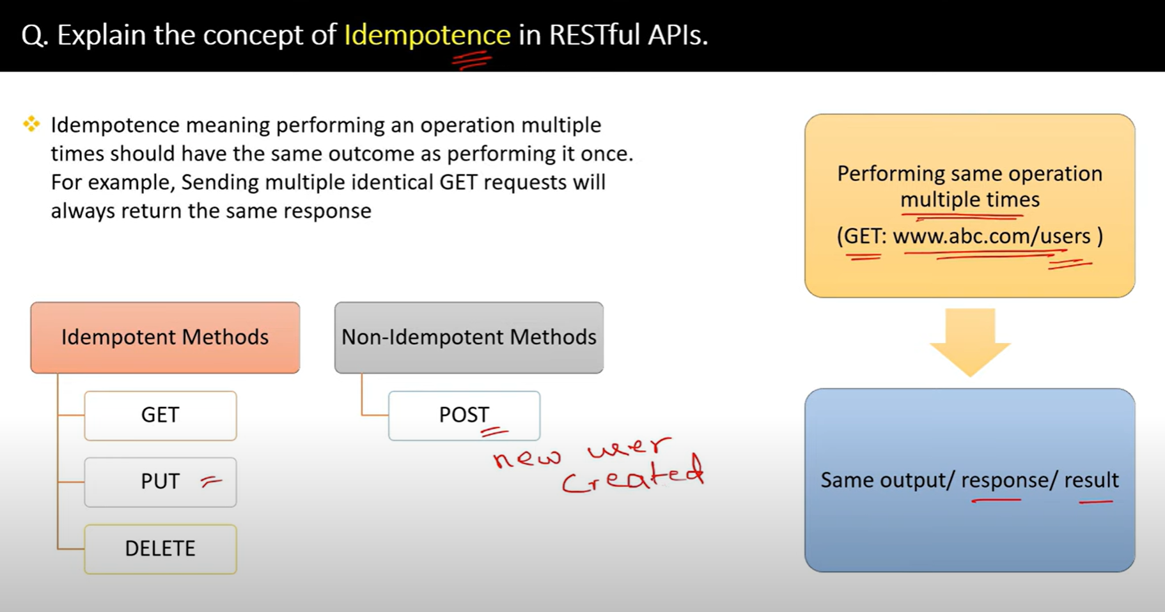

56.

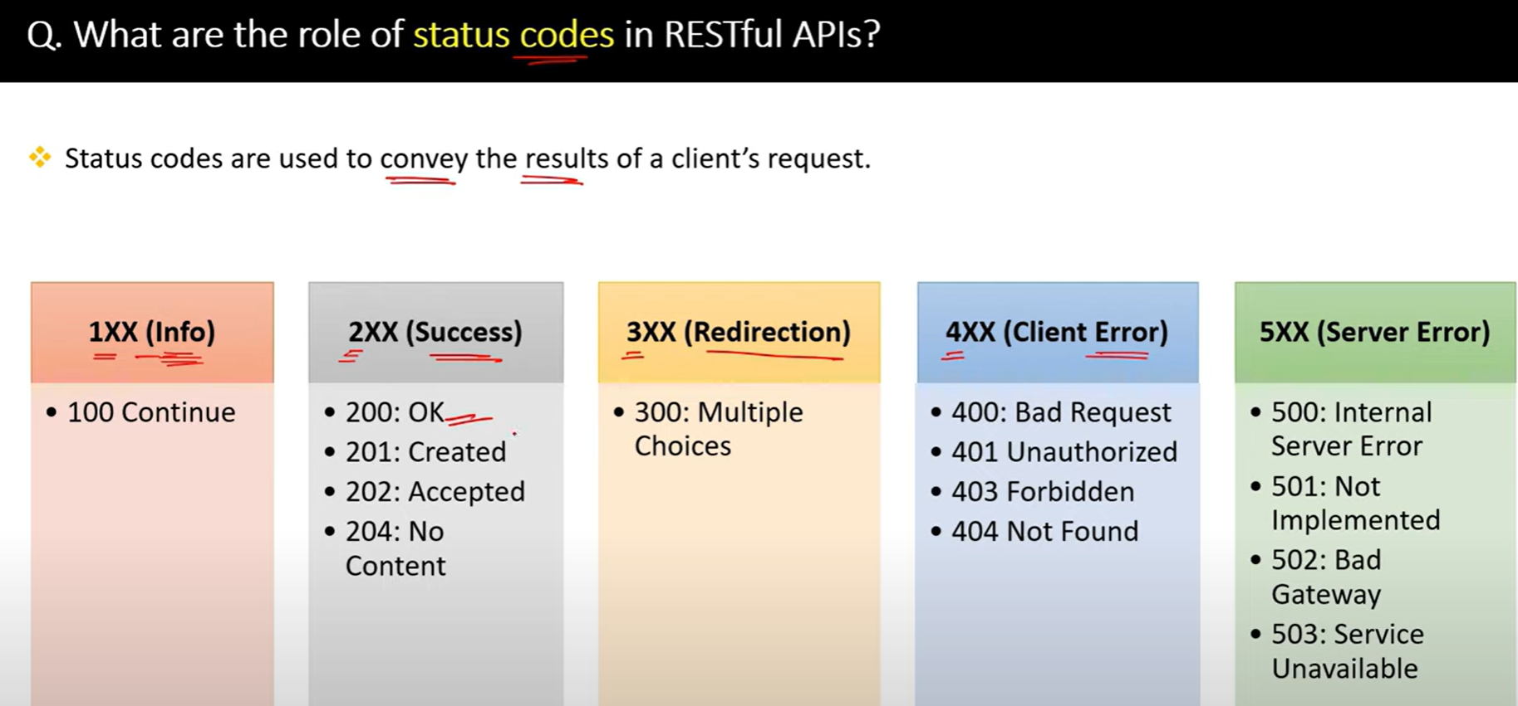

57.

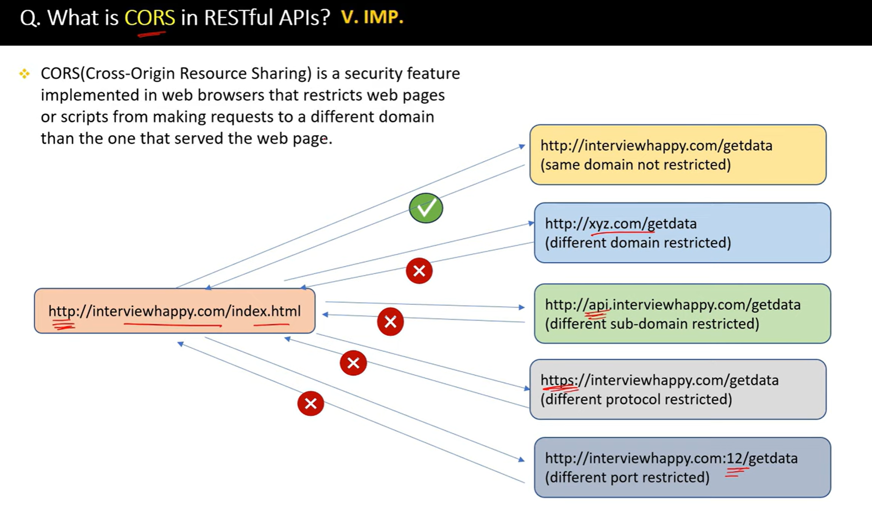

58.

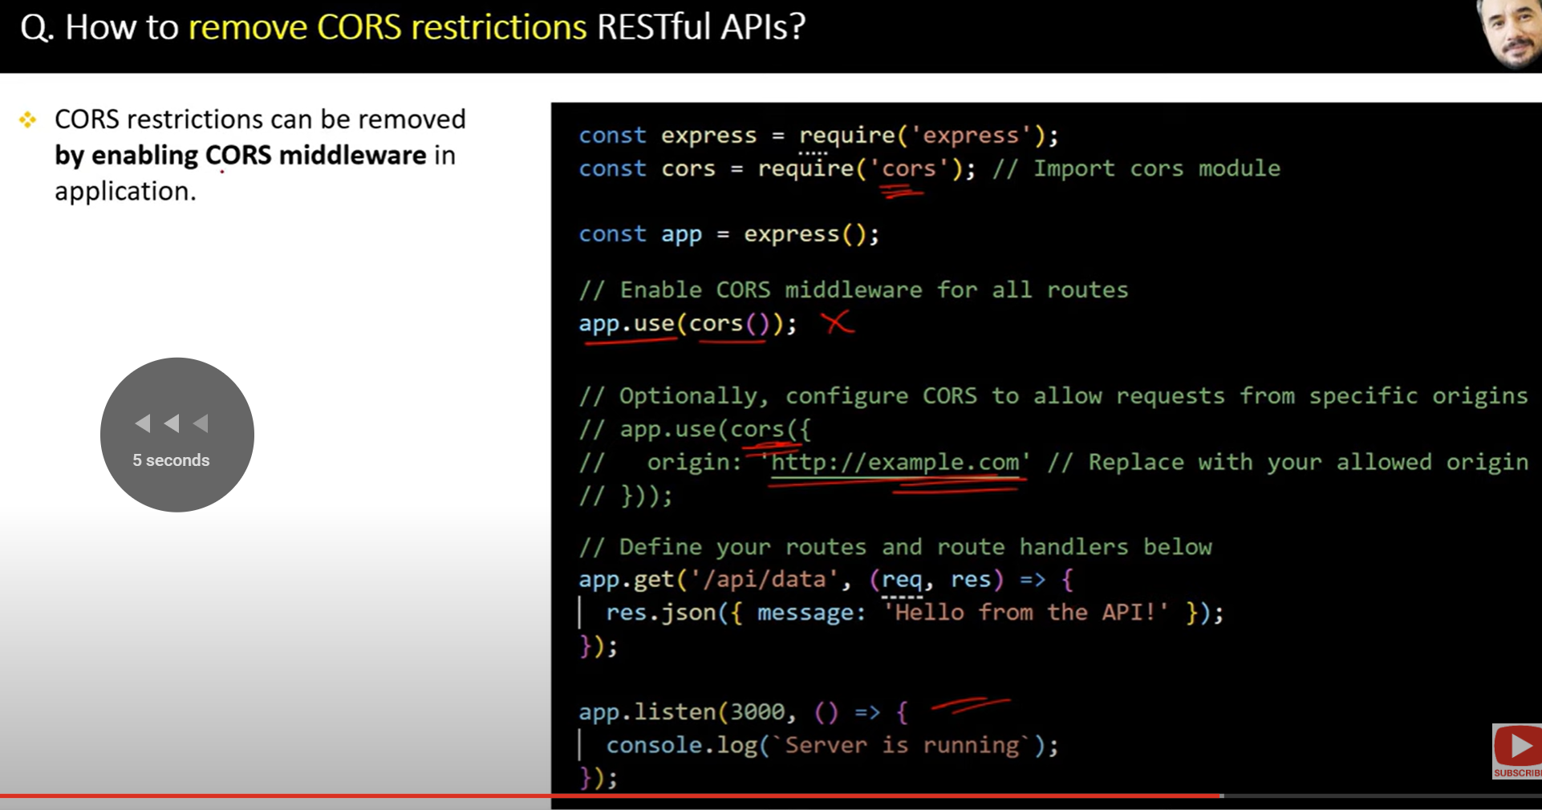

59.

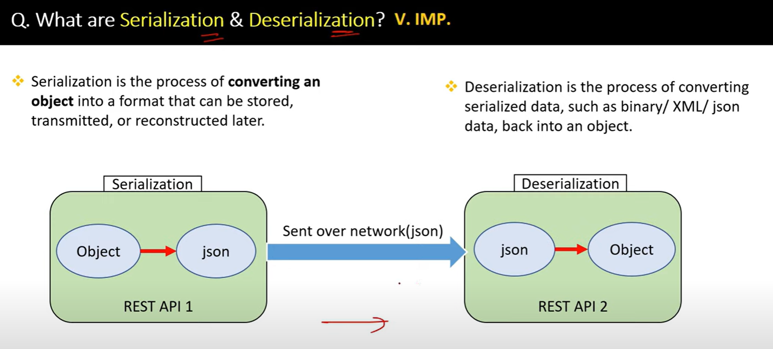

60.

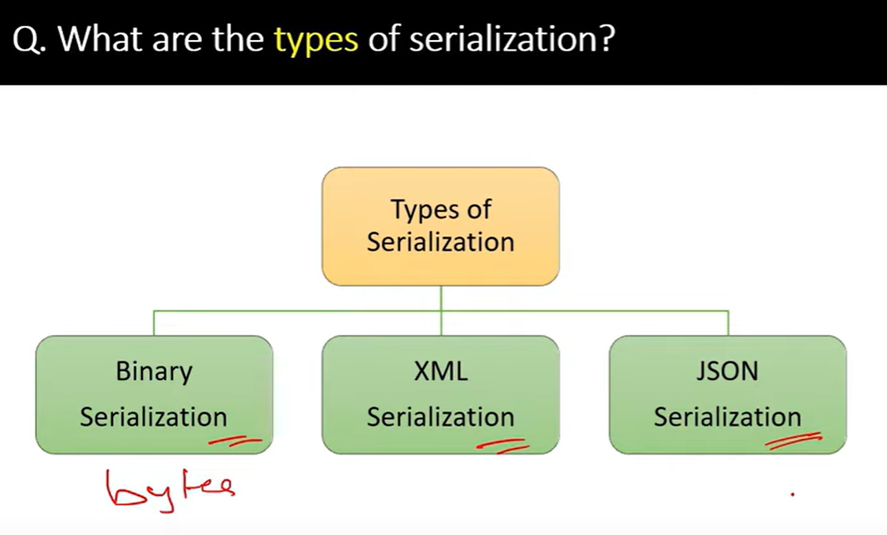

61.

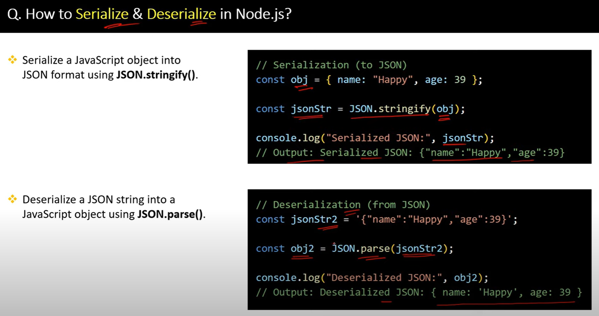

62.

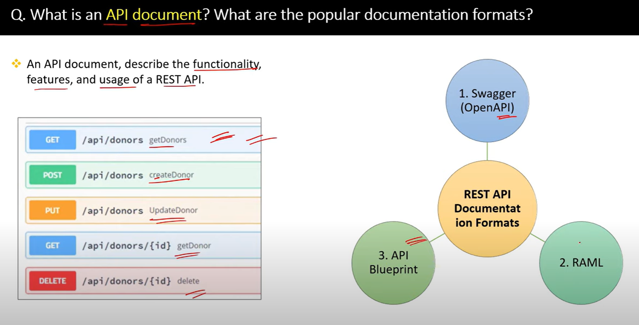

63.

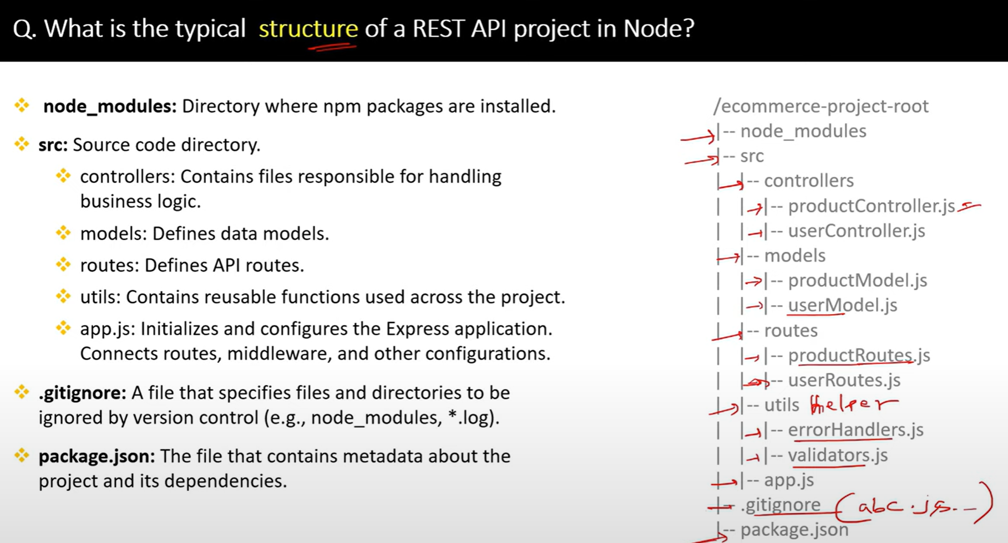

64.

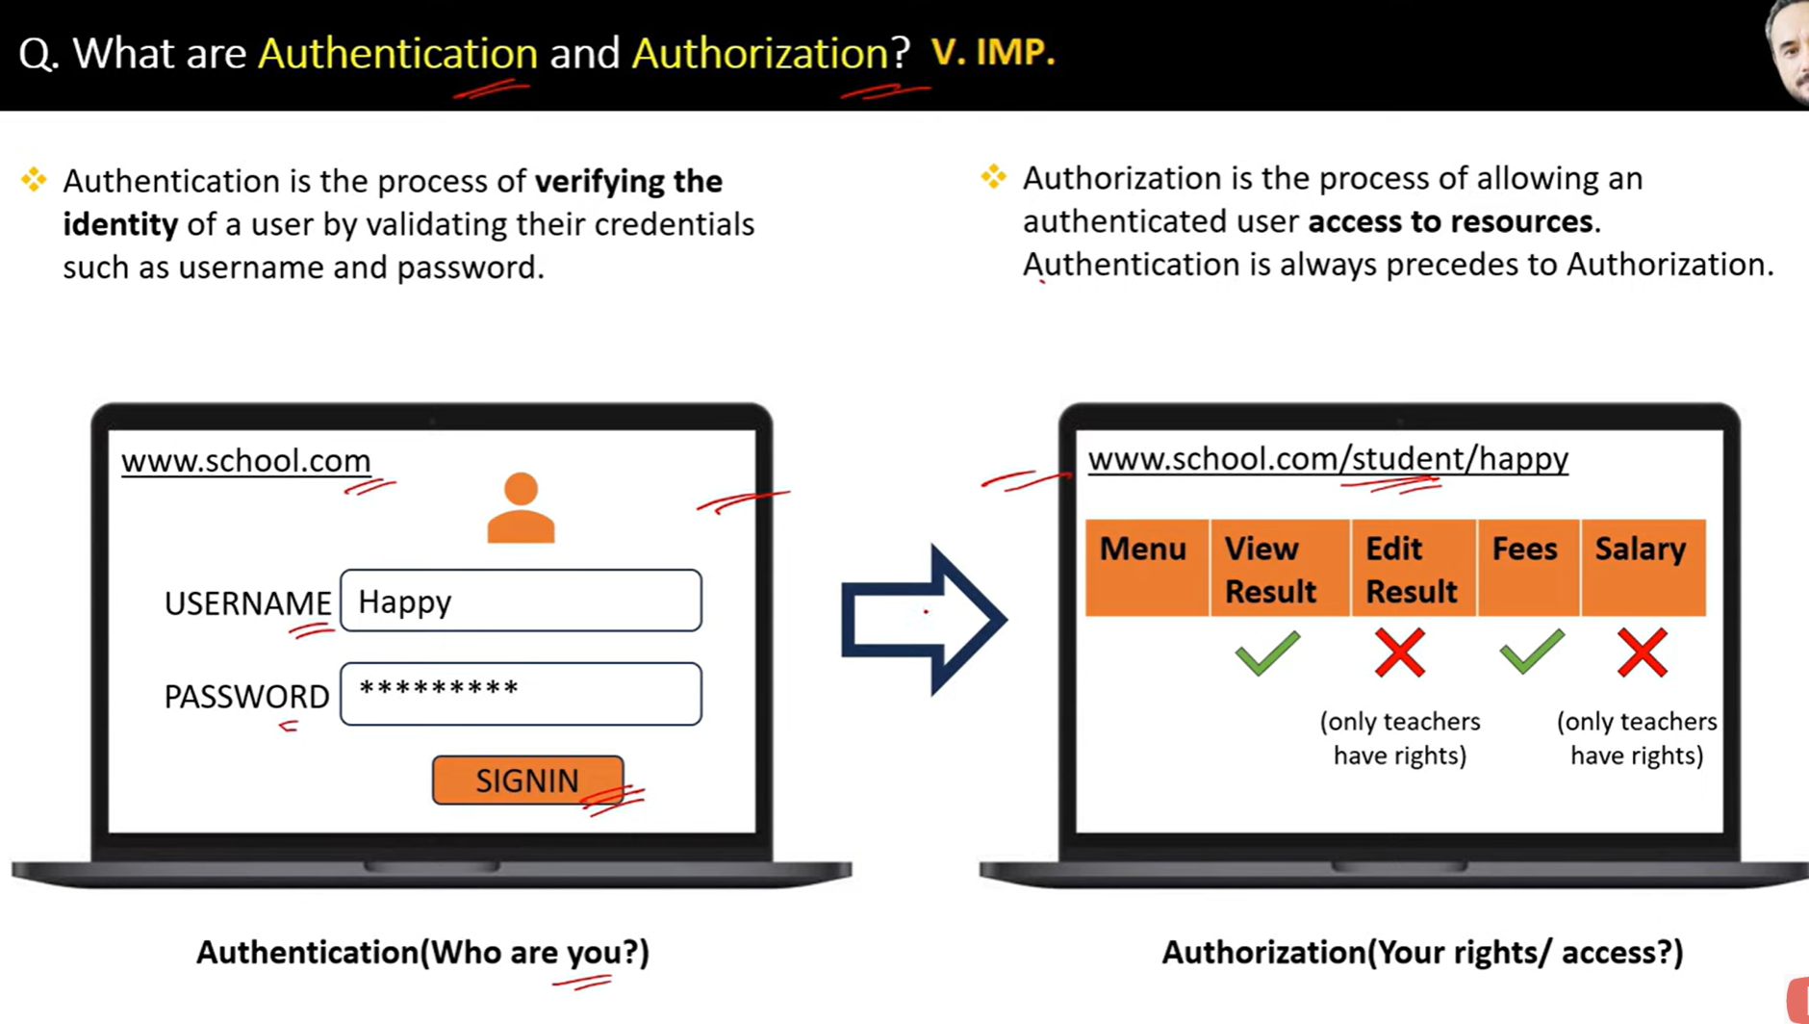

65.

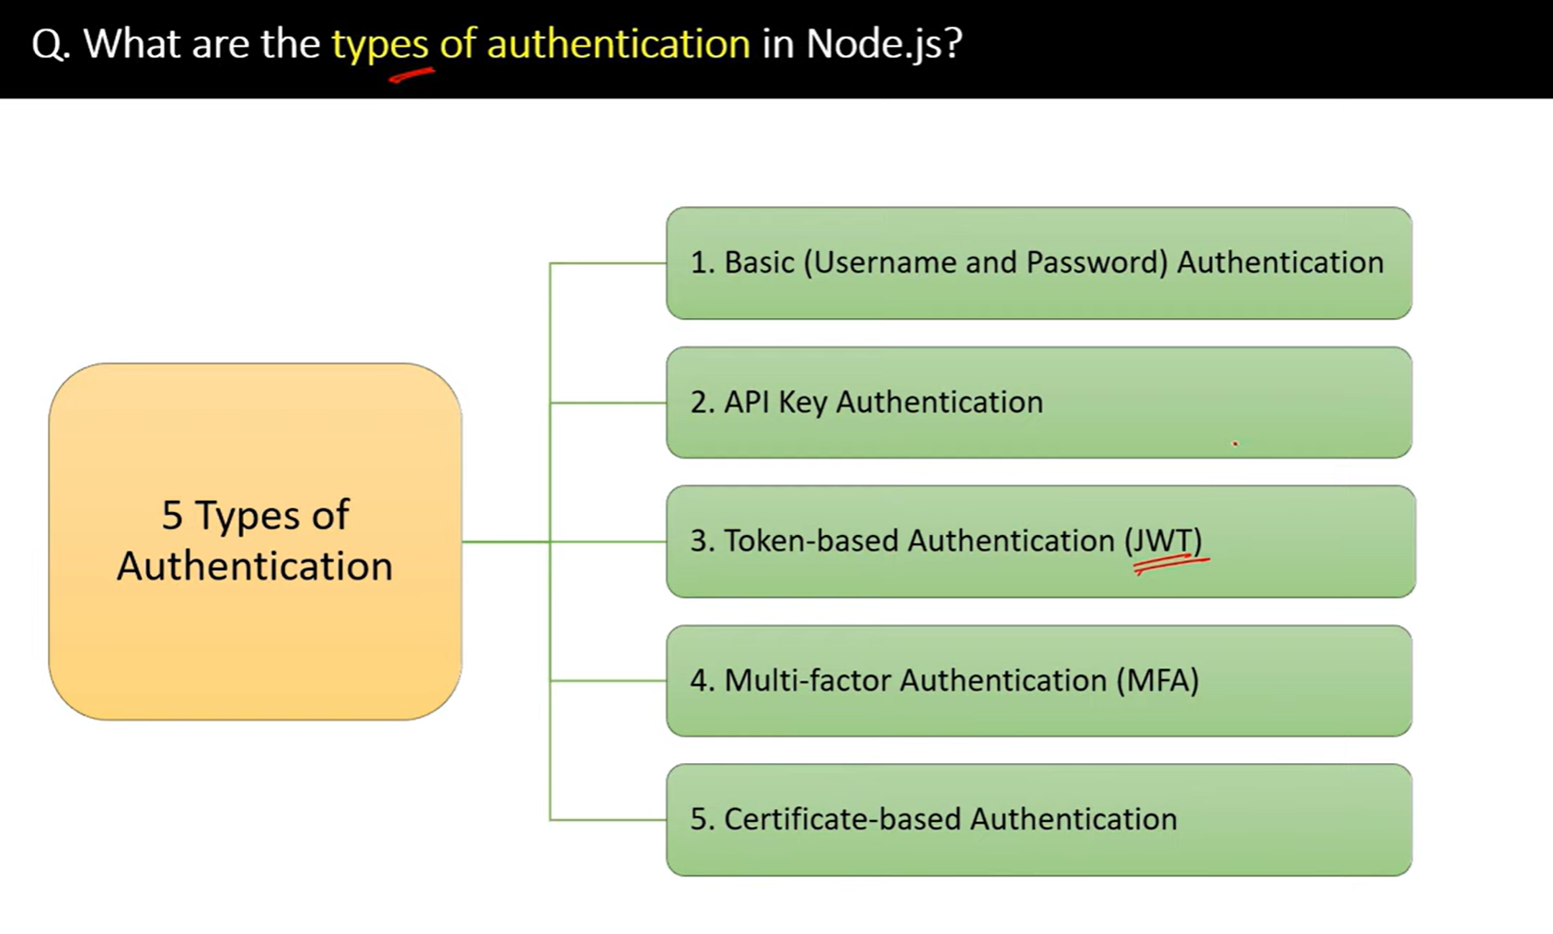

66.

67.

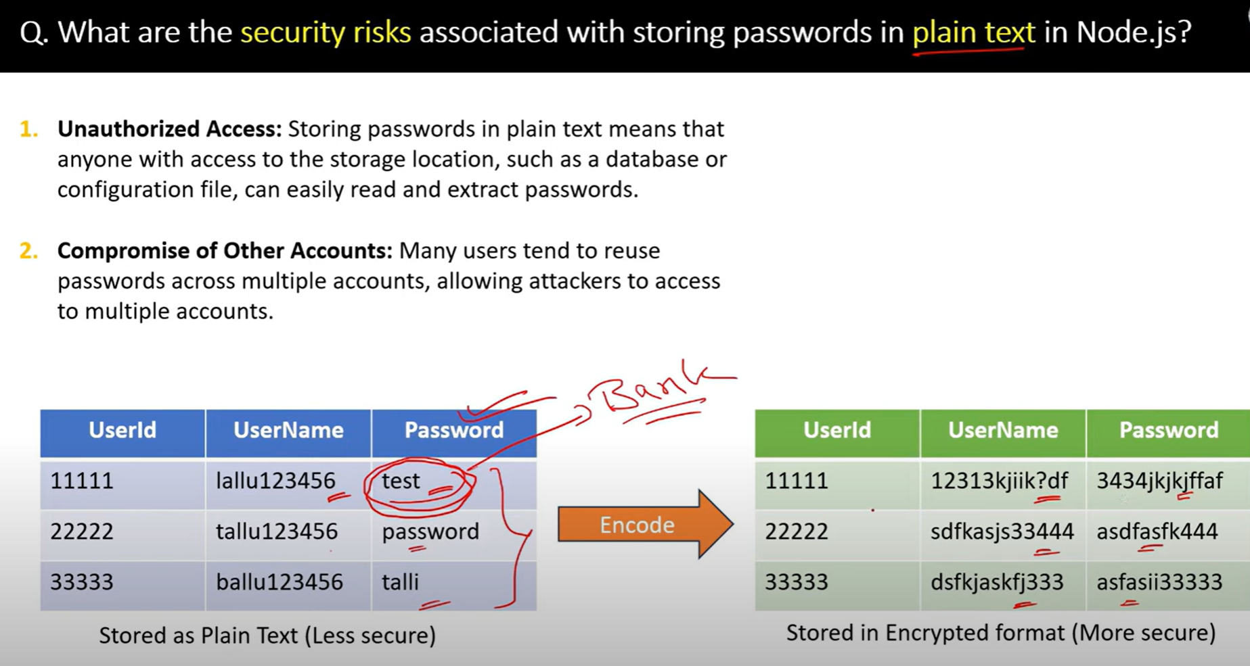

68.

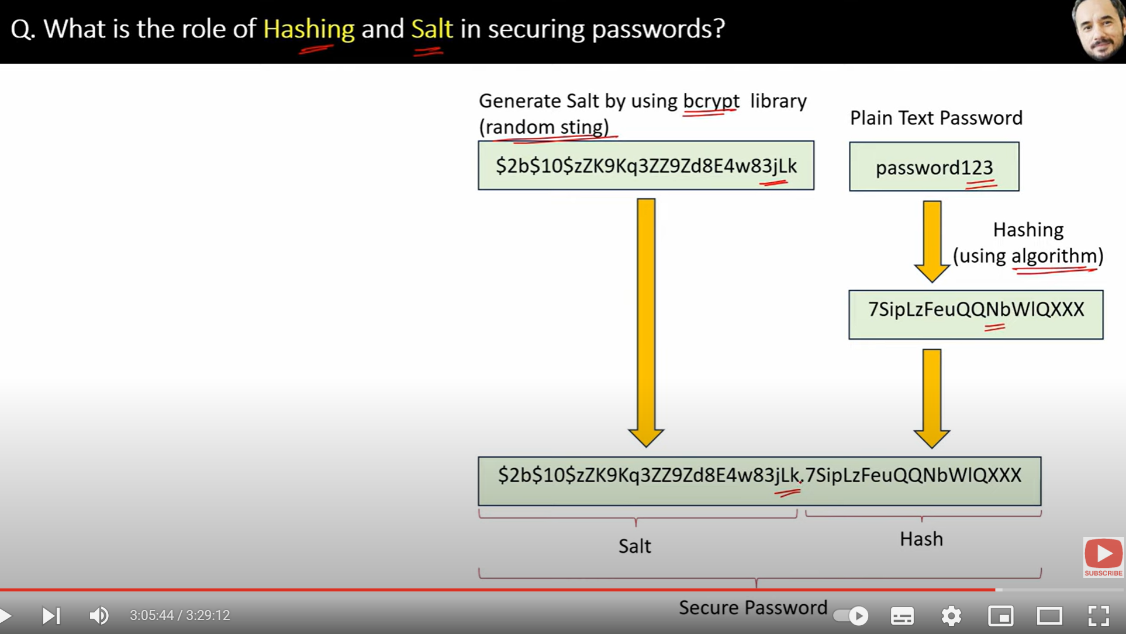

69.

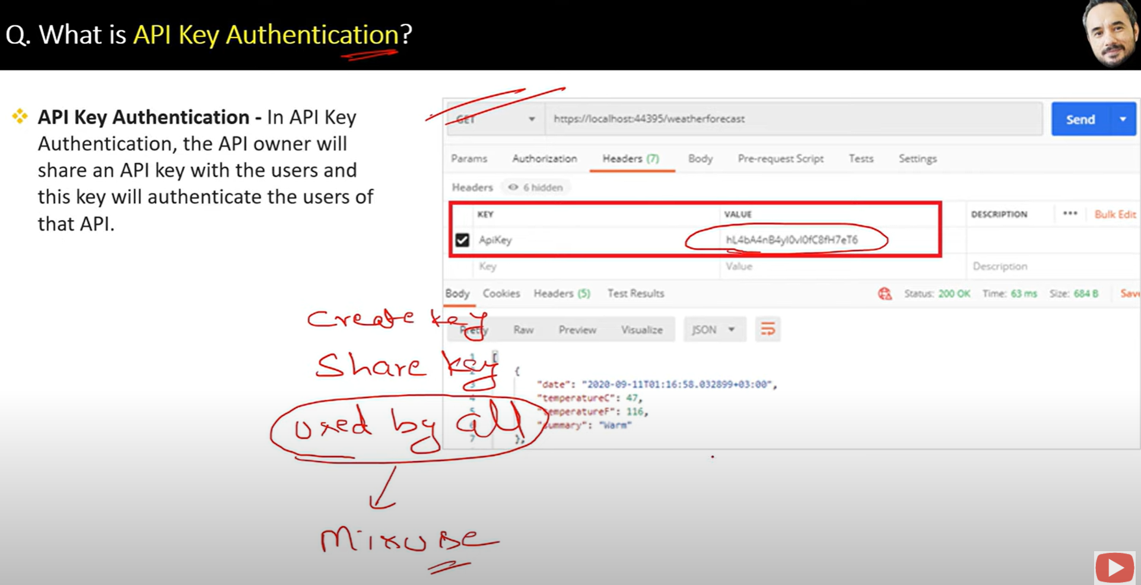

70.

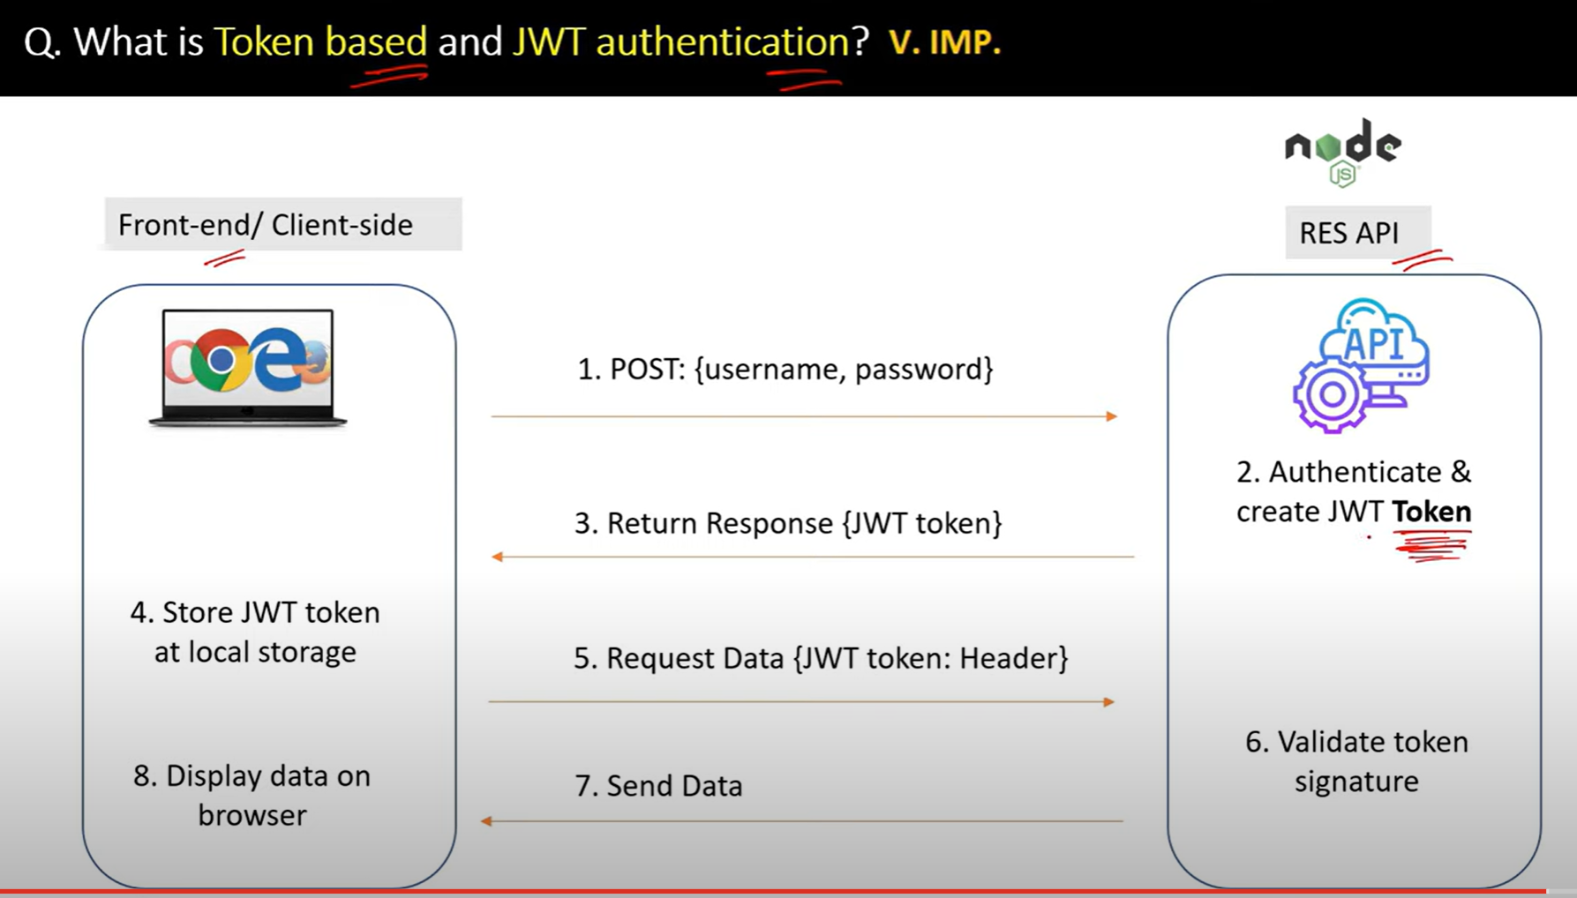

71.

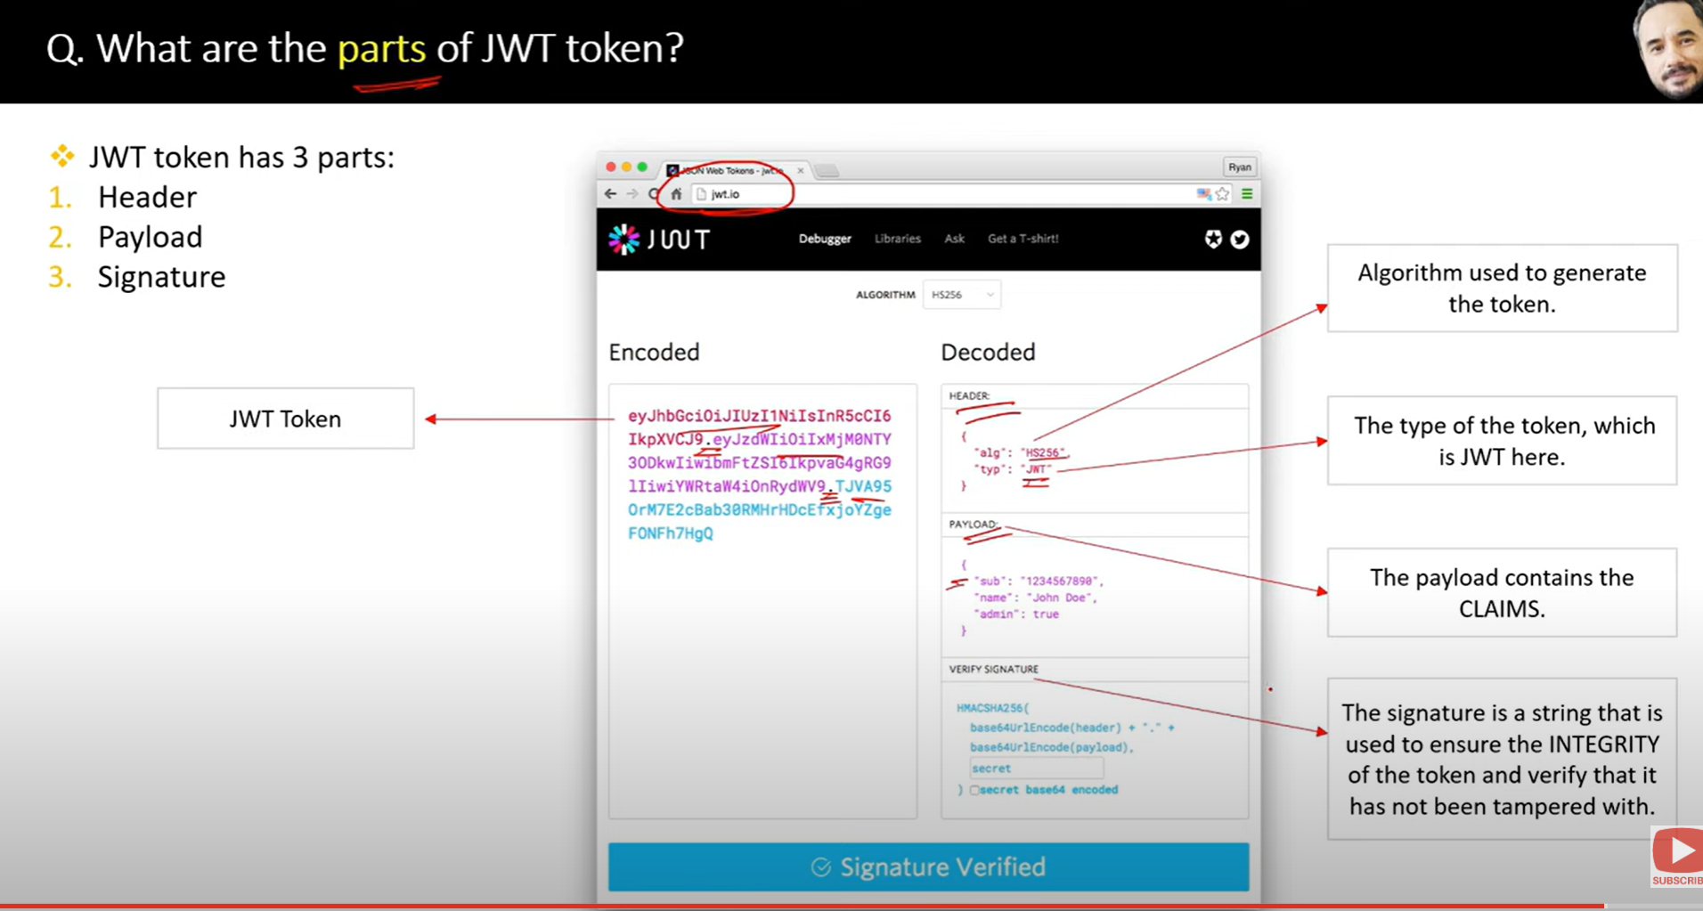

72.

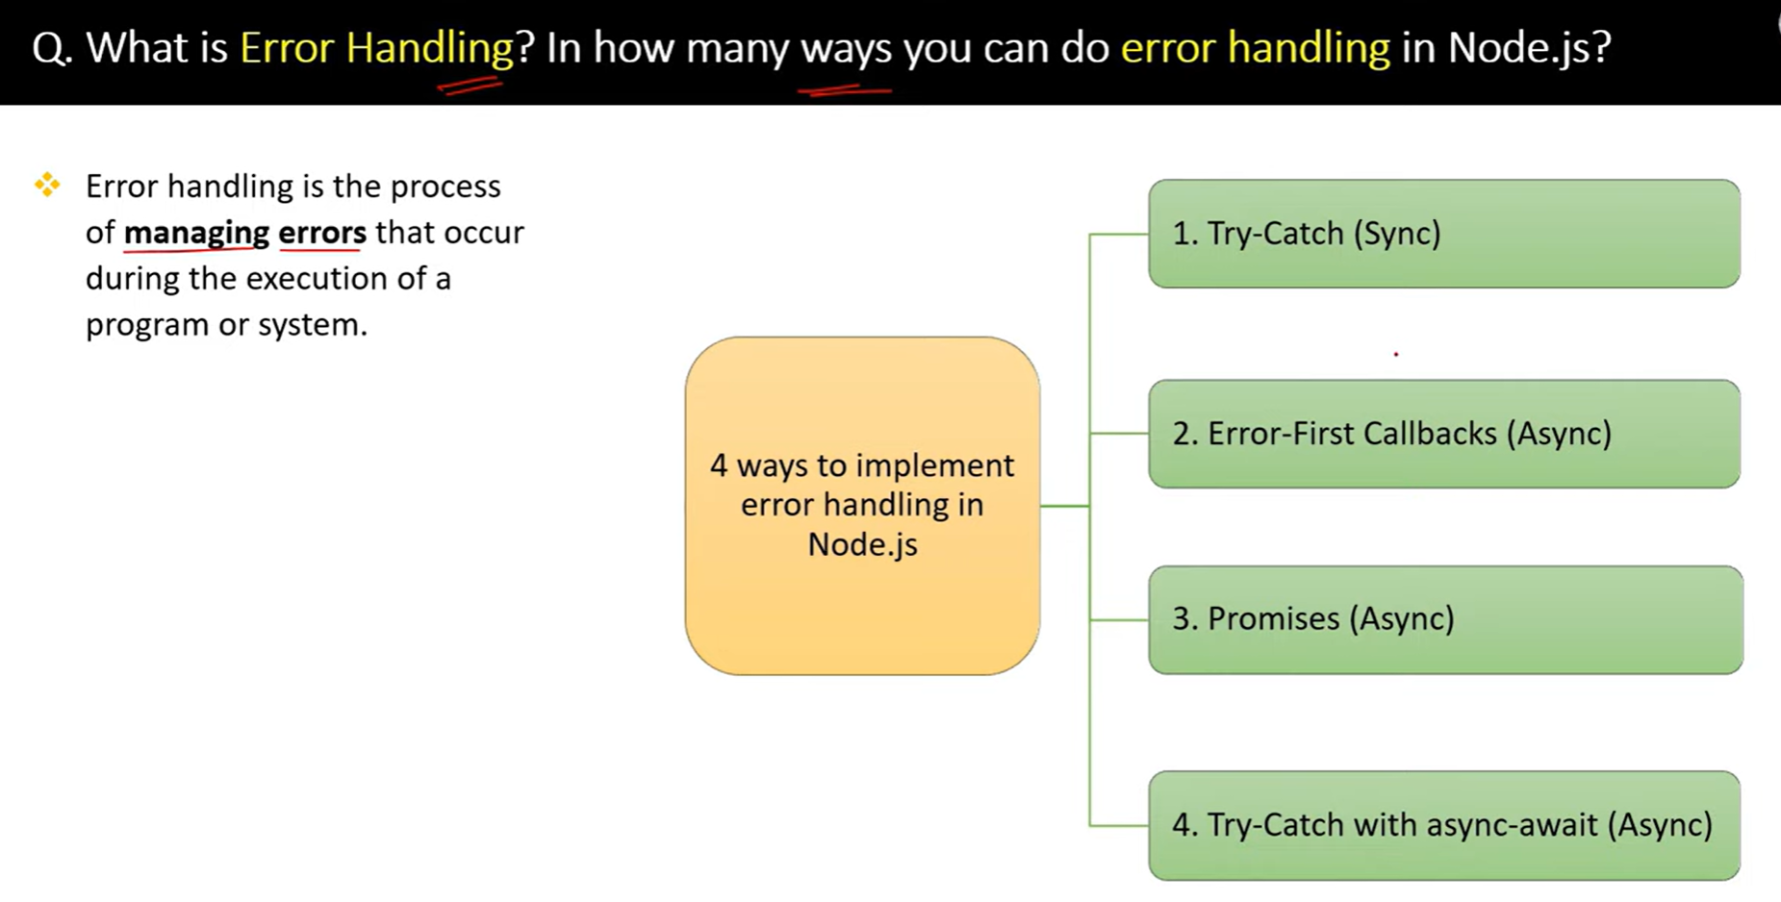

73.

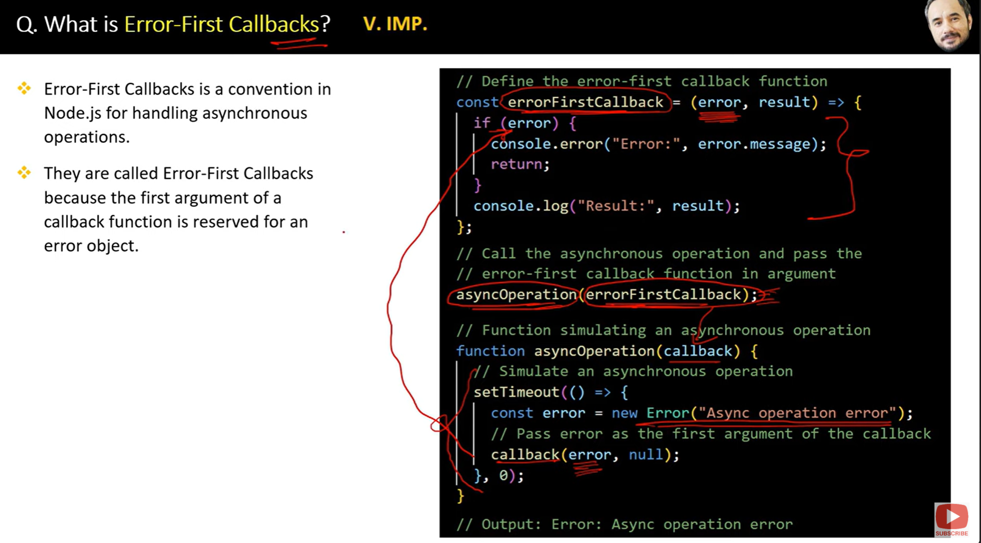

74.

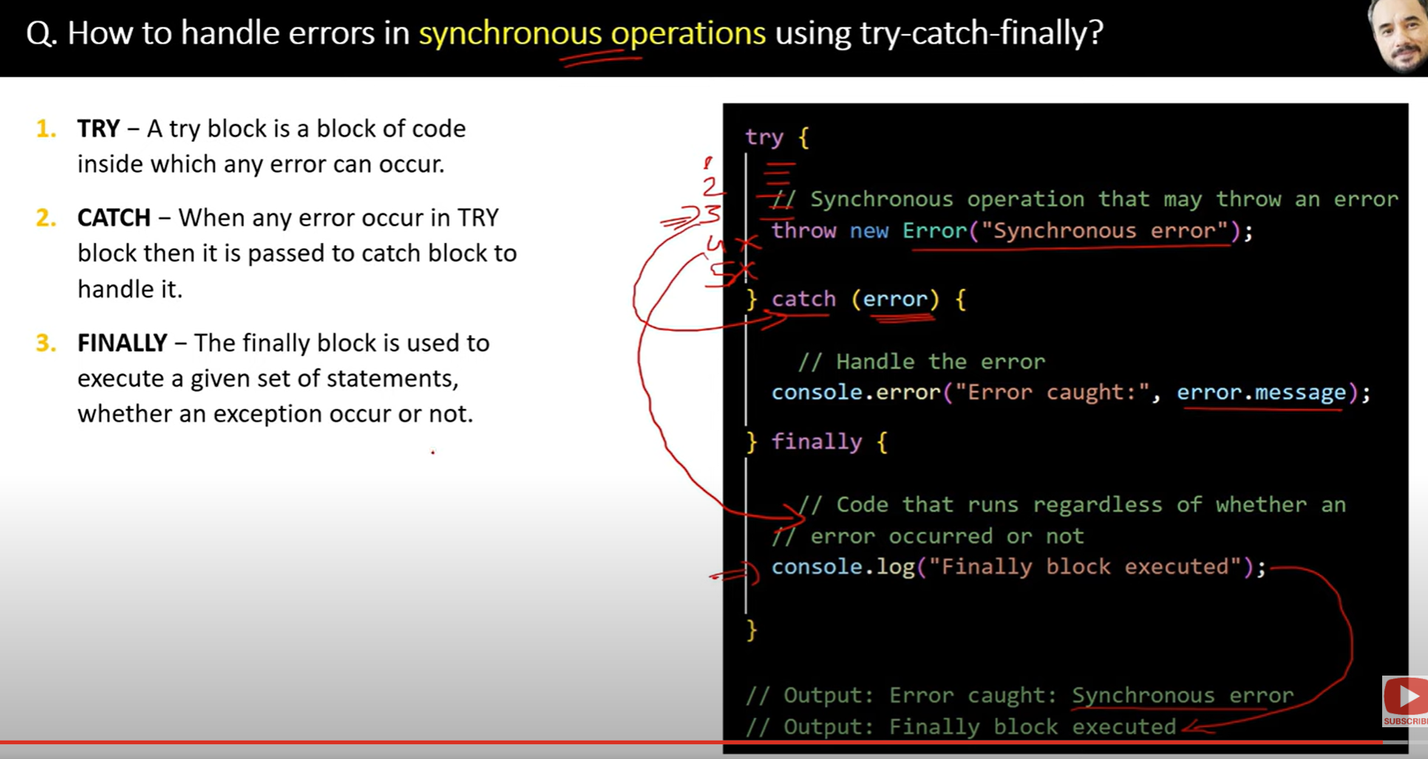

75.

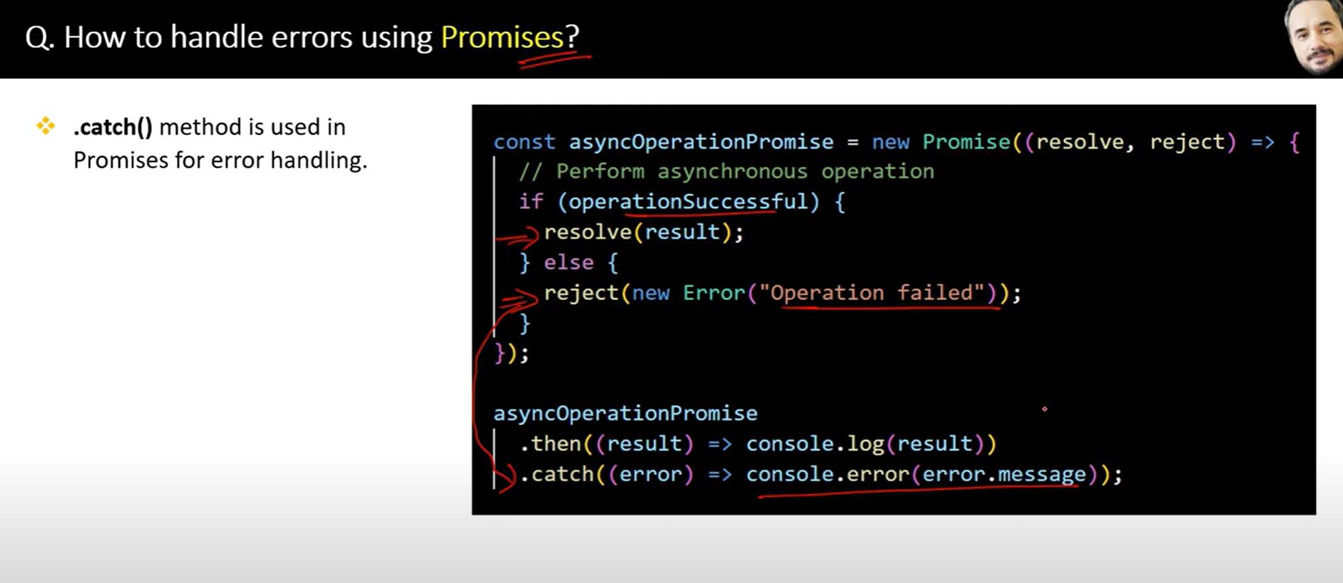

76.

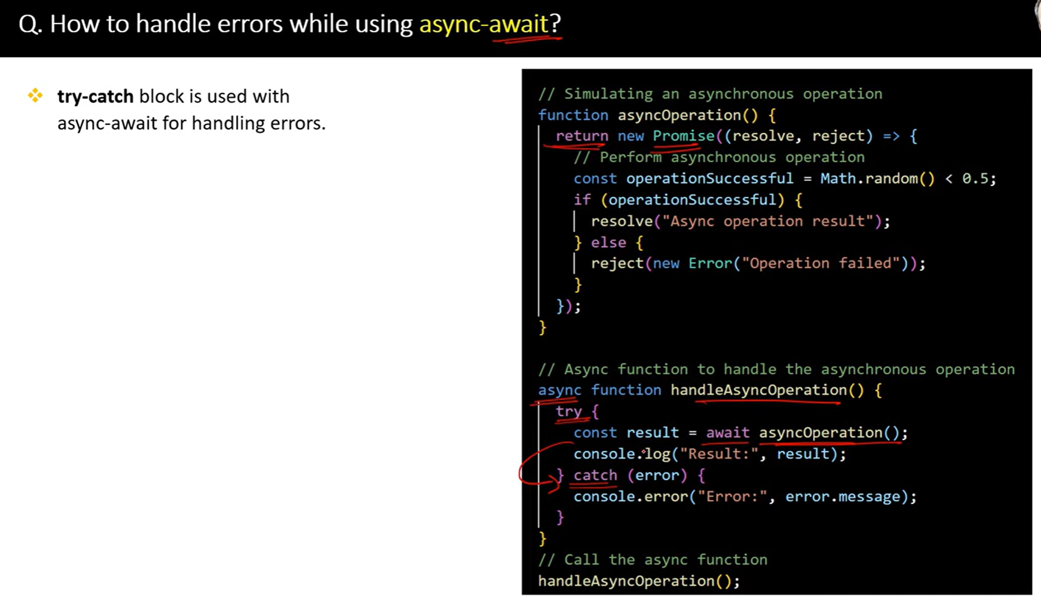

77.

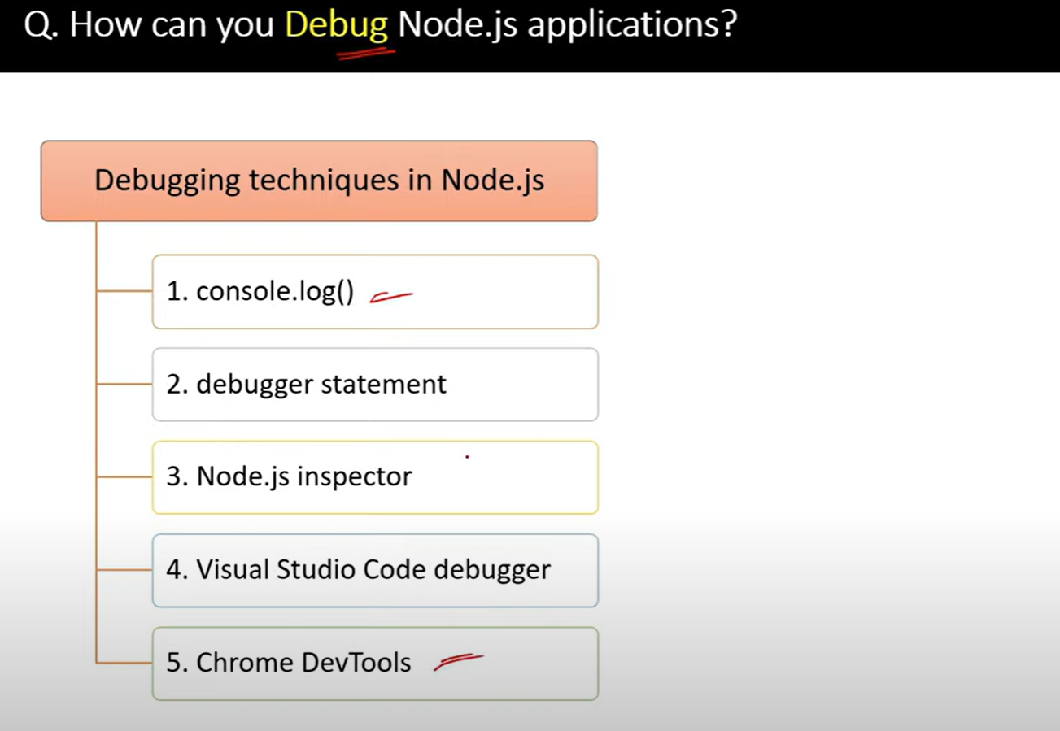

**🔄 WebSocket vs. Webhook: What's the Difference?**

While **WebSockets** and **Webhooks** both deal with communication between systems, they work very differently and are suited for different use cases. Let’s break it down:

**1. Communication Type 🗣️**

* **WebSocket**:
  + **Two-way** communication.
  + **Real-time**, bidirectional communication between client and server.
  + The client **and** the server can both **send messages** at any time after the connection is established.
* **Webhook**:
  + **One-way** communication.
  + A server sends data to another server (usually a specific endpoint) when a particular event happens.
  + The client **cannot** send messages back to the server via the same webhook.

**Purpose 🎯**

* **WebSocket**:
  + Used for **real-time applications** that need constant data exchange, such as:
    - **Chat apps** (messages appear instantly)
    - **Live data** feeds (sports scores, stock prices)
    - **Online games** (real-time multiplayer interactions)
* **Webhook**:
  + Used for **notifications** when something specific happens, such as:
    - **Payment notifications** (payment gateway tells your app when a payment is successful)
    - **Form submissions** (your server notifies an external service when a form is submitted)
    - **Event triggers** (sending data when a specific event happens in your system)

**🧠 Summary:**

| **Feature** | **WebSocket** | **Webhook** |
| --- | --- | --- |
| **Communication** | Two-way, real-time | One-way, event-based |
| **Connection** | Persistent, stays open | Temporary, closed after sending the data |
| **Use case** | Real-time applications (chat, live feeds) | Event notifications (payment, form submission) |
| **Data flow** | Continuous, can be sent at any time | One-time, triggered by events |
| **Setup** | Requires more infrastructure (long-lived connections) | Simpler, typically just an HTTP endpoint |

| **Feature** | **HTTP** | **HTTPS** |
| --- | --- | --- |
| **Security** | No encryption, data can be intercepted | Encrypted, data is secure |
| **Authentication** | No authentication | Website is authenticated with an SSL certificate |
| **Performance** | Faster, no encryption overhead | Slightly slower due to encryption |
| **Data Integrity** | No guarantee data hasn’t been altered | Data integrity is ensured (not tampered) |
| **SEO** | Lower ranking in search engines | Better ranking in search engines |
| **URL Prefix** | http:// | https:// |
| **Browser Indicators** | No padlock, warnings on sensitive data | Padlock symbol, safe connection |

**How to Increase Node.js Performance (with Examples)**

Whether you're building APIs, handling large data, or scaling systems, performance tuning in Node.js can make a **huge** difference.

Let’s cover **practical tips** with code and reasoning:

**🔧 1. Use Asynchronous Code Wherever Possible**

**✅ Why?**

Blocking functions stop the event loop. Use async functions to keep Node fast.

**❌ Bad**

const fs = require('fs');

const data = fs.readFileSync('file.txt'); // BLOCKING

**✅ Good**

const fs = require('fs');

fs.readFile('file.txt', (err, data) => {

// Non-blocking

});

Or with async/await:

js

CopyEdit

const fs = require('fs/promises');

const data = await fs.readFile('file.txt'); // Still async!

**🧠 2. Use worker_threads for CPU-bound tasks**

Node.js is single-threaded — heavy CPU work blocks everything.

✅ **Offload to worker threads:**

js

CopyEdit

const { Worker } = require('worker_threads');

new Worker('./heavyTask.js'); // run JS code in parallel

**🗂️ 3. Use Clustering to Utilize All CPU Cores**

Clustering helps scale your Node app across CPU cores.

js

CopyEdit

const cluster = require('cluster');

const http = require('http');

const os = require('os');

if (cluster.isPrimary) {

const numCPUs = os.cpus().length;

for (let i = 0; i < numCPUs; i++) cluster.fork();

} else {

http.createServer((req, res) => {

res.end('Handled by worker: ' + process.pid);

}).listen(3000);

}

✅ Spawns multiple Node processes — great for web servers.

**🗃️ 4. Cache Frequently Used Data**

Use in-memory cache for database results, static config, etc.

js

CopyEdit

const cache = new Map();

app.get('/user/:id', async (req, res) => {

const id = req.params.id;

if (cache.has(id)) return res.json(cache.get(id));

const user = await db.findById(id);

cache.set(id, user);

res.json(user);

});

Or use **Redis** for shared cache in distributed apps.

**🚫 5. Avoid Memory Leaks**

Use tools like:

* Chrome DevTools (node --inspect)
* clinic.js or heapdump

Bad:

js

CopyEdit

let users = [];

setInterval(() => users.push(new Array(1000000)), 1000); // 🔥 Memory leak

**📊 6. Use Profiling & Monitoring**

Track performance with:

* node --inspect
* [clinic.js](https://clinicjs.org/)
* APM tools: New Relic, Datadog, Prometheus + Grafana

**⚡ 7. Use Fast Libraries and Efficient Data Structures**

* Use **streams** for large data instead of loading all into memory.
* Use **Buffer** for binary data (e.g., image, files).
* Use native JSON functions instead of big packages.

**🌐 8. Enable GZIP Compression & HTTP/2**

Gzip reduces data size in HTTP responses:

js

CopyEdit

const compression = require('compression');

app.use(compression()); // easy middleware

**🔌 9. Avoid Unnecessary Dependencies**

* Every npm package adds memory and CPU overhead.
* Use built-in modules like fs, crypto, url, etc.

**⚙️ 10. Use the Latest Node.js Version**

Newer versions come with:

* Better performance (V8 optimizations)
* Native module improvements
* Security and stability fixes

Check current version:

bash

CopyEdit

node -v

**✅ Summary Table**

| **Technique** | **Improves** |
| --- | --- |
| Async code | Event loop responsiveness |
| worker_threads | CPU-heavy parallelism |
| Clustering | Multi-core scaling |
| Caching | Speed & DB load |
| Profiling tools | Detect performance bugs |
| Streaming data | Memory efficiency |
| Gzip / HTTP2 | Faster network delivery |
| **what is memory leak in node js**  **🧠 What is Memory in Node.js?**  Think of Node.js like a **kitchen** where a chef (your app) is cooking (running code). To cook properly, the chef uses a **counter (memory)** to keep ingredients (data) temporarily.  After cooking each dish, the chef is supposed to **clean the counter (free memory)**. If the chef **forgets to clean**, the counter gets messy, space runs out, and cooking slows down or stops.  **🐛 What is a Memory Leak?**  A **memory leak** happens when:   * The app uses memory (which is fine ✅), * But **forgets to release it after use ❌**.   This means old, unused data just sits there taking up space. Over time, the kitchen (your app) runs out of counter space (RAM), and the app becomes slow, unstable, or even crashes.  **What is process.nextTick() and setImmediate() in Node.js?**  Imagine you're in a restaurant.   * You (Node.js) are the waiter. * Customers are asking for things (requests). * You take orders, bring food, clear tables — all in a loop (called the **event loop**).   Now you have two special **notes** (tasks) you want to do soon:  **📝 process.nextTick(): "Do this right after current table"**   * It’s like saying: 👉 “After I finish with this table (current task), I’ll IMMEDIATELY do this before taking any other customer.” * It runs **before** anything else (even before timers, file reads, etc).   📦 **Example**: Clean up spilled water on the same table **before** moving to the next customer.  **📝 setImmediate(): "Do this after the current round"**   * It’s like saying: 👉 “Let me finish with **all current tables**, then I’ll do this.” * It runs **after** the current round of customers.   📦 **Example**: Wipe all menus after you've taken care of all tables.  **🍽️ A simple analogy table:**   | **Situation** | **Like in Restaurant** | **Function** | | --- | --- | --- | | Task to run **immediately next** | Handle spilled drink **before next table** | process.nextTick() | | Task to run **after others** | Clean menus **after helping all tables** | setImmediate() |   **🧪 Real Code Example:**  console.log('Start');  process.nextTick(() => {  console.log('This runs IMMEDIATELY after current task');  });  setImmediate(() => {  console.log('This runs AFTER current round');  });  console.log('End');  **📦 Output:**  Start  End  This runs IMMEDIATELY after current task  This runs AFTER current round  **✅ Summary for Non-Tech**   | **Term** | **Meaning in Simple Words** | | --- | --- | | process.nextTick | "Do this right after I finish this task" | | setImmediate | "Do this when I finish this whole round" | |  |